TITLE OF PAPER

Author One¹, Author Two² and Author Three¹²
¹ Name of Organisation, City, Country
email: email.address@email.address
² Name of Organisation, City, Country
email: email.address@email.address

Abstracts for oral presentations are invited and should be provided by 15th July 2022. They will be collated in a Digest and distributed at the Symposium. Please prepare abstracts in Microsoft Word using this template and send in Word format to: PAFAR2022@csiro.au with “Abstract PAFAR2022” as the subject of the email.

Each abstract is limited to one page including all figures, tables and photos. Abstracts will undergo a single-pass review process and will be assessed according to their relevance, originality, clarity, technical content and adherence to the format requirements. Notification of accepted contributions will be sent by 8th August 2022.

If you are using figures in your abstract, please use a caption below the figure as shown in Figure 1. For tables, the caption should be above the table as shown in Table 1.

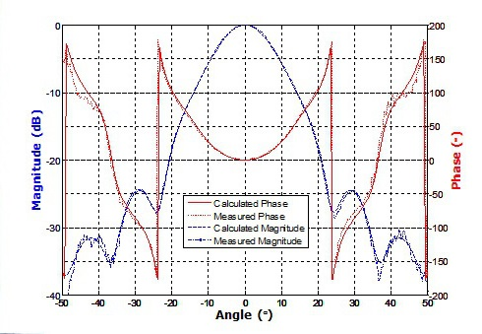
Figure 1. Plot of measured versus calculated radiation patterns of a 200GHz horn.

Table 1. Title of table.

Care should be taken with the appearance of the equations. The equation number should be placed in parentheses and flush with the right hand margin. Leave a space before and after the equations. Always refer to equations by number, as Eq. 1 or Eq. 3-6.

(1)

References are listed at the end of the article in order of citation, the numbers being enclosed in square brackets [ ].

- A. P. Chippendale, D. McConnell, K. Bannister, N. Nikolic, A.W. Hotan, K.W. Smart, R.D. Shaw, D.B. Hayman, S.G. Hay, “Recent Developments in Measuring Signal and Noise in Phased Array Feeds at CSIRO,” European Conf. on Antennas and Propagation (EuCAP), Davos, Switzerland, pp. 1-5, 2016.
- C.A. Balanis, Antenna Theory: Analysis and Design, Wiley, New Jersey, 2005.
- H. Yagi, “Beam transmission of ultra short waves,” Proc. IRE, vol. 16, pp. 715 – 741, June 1928.

