Adoption of conservation agriculture for increased income and food security in the Pacific: A case-study in Samoa

Author
S.A.T. Fulton

Supervisors
D.L. Antille, M. Monjardino

Abstract
A shift towards overexploitation of traditional agricultural practices in Pacific Island Countries and Territories (PICT) has shown to accelerate the declining trend in soil security and therefore threaten the future of income and food security in the region. To narrow existing yield gaps in Samoan taro farming systems and encourage the adoption of more sustainable practices, a conservation agriculture (CA) system was designed for taro farming in Samoa. The system targets the issue of soil security and is predicted to have follow on socio-economic benefits for the country of an unknown magnitude. This research aims to quantify the potential benefits of the proposed CA system in terms of income and food security and determine its relative advantage for the population. Using smallholder ADOPT, the adoption of the CA system was predicted, and the drivers and barriers to adoption were identified. Using an experimental site in Samoa as a case-study, the research determined that the CA system would increase gross margins by 97% and provide greater access to safe and nutritious foods with increased energy and protein production. The CA system is predicted to reach a peak adoption level of 77% after 15 years. The key drivers to the innovation’s adoption were its benefits to soil, income, and food security as well as its ability to be trialled and minimise production risks. Key barriers to adoption were identified as a non-commercial grower mindset, financial constraints, and limited access to information about the CA system. Recommendations for future research include the use of APSIM to simulate the effect of different biophysical processes on Samoan taro farming systems, and the use of the Value-ag framework to quantify the impact of the CA system on whole farm productivity, profitability, and resilience.

Key words
Taro-based system, farm resilience, Profitability, Smallholder ADOPT, Climate adaptation, Sustainable intensification.
Contents
1. Introduction 3
2. Methods and Materials 5
2.1 Samoan Context 5
2.2 Experimental Site 5
2.3 Experiments 6
2.3.1 Baseline Scenario 6
2.3.2 Conservation Agriculture System 7
2.4 Modelling 8
2.4.1 Partial Budget Analysis 8
2.4.2 Food Security 9
2.4.3 Adoption 9
2.5 Data Collection and Parameterisation 10
2.6 Sensitivity Analysis 11
2.6.1 Ratio of the two intercrops occupying the cultivated land 11
2.6.2 Adjusting responses to the smallholder ADOPT questions 11
3. Results and Discussion 12
3.1 Income Security 12
3.2 Food Security 16
3.3 Adoptability 17
3.4.1 The Adoption Process 17
3.4.2 Smallholder Adopt Predictions 19
3.4.3 Sensitivity Analysis 21
4. Conclusions 26
4.1 Recommendations 27
Funding and Acknowledgements 28
Disclaimer 28
Data availability statement 28
References 28
Reference list 28
Appendix 32

Introduction

Dispersed throughout the Pacific Ocean are over 25,000 islands with diverse environments, marine ecosystems, agricultural systems, and traditional cultures (Parsons, 2022). Agricultural production in Pacific Island countries and territories (PICT) is largely dominated by small-scale, family-based farming systems, which play a vital role in the production of food for community and commercial consumption as well as employment, community development, and the preservation of cultural traditions (Sherzad, 2018). PICT face major challenges, which hinder the development and success of their agricultural systems, one being their ability to maintain arable land in good agricultural and environmental condition. This has direct effects on soil, income, and food security in these regions. To keep land in arable condition it is imperative that effective soil protection measures are implemented that minimise impacts on water quality, soil erosion, loss of soil organic matter, and maintain good soil structure.
A shift towards overexploitation of traditional agricultural practices in PICT has shown to accelerate this declining trend in soil fertility and soil carbon (Susumu et al., 2023). Mechanised and semi-mechanised systems in PICT rely on tillage, and monocropping is a common practice, both of which are not sustainable from a soil protection perspective. In addition to this, many of the PICT’s governments are pushing to ban the use of broad-spectrum herbicides in agricultural systems and encourage organic farming methods. Given that training and extension programs in crop protection are limited and advanced technology (e.g., spot spraying or weed seeker) for weed control is not available, it is anticipated that a complete ban of herbicide use will likely increase the reliance on tillage, which could exacerbate soil degradation processes if not properly implemented. This is also likely as there is no provision from governments and extension offices as to how this shift in farming methods may be implemented in practice, nor is there any academic program at local universities covering, both in depth and scope, aspects of soil tillage and farm mechanisation. As a result, there is no provision for effective, long-term capacity building in these and broader areas of agricultural engineering and soil management (Antille and Stockmann, 2024).
In general, PICT are at a comparative disadvantage to other agricultural producers due to their poor economic geography. The vast distances lying between them and importing countries amplify the cost of transport, making it more difficult to develop export markets. With limited access to financial support, information, and farming resources, it can be extremely difficult for farmers to maintain a consistent supply of produce that meets the quality and food safety requirements of modern outlets (Sherzad, 2018).
The effects of climate change are extreme in the Pacific region due to the low-lying nature of the islands which sit only a few feet above sea level (Sherzad, 2018). This puts them at greater vulnerability when extreme weather events and natural disasters occur.
These are some of the copious reasons why there is an urgent need for transformational change in PICT to improve soil condition, food security and the resilience of farming systems, particularly in the face of climate change.
In 2022, the Australian Government’s Department of Foreign Affairs and Trade (DFAT) funded a research project to narrow existing yield gaps and promote sustainable and resilient farming in PICT. The project aims to investigate opportunities for climate-smart agriculture practices such as conservation agriculture (CA) in Fijian and Samoan cropping systems (e.g. Meier et al., 2023 and Antille et al., 2023). The definition of CA used for this study is “a series of recommendations that enable farmers to produce more with less, and the resource-conserving behaviour provides a pathway to sustainably intensifying production on existing farmland” (Monjardino et al., 2021).
As a part of the DFAT funded project, experimental trials in Samoa identified improved management strategies for the sustainable intensification of traditional taro-based systems. The experiments investigated crop nutrition through determining the optimal application rates of NPK, manure, and urea in taro farming systems. The project also looked at crop configuration, and how row and intra-row plant spacing could be modified to meet mechanisation requirements and allow for intercropping with maize and soybean. The research demonstrated that current agronomic practices for taro production in Samoa could be improved with a few adjustments to the way the cropping systems are managed and designed. Through this improved understanding of soil nutrient dynamics and the development of nutrient management guidelines for taro production systems, the research hopes to improve soil security which will have follow on benefits for income and food security in Samoa. The magnitude of the CA systems anticipated socio-economic benefits, and its likelihood of being adopted are unknown, thus a knowledge gap was identified. Using an experimental farm site in Samoan, while contributing to the larger DFAT project, and following on from earlier adoption work by Juttner-Melland et al. (submitted), this study aims to:
- Quantify the potential benefits of a proposed CA system in terms of income, and food security.
- Using smallholder ADOPT, predict the likely farmer adoption of the proposed CA system developed in the larger project, and identify the specific drivers and barriers for its adoption in the context of smallholder taro farmers in Samoa.
- Provide a set of recommendations for future research and development priorities.

Methods and Materials

Samoan Context

Samoa is a Polynesian country of the PICT, located northeast of Fiji and has a population of 227,000 (Worldometre, 2023). The country consists of two main islands, Upolu and Savai’I, as well as several smaller islands (DFAT, n.d.). Samoa is run by a parliamentary democracy that places significant emphasis on preserving Samoan traditions and culture through its constitution and political system. According to the Samoan Multidimensional Poverty Index (MPI) report, ~25% of Samoans experienced poverty in 2022 (Samoa Bureau of Statistics, 2022), with the leading causes being poor access to education and resources, high unemployment rates, gender inequity, and threats to agricultural production including extreme weather events.
Samoa’s climate is tropical, with the average temperature ranging between 23℃ and 30℃ throughout the year and a mean relative humidity of ~80%. Annual rainfall averages 2,800 mm, occurring in the form of downpours which are short in the dry season (June – September) and can last several days in the wet season (December – March). Agriculture is the foundation of Samoa’s economy, representing and over 27,000 households depend on the sector for their livelihoods (Troubat et al., 2020). The four major crops grown in the country are coconut, cocoa, banana, and taro. Approximately 90% of Samoan taro is grown by subsistence farmers; the remaining 10% are semi-subsistence and commercial farmers (Fata Philip Tuivavalagi, FAO, Apia, Pers. Comm., 2023).
Taro (Colocasia esculenta) is a starchy root vegetable from the Aracea family and is grown in many tropical and sub-tropical regions around the world (Grimaldi, 2016). Its production is particularly important in Samoa, where it plays a leading role in feeding communities and generates ~10% of the dietary energy consumed in the country (FAO, 2005). Taro is also key contributor to family incomes and important export earnings. As a result of poor soil management and inefficient weed control, Samoan taro yields have seen a gradual decline in recent years. While the use of fertiliser and soil amendments in taro production systems is rare and often perceived as expensive, previous studies have shown significant improvements to crop yield and quality from regular applications of organic and inorganic fertilisers (Miyasaka et al., 2001 and Antille et al., 2023).

Experimental Site

The focus of this case study is an experimental site established in 2023. The site is a commercial taro farm located in the northwest region of the main island Upolu (13°52.5’ S, 171°56.9’ W, elevation: 270 m above-sea-level) (Fig 1). The farm receives an average of 2,800 mm of rainfall annually and relies predominantly on clay loam soils. Taro is the main crop on the farm both in terms of area occupied and financial value. The farming system integrates other crops and livestock such as banana, coconut, cocoa, chickens, and pigs but on a much smaller scale. The system currently produces approximately 300 baskets (one basket = 22.5 kg of taro corm) of taro per ha and employs 12 part time and five full time workers, and one financial manager who works remotely. The farm owner resides in Apia, a ~24 km distance from the farm.
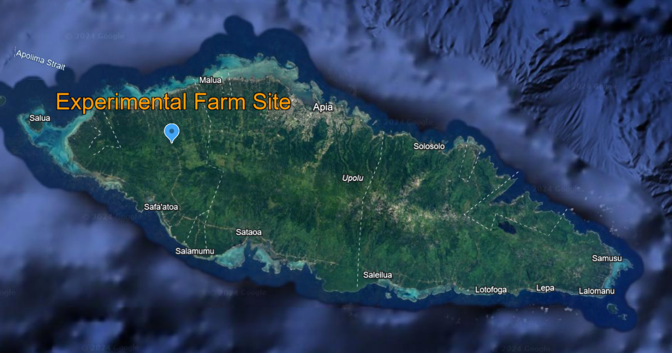
Figure 1. Map of Upolu Island, Samoa, showing the location of the experimental site established in 2023 (13°52.5’ S, 171°56.9’ W, elevation: 270 m above-sea-level).

Experiments

2.3.1 Baseline Scenario

In Samoa, the traditional taro cropping system follows a 1 x 1 m planting configuration. Planting, crop protection (including weed control), and harvesting is performed weekly. The crop takes approximately eight months to reach harvest maturity, at which time the plant is pulled out of the ground and the corm is severed from the base of the stem (or sucker). The stem is then immediately replanted in the ground. The application of nutrients, whether synthetic or organic fertilisers, is seldom practiced. All labour is manual, except for initial land clearing (removal of native vegetation and soil de-stoning), which employs an excavator. The parameterisation of the baseline system is informed by assumptions presented in table 4 (Appendix).

2.3.2 Conservation Agriculture System

The CA system increases diversity on the farm by intercropping the taro with maize and soybean. Consequently, the CA system encompasses two components, the taro-maize system, and the taro-soybean system, which are expected to be rotated annually.
The taro-maize system follows a planting configuration where taro plants are separated by 1.5 m and 0.8 m along the horizontal and vertical axis respectively. Between each taro along the horizontal are three to four maize plants in a single line going down the vertical 0.8 m distance. The taro-maize system requires 4,765 kilograms of fertiliser per ha. The design of taro-soybean system follows a similar planting configuration with taro plants also separated by 1.5 m and 0.8 m along the horizontal and vertical axis. Two lines of 20 soybean plants are placed between each taro along the horizontal axis. The lines of soybean move down the vertical 0.8 m distance. The taro-soybean system requires 5,230 kilograms of fertiliser per ha.
While farmers tended to prefer the soybean crop option due to its higher selling price per kg, maize produces higher biomasses thus has the advantage of providing better inter-row soil cover over a longer period. The challenge for farmers is to balance short-term profitability and longer-term sustainability of their CA system by deciding on the relative area allocated to each intercrop. Factors such as grain price, fertiliser supply, labour availability, and seasonal conditions may affect adoption of one over the other.

Table 1. Summary description of the Baseline and CA systems compared in this case study.
 | Baseline System | CA System
 |  | Taro-Maize | Taro-Soybean
Proportion of cultivated land (%) | 100% | 50% | 50%
Crop yield (kg ha⁻¹) | Commercial yield target: 10,000 - 30,000  Farm site: 6,420  National average: 6,250 (See Antille et al., 2022) | Taro: 9,080  Maize: 4,000 – 5,500 | Taro: 9,080  Soybean: 86 - 257
Crop density (plants ha⁻¹) | Taro: 10,000 | Taro: 8,333  Maize: 29,166 | Taro: 8,333  Soybean: 41, 666
Labour requirements  (8-hour days ha⁻¹) | 82 | 104 | 116
Fertiliser requirements  (kg ha⁻¹) | 0 | 4,765 | 5,230
Other inputs (WST ha⁻¹) | Glyphosate: 79  Diesel: 850  Planting material: 988

2.4 Modelling

2.4.1 Partial Budget Analysis

Income security is defined as the level of income, assurance of receipt and the expectation of income adequacy now and its improvement or deterioration in the future (International labour organisation, n.d.).
The relative profitability of the two systems was assessed using a Partial Budget Analysis (PBA). This method quantifies the net economic impact of proposed changes in the current system using gross margins (WST per ha), i.e. the difference between the gross income (yield x price) and the variable costs required in each system. In this analysis, the baseline system is assumed to occupy 100% of the cultivated land. Both taro-maize and taro-soybean intercrop options are assumed to occupy 50% of the cultivated land each. The CA systems gross margin per ha was therefore calculated as the sum of the taro-maize gross margin per ha x 50% and the taro-soybean gross margin per ha x 50%.

2.4.2 Food Security

Food security is defined as having access to safe and nutritious food that meets the requirements for an active and healthy life (Simon, 2012). The relative food security of the baseline and CA system was quantified in terms of the calorific energy and protein produced per ha.
Energy (kJ per ha) was calculated using average nutritional values for the crops (calories per gram of crop) that were then multiplied by their respective yields. The average energy values used in the calculations were 1.06, 0.86, and 4 calories for uncooked taro, maize, and soybean respectively. The energy value was then converted to Kj per ha. For this calculation, it was assumed that the taro-maize and taro-soybean intercrops would occupy 50% of the cultivated land each while the baseline system would occupy 100%. The CA systems kJ per ha was therefore calculated as the sum of the taro-maize kJ per ha x 50% and the taro-soybean kJ per ha x 50%.
Protein (grams per ha) was calculated using average protein contents for the crops (grams of protein per gram of crop) that were then multiplied by their respective yields. The average protein concentrations used in the calculations were 0.01, 0.03 and 0.4 grams of protein per gram of crop for uncooked taro, maize, and soybean, respectively. For this calculation, it was assumed that the taro-maize and taro-soybean intercrops would occupy 50% of the cultivated land each, while the baseline system would occupy 100%. The CA systems grams of protein per ha was therefore calculated as the sum of the taro-maize grams of protein per ha x 50% and the taro-soybean grams of protein per ha x 50%. Values were then converted to kilograms of protein per ha as a more user-friendly unit.

2.4.3 Adoption

Adoption of the innovation scenarios were predicted using Smallholder ADOPT (Llewellyn and Brown, 2020). This framework presents users with 22 questions about commonly influential adoption factors (Fig. 2). The questions relate to the innovations’ relative advantage to the population, relative advantage compared to current practices, learnability characteristics, and learnability of the population. Users answered these questions via a choice of Likert-scale responses that where then fed into a series of formulas that provided numeric predictions for Peak Adoption Level and Time to Peak Adoption. The predictions were then used to generate an S-curve that approximated adoption values for the innovation in practice. Despite not capturing all factors that influence the rate of adoption in smallholder innovation systems, the framework generates a good estimate which is useful to a wide range of people and applications.
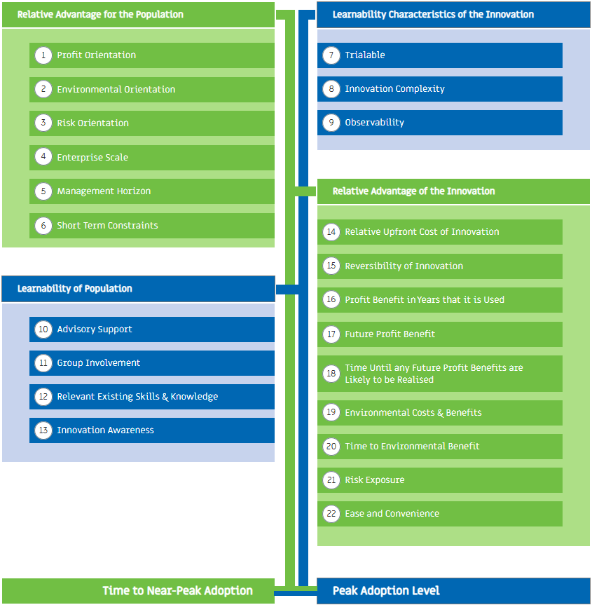
Figure 2. The four quadrants of the ADOPT model and how the questions fit into them (https://adopt.csiro.au/).

2.5 Data Collection and Parameterisation

Key data used in the PBA analysis ̶ including crop yields, input rates, and all prices and costs, were collected directly from the owner of the experimental site, Sala Sagato, during a research visit to Samoa in November 2023. The information provided was complemented by project data, expert assessment, and relevant literature. The assumptions used in the analysis are shown in the appendix (table 1).
Smallholder ADOPT was parameterised via consensus, with input from Samoan taro farmers, a Samoan FAO representative as well as expert opinions and researchers in the field. Overall, parametrization of the models used in this study (along with a bioeconomic simulation model, IAT within the Value-ag framework, to be used in a planned follow-up study) was informed by data collected during extension and knowledge transfer activities (henceforth field days) that took place at the experimental site in November 2023. Field days were attended by approximately 30 farmers from the Samoan Farmers Association (SFA) who shared their perception about the agronomic practices being tested at the sites.

2.6 Sensitivity Analysis

2.6.1 Ratio of the two intercrops occupying the cultivated land

Depending on the chosen ratio of taro-maize to taro-soybean occupying the cultivated, the systems resulting gross margin per hectare will change. A sensitivity analysis was performed to show the possible combinations of land allocated to each intercrop and their respective gross margins. The combinations that were used included 0%-100%, 10%-90%, 20%-80%, 30%-70%, 40%-60% and 50%-50% for both intercrops.

2.6.2 Adjusting responses to the smallholder ADOPT questions

The smallholder adopt model independently identifies the single most sensitive question determining peak adoption level and time to peak adoption. Once identified, the answer to the question is stepped up (moved to a more positive choice) and stepped down (moved to a less positive choice) to determine the influence the questions response has on adoption predictions.
To determine the influence of adoption barriers associated with the CA system and population’s characteristics on the predicted adoption values, a sensitivity analysis of the smallholder ADOPT responses was conducted. Each characteristic/potential barrier was attributed to one or two questions that were then adjusted from the consensus responses to simulate the removal or reduction of a barrier. The changes in the models output results would consequently represent the influence each barrier has on the CA systems adoption in the context of the Samoan taro farming community. The analysed characteristics and their attributed questions are detailed in table 2.

Table 2. Characteristics and their attributed questions used for the smallholder ADOPT sensitivity analysis.
Barriers to Adoption | Question/s Altered
The CA system’s characteristics
Potential economic benefits | 16 & 17
Potential social benefits | 19
Time for benefits to be realised | 18 & 20
Risk exposure | 21
Difficulty to trial | 7
Farm management complexity | 8 & 22
Characteristics of the population
Technical knowledge availability | 10
Financial constraints | 6
Peer-peer communication | 9 & 11
Grower mindset (commercial vs subsistence) | 5
Knowledge of innovation | 8 & 13

Results and Discussion

Income Security

Both the measles outbreak in 2019 and COVID-19 in the subsequent two years had a profound impact on Samoa’s economy, which experienced a slow recovery following the reopening of borders in 2022 (DFAT, n.d.). For the Samoan people, this meant a significant decline in income security, which refers to the level of income, assurance of receipt and the expectation of income adequacy now and its improvement or deterioration in the future (International labour organisation, n.d.).
A survey conducted by the United Nations in 2020 found that the COVID-19 pandemic and related restrictions resulted in 70% of the population having trouble repaying debts, 50% struggling to afford their children’s education, 50% eating cheaper, less nutritious foods, and almost 60% eating less overall (United Nations, 2020). This resulted in a predicted rise in poverty and as said by Simona Marinescu, “the hard work done in recent years to advance many of the sustainable development goals could be reversed, unless we take action now to protect the most vulnerable.”
The proposed CA system is expected to increase the income security of Samoan taro farmers and consequently improve their access to resources and services such as education, healthcare, and nutritious foods. To quantify the size of the CA systems economic benefit, a PBA was conducted which investigated variable costs, gross income, and consequential gross margins.

Figure 3. Variable costs per ha for the baseline and CA system components.
It was found that the taro-maize intercrop would cost significantly more to run relative to the baseline system. Fertiliser inputs are the main cause for this difference and add a further WST 14,094 in variable costs per ha. Poultry manure was the chosen nitrogen source to be applied to the maize plants and had a desired application rate of 100 kg of nitrogen per ha. The poultry manure input has a relatively low nitrogen concentration of 2.5%. Consequently, the cost of fertiliser in the taro-maize system is much greater than shown in the taro-soybean system which implements NPK with a nitrogen concentration of 12%. It is important to note that the calculations assume poultry manure would be outsourced, however in reality, many farming systems are integrated with livestock, in which case the input could be sourced on farm.
The labour requirements for the taro-maize system are slightly higher than the baseline system due to the increased complexity of managing an additional crop and applying nutrients. The taro-soybean system has the largest labour requirements on account of it having the greatest number of plants in each ha and being the most at risk to pests and disease.
The increased cost of ‘other’ inputs is a result of the seeds that are required for each CA system which is approximately 29,160 maize seeds in the taro-maize system, and 41,660 soybean seeds in the taro-soybean system.
Overall, the total costs of each system were 5,993, 21,280, and WST 13,456 per ha (also shown in table 3) for the baseline, taro-maize, and taro-soybean systems respectively.

Figure 4. Gross income per ha for the baseline and CA system components.
Both the taro-maize and taro-soybean systems are expected to generate a greater gross income than the baseline system. The gross incomes generated by the taro were calculated based on the prediction that with nutrient applications, yields would increase by 2.5 DM tonnes per ha (Antille et al., 2023). This resulted in an increase from 5.12 (National average yield (2018-19) after changed planting rate had been accounted for) to 8.94 fresh weight (FW) tonnes per ha and consequently increased the taro gross income from 34,884 to WST 50,682 per ha.
As shown in figure 4, the maize intercrop is predicted to generate substantially larger gross incomes per ha than the soybean interop. It was estimated that in the CA system, maize yields would reach 3.9 tonnes per ha while the soybean would reach only one tonne per ha. Maize is a C4 plant, and thus produces a greater biomass than C3 plants such as soybean, which explains the significant difference in yields. With a selling price of WST 10.79 and WST 11.53 per kg for maize and soybean respectively, the intercrops generated incomes of WST 35,899 and WST 11,720 per ha. The gross incomes generated by the baseline, taro-maize and taro-soybean systems respectively were 34,883, 86,580 and WST 62,402 per ha.

Figure 5. Comparing total variable costs, gross income, and gross margin for the baseline system and CA system components.
As shown in figure 5, the taro-maize system is predicted to generate the greatest gross margin of WST 65,300 per ha, followed by the taro-soybean system with WST 48,946 per ha and then the baseline system at WST 34,884 per ha.

To conform with the three pillars of CA, it is recommended that a farmer should alternate between or combine the two intercropping systems to meet crop diversity and crop rotation suggestions. Figure 6 illustrates the possible combinations of the two CA intercropping systems, and their resulting gross margins.

Figure 6. Combinations of land allocated to each intercropping system and their resulting gross margins per ha.
The greatest gross margin is generated with 100% of the cultivated land allocated to the taro-maize system, however, it is recommended that farmers stay between 10% – 70% taro-maize, with the ideal combination being an equal split between the two intercropping systems. This combination would generate a gross income of WST 57,123 per ha which is still a significant increase from the baseline system and provides the best protection to the soil from degradation.
From this PBA, it is expected that the innovative CA system would significantly benefit the Samoan taro farming community by generating an additional WST 28,232 per ha and thus improving income security. With this increase in gross incomes, farmers and families will experience greater access to services such as education and health care etc, which can support them in maintaining healthy lives. The results from this analysis are based on prices, costs, and conditions from November 2023, and thus will vary with changes in crop yields, market prices and access to inputs such as seeds or fertilisers. It is recommended that a further sensitivity analysis is conducted on these values to determine gross margins in worst- and best-case scenarios.

Food Security

Samoa has a high incidence of food insecurity, with 25% of the population not having access to safe and nutritious food that meets the requirements for an active and healthy life (Troubat et al., 2020) (Simon, 2012). Despite this, obesity is a major issue in Samoa with almost 46% of the adult population being significantly overweight, suggesting that there is an abundance of available dietary energy. The reason behind these numbers is somewhat explained by the high proportion of imported foods that make up the mainstream Samoan diet. These foods tend to be calorie-dense but have low nutritional value and are more affordable than the healthier, locally grown produce. As a result, there is a high frequency of non-communicable disease in Samoa which is partially caused by income and food insecurity.

Figure 7. Energy and protein generated per ha by the baseline and CA system (50% of cultivated land allocated to each intercropping system).
From the food security analysis, it was estimated that the CA system will yield 28,349 kJ more energy the baseline system. 72% of this energy is generated by taro and the remaining 28% is from the intercrops. Despite not contributing majorly to the total energy production per ha shown on the left side of figure 7, the intercrops in the CA system generate an additional 264 kilograms of protein per ha. 23% and 77% of this additional protein comes from the maize and soybean respectively.
As demonstrated by the above analysis, the CA system is predicted to address the issue of food insecurity by making nutritious foods more accessible to the population through increased yields and incomes. Whether the additional yields are consumed, sold, or fed to livestock that can then be eaten, they will decrease the populations reliance on imported foods through greater access to local and nutritious produce. This does not necessarily mean that the community will choose nutritious foods over the cheaper, less nutritious options, however it does empower them to make that choice instead of being dictated entirely by their financial constraints.

Adoptability

3.4.1 The Adoption Process

The adoption of innovations is a complex process which varies significantly in different scenarios. The process is largely influenced by the attitudes and socio-economic characteristics of a target population but is also greatly dictated by the properties of the innovation itself (Kuehne et al., 2017). Understanding the process of adoption is critical for designing an innovation that is successfully and consistently implemented, and therefore is highly relevant to the development of sustainable agricultural practices in PICT.
Several adoption models have been developed in the last 70 years in numerous fields (see reviews by Mahajan et al., 1990 and Turner et al., 2010) however, the five stages of adoption constructed by Rogers (2003) remains a powerful framework that is frequently used to predict and understand the process of innovation adoption (e.g., Widiati et al., 2023 and Srivastava & Fernandes, 2022). The first stage of Rogers model is Knowledge during which the target population is exposed to the innovation and gains a basic understanding of how it functions. In the second stage, referred to as Persuasion, a person will form an attitude (favourable or unfavourable) towards the innovation from their experience and discussions with others. Stage three is Decision; a person will decide to adopt or reject the innovation. Stage four, Implementation, occurs when the decision is put into practice and the innovation is either trialled or rejected. The final stage is Confirmation and occurs when the person receives positive results from implementing their decision and chooses to continue. There is potential for a sixth Disadoption stage to be added to this framework, which would address the relative risk for and reasons why individuals may choose to return to their previous practice. This will not be explored in this article but may be a topic of further discussion and research in future projects.
During the Persuasion stage of the adoption process, individuals form an attitude about the innovation based on its perceived characteristics. These characteristics are pivotal to the adoption or rejection of an innovation in the Decision stage. Frequently considered innovation characteristics include:
- The relative advantage of the innovation to the existing operation (both economically and non-economically),
- The compatibility of the innovation in the existing operation,
- The complexity of the innovation, and how difficult is it to learn,
- The trialability of the innovation,
- The observability of the innovation by other potential adopters.
The Smallholder ADOPT framework addresses each of these characteristics as well as establishing some of the attitudes, motivations, and values of the target population. With this information, the model predicts an innovations peak adoption level and the time to reach peak adoption in the unique context of a target population. For a successful example of the model’s application see Monjardino et al. (2021).

3.4.2 Smallholder Adopt Predictions

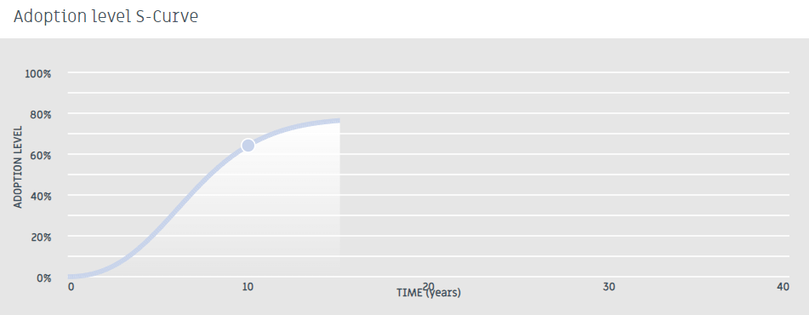
Figure 8. Adoption results, s-curve generated by consensus survey responses.
The model estimated a peak adoption level of 77% and a time to peak adoption of 15 years. These results are considered relatively high in comparison to other findings from the model’s application such as Juttner-Melland et.al. (submitted). Despite this, it is believed that the results are a good estimate for several reasons due to there being numerous drivers for the CA systems adoption which are explored below.
Firstly, from the survey it was determined that most of the Samoan taro farming community are strongly motivated to maximise income and productivity, benefit their community, and minimise production risks. The CA system seeks to enhance all three of these factors, and therefore aligns with the population’s values and drivers.
Secondly, it was found that most of the target population depend highly on their taro enterprise for their livelihoods and are experiencing a severe short-term financial constraint. According to an interviewee from the FAO in Samoa (Fata Philip Tuivavalagi, FAO, Apia, Pers. Comm. 2023) approximately 90% of Samoan taro producers are subsistence farmers, thus they rely on their production system solely to feed their families and community. The remaining 10% of producers are semi-subsistence or commercial farmers and depend highly on their enterprise for household consumption as well as income. With this information it is understood that most of the target population could not access the CA system if it were to require a large initial investment. During the PBA it was determined that the CA system would require an investment which is WST 11,378 more than is currently required for the baseline system per ha. This investment is considered moderately sized relative to the calculated gross margin of WST 28,232 per ha. Unlike many innovative agricultural practices, the CA system does not require any machinery or new technology. Because of this, the innovation is considered accessible to most of the target population and this characteristic contributes to the high adoption predictions.
Thirdly, once the necessary inputs are acquired, trialling the CA system in a small-scale experiment is relatively easy and achievable. The system is designed such that it can be gradually adopted. Trialling the innovation is an adaptable process that can be made to suit the desired pace of each farmer. Also, discontinuing trials and returning to previous practices is believed to be an easy adjustment and has very little consequences when done on a small scale. These characteristics of the system make it more attractive to farmers and therefore increases its likelihood of being implemented and adopted. The effects of the CA system can be observed as changes in the taro (size, weight, yield, growth rate), the addition of intercrop yields, and changes in gross margins, making it easy for farmers to decide to continue or discontinue with the trials. This is also a desirable trait of the CA system.
Fourthly, it was found that most of the target population regularly access information advisors relevant to the CA system and are involved in farmer-based groups that discuss new farming practices. In Samoa, the Ministry of Agriculture and Fisheries (MAF) plays a valuable role in providing technical support to farmers with the goal to create “a sustainable sector for food, nutritional and income security, prosperity, wealth and resilience”. Samoan farmers said they trust institutions such as MAF. Additionally, farmer-farmer communication and support increase the spread of information and knowledge, such activities are known to boost adoption rates of successful practices. These support networks drive the CA system’s adoption by reassuring the farmers that they have people they can reach out to for trusted advice, consequently contributing to the higher adoption predictions.
Fifthly, the CA system is believed to increase income/productivity and have a community advantage in the years it is used. These consequences of the innovation have been analysed and explored in sections 3.1 (Income Security) and 3.2 (Food security). Benefits are expected to be realised relatively soon after the CA system’s adoption (1-2 years). The effects on income and food security are a major driver of adoption as they have potential to improve the lives of farmers, their families, and whole communities.
Sixthly, it is anticipated that adoption of the CA system will result in a moderate reduction in production risks due to the increased crop diversity in the system and overall better soil management. These benefits contribute to improving resilience of the farm by making it less susceptible to variables such as market fluctuations and extreme weather events.

3.4.3 Sensitivity Analysis

3.4.3.1 Peak adoption level (%)

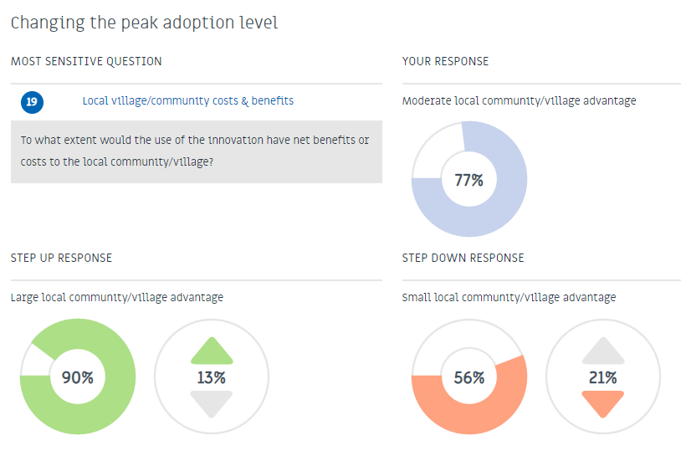
Figure 9. Image from the Smallholder Adopt results - Changing the peak adoption level via step-up and step-down analysis.
The step-up and step-down scenarios are automatically performed by the smallholder adopt model. They show the effect that altering the single most sensitive question has on adoption values – in this case it was question 19 which relates to community benefits. The peak adoption level ranged from 56% to 90% when this question was altered, thus suggesting that the innovations benefit to the community plays a significant role in determining its adoption. Community benefits are realised when the economic and social benefits that occur on farm extend outside the system. Caring for the community is a prominent part of the Samoan culture. Individuals are known to contribute services to their aiga (family unit - Includes relatives from blood, marriage, and adoption) and matai (chief), including the provision of food harvested from the land and sea (Grattan, 1948). As a result, when participants were asked what proportion of the target population have benefits to their community as a strong motivation? (question two), they responded, “a majority”. This is believed to have established community benefits as important to the farmers within the model, and therefore likely enhanced the output’s sensitivity to question 19.

Figure 10. Effect of reducing barriers associated with the CA system’s characteristics on peak adoption level.
It was found that the relative economic benefit of the CA system was the strongest determiner of peak adoption level out of this group of barriers. The adjustments made to test this characteristic were to questions 16 and 17 which resulted in an increased peak adoption level of 17%. The second most influential characteristic was farm management complexity, which when decreased from the consensus response resulted in an increased peak adoption level of 16%. Increased community benefits and reduced risk exposure resulted in an increased peak adoption level of 13% and 14% respectively. Reduced time for community and economic benefits to be realised and a decreased difficulty to trial had minor effects on the peak adoption level.

Figure 11. Effect of decreasing barriers (associated with the population’s characteristics) on peak adoption level.
Figure 11 shows no difference in peak adoption level between the different population barrier removed scenarios, with the only exception being the barrier of a non-commercial grower mindset. The grower mindset barrier was attributed to question five which asks What proportion of the target population have a management horizon greater than 10 years for their enterprise? To determine the influence of this barrier the consensus response was changed from “a minority” to “almost all”, which consequently increased the peak adoption level by 6%. Planning for the future is an important part of a farmers decision-making process, however one’s capacity to plan can be restricted by obstacles and uncertainties occurring in the present or near future (Marion et al., 2016, Stringer et al., 2020, Burnham and Zhao, 2018). Samoan farmers face several significant challenges which hinder their ability to plan, thus, most participants were found to have management horizons which extend one or two growing seasons, as opposed to planning ten years in advance. As a result of the increased peak adoption level in this population barrier removed scenario, the non-commercial grower mindset is recognised as a key barrier to adoption and is influential in determining peak adoption level.

3.4.3.2 Time to peak adoption (years)

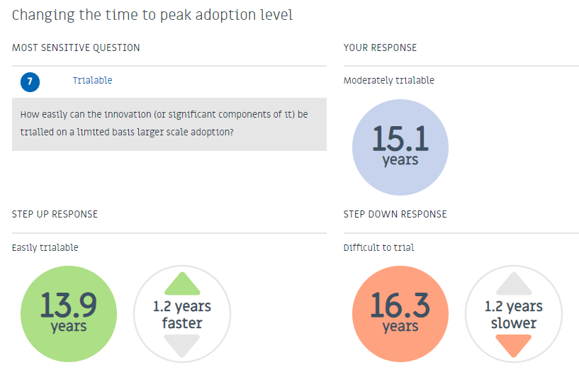
Figure 12. Image from the Smallholder Adopt results - Changing the time to peak adoption level.
Time to peak adoption was most sensitive to question seven which addressed the trialability of the CA system. When the response was stepped down from “moderately trialable” to “difficult to trial”, the model predicted that the time to reach peak adoption would take an additional 1.2 years. Equally, when the response was stepped up to “easily trialable”, time to peak adoption decreased by the same amount. This was also seen in the barrier analysis shown in figure 13.

Figure 13. Effect of reducing barriers associated with the CA system’s characteristics on time to peak adoption.
Despite not having any effect on the peak adoption level as shown in figure 10, the CA system’s relative trialability has shown to be a dominant factor in determining the time to peak adoption. Reduced farm management complexity (which was attributed to question 7) was found to be the second most influential innovation characteristic in deciding time to peak adoption and resulted in a decreased time of one year. All other innovation characteristics had no effect on the time to peak adoption.

Figure 14. Effect of decreasing barriers (associated with the population’s characteristics) on time to peak adoption.
Removing the populations barriers such as financial constraints and limited access knowledge about the innovation had the largest effect on time to peak adoption which was decreased by two years in both scenarios. This response suggests that these characteristics are the key barriers which hinder the innovations adoption. Increasing peer-peer communication was the next most responsive characteristic and when adjusted resulted in the reduction of time to peak adoption by one year. Grower mindset and technical knowledge availability had no effect on time to peak adoption.

3.4.3.3 Important Takeaways

From the sensitivity analysis, it was determined that in the context of the Samoan taro farming community, properties of the CA system that were found to significantly increase its predicted adoption level included greater community and economic benefits, greater trialability and decreased farm management complexity. The major barriers limiting the CA systems adoption were identified as a non-commercial grower mindset, financial constraints, and limited access to information about the CA system.
To overcome these challenges, alterations to the innovations design could be made so that it would be equally beneficial to non-commercial growers and more accessible to farmers with severe financial constraints. A user-friendly handbook could be provided to interested farmers that contains all the required information for the CA system.
The PBA, food security analysis and adoption results from the study are summarised in table 3.
Table 3. Summarised key findings for income security, food security and adoption.
 |  | Unit | Baseline system | CA System
 |  |  |  | Taro-Maize | Taro-Soybean
Income security | Total running costs  Gross income  Gross margin | WST ha⁻¹ | 5,993  34,883  28,891 | 21,280  86,580  65,301 | 13,456  62,402  48,946
Food security | Energy production Protein | kJ ha⁻¹  grams ha⁻¹ | 27,719  62,500 | 56,068  354,827
Adoption | Peak adoption  Time to peak adoption | %  Years |  | 77  15

Conclusions

Current agronomic practices for taro production in Samoa could be improved with a few adjustments to the way the cropping systems are designed and managed. Using an experimental farm site in Samoa, this study i) quantified the potential benefits of the proposed CA system in terms of income, and food security, and ii) predicted the likely farmer adoption for the proposed CA system using smallholder ADOPT and highlighted the specific drivers and barriers to adoption for smallholder taro farmers in Samoa.
From the PBA, it was determined that the CA system could improve income security with the production of an additional WST 28,232 per ha. In consequence, services such as education and healthcare may become more accessible for the target population which can support healthy and fulfilling lives for the Samoan people. It was found that the CA system would improve food security by generating a further 28,349 kJ of energy per ha and 292 kilograms of protein per ha. Whether these additional yields are consumed, sold, or fed to livestock that can then be eaten, they will decrease the populations reliance on imported foods through greater access to local and nutritious produce.
Smallholder ADOPT predicted a peak adoption level of 77% that would be reached after 15 years. These results, despite being unusually high, are thought to be a good estimate due there being numerous drivers for the CA systems adoption including its social, economic, and environmental benefits, its trialability, and its accessibility to the target population. Properties of the CA system that were found to significantly increase its predicted adoption level by smallholder ADOPT included greater community and economic benefits, greater trialability and decreased farm management complexity. The major barriers limiting the CA systems adoption were identified as a non-commercial grower mindset, financial constraints, and limited access to information about the CA system.
The project highlighted the need for employing a range of methods and tools to understand the relative value of agricultural innovations for a unique population and context. The research in this study can be adapted for non-academic audiences, such as farmers, extension officers and policy makers, to help inform decision-making. Modelling and analysis techniques such as that are used in this study could be performed to inform other country and crop specific agricultural innovations.

4.1 Recommendations

This project has identified some opportunities for follow-up research as part of the wider DFAT-funded SciTech4Climate Initiative, including:
- Implementing APSIM to simulate different biophysical processes in Samoan taro farming systems, particularly as it relates to the economic and ecological outcomes of management practices in the face of climate risk.
- The use the Value-ag framework to quantify the impact of the CA system on whole farm productivity, profitability, and resilience. The framework provides explicit insights into bioeconomic and socioeconomic trade-offs that can improve the design/delivery of innovations, the engagement of project proponents in R&D evaluation, and the building of research capacity.
- Further research and analysis into gender inclusion or disparities within Samoan agricultural practices.

Funding and Acknowledgements

The author would like to acknowledge The Department of Foreign Affairs and Trade (DFAT, Australian Government, https://www.dfat.gov.au/) for financial and operational support to conduct this research as part of their SciTech4Climate Indo-Pacific Climate-Smart Agriculture Initiative. The author (Sarah Fulton) was recipient of a CSIRO Scholarship jointly sponsored by MLA (https://www.mla.com.au), CSD (https://csd.net.au/), CRDC (https://www.crdc.com.au/), GRDC (https://grdc.com.au/), and the Crawford Fund (https://www.crawfordfund.org/). The author is appreciative of the CSIRO summer vacation team for organising the scholarship program. The author is appreciative of the contributions made by Sala Sagato, Polito Vili and Fata Philip Tuivavalagi who provided information for the PBA, food security and adoption analyses presented as part of this work. Finally, the author is highly appreciative of their supervisory team Diogenes Antille, Marta Monjardino and Polly Hilder who provided valuable advice and support throughout the research program.

Disclaimer

The material reported in this article may include the views or recommendations of third parties and does not necessarily reflect the views of the Australian Government or indicate a commitment to a particular course of action.

Data availability statement

Any data contained in this article can be requested from the corresponding author. Data quoted in-text or in figures and tables are fully credited to the original sources and the corresponding citations are provided in the list of References.

References

Reference list
ACIAR (2020). From the ground up – soil science improves Pacific diets | ACIAR. www.aciar.gov.au. [online] 30 Sep. Available at: https://www.aciar.gov.au/media-search/news/ground-soil-science-improves-pacific-diets [Accessed 28 Jan. 2024].
Australian Government Department of Foreign Affairs and Trade. (n.d.). Samoa Country Brief Overview. [online] Available at: https://www.dfat.gov.au/geo/samoa/samoa-country-brief.
Burnham, M. and Ma, Z. (2018). Multi-Scalar Pathways to Smallholder Adaptation. World Development, 108, pp.249–262. doi:https://doi.org/10.1016/j.worlddev.2017.08.005.
calcount. (2021a). Calories in Corn, Whole-Kernel, Raw calcount. [online] Available at: https://www.caloriecounter.com.au/food/calories-in-corn-whole-kernel-raw/#:~:text=Corn%2C%20Whole-Kernel%2C%20Raw%20has%20111%20calories%20%28464%20kilojoules%29 [Accessed 28 Jan. 2024].
calcount. (2021b). Calories in Taro, raw calcount. [online] Available at: https://www.caloriecounter.com.au/food/calories-in-taro-raw/#:~:text=Taro%2C%20raw%20has%20106%20calories%20%28451%20kilojoules%29%20per [Accessed 28 Jan. 2024].
calorieking. (n.d.). Calories in Soybeans, raw | CalorieKing. [online] Available at: https://www.calorieking.com/us/en/foods/f/calories-in-fresh-or-dried-legumes-beans-soybeans-raw/8yxTIhxXRw-d255L6gpSnw [Accessed 28 Jan. 2024].
Grattan, H. (1948). An Introduction to Samoan Custom.
International Labour Organization. (n.d.). Income Security Index: Information. [online] Available at: https://www.ilo.org/sesame/SESHELP.NoteISI [Accessed 28 Jan. 2024].
Llewellyn, R.S. and Brown, B. (2020). Predicting Adoption of Innovations by Farmers: What is Different in Smallholder Agriculture? Applied Economic Perspectives and Policy, 42(1), pp.100–112. doi:https://doi.org/10.1002/aepp.13012.
Meier, E.A., Antille, D.L. and S. Mahimairaja (2023). Priorities for narrowing the yield gap and increasing farming systems resilience in the Fiji sugar industry. Farming System, 1(3), pp.100048–100048. doi:https://doi.org/10.1016/j.farsys.2023.100048.
Ministry of Agriculture and Fisheries. (n.d.). Ministry of Agriculture & Fisheries. [online] Available at: https://www.maf.gov.ws/.
Miyasaka, S.C., Hollyer, J.R. and Kodani, L.S. (2001). Mulch and compost effects on yield and corm rots of taro. Field Crops Research, 71(2), pp.101–112. doi:https://doi.org/10.1016/s0378-4290(01)00154-x.
Monjardino, M., Ridaura, S.L., Van Loon, J., Mottaleb, K.A., Kruseman, G., Zepeda, A., Hernández, E.O., Burgueño, J., Singh, R.G., Govaerts, B. and Erenstein, O. (2021). Disaggregating the Value of Conservation Agriculture to Inform Smallholder Transition to Sustainable Farming: A Mexican Case Study. Agronomy, 11(6), p.1214. doi:https://doi.org/10.3390/agronomy11061214.
Parsons, C. (2022). The Pacific Islands: The front line in the battle against climate change. [online] NSF - National Science Foundation. Available at: https://new.nsf.gov/science-matters/pacific-islands-front-line-battle-against-climate.
Robert, M., Thomas, A. and Bergez, J.-E. (2016). Processes of adaptation in farm decision-making models. A review. Agronomy for Sustainable Development, 36(4). doi:https://doi.org/10.1007/s13593-016-0402-x.
Rogers, E.M. (2003). Diffusion of innovations. 5th ed. New York: Free Press.
Samoa: Multidimensional Poverty Index. (2022). Samoa Bureau of Statistics .
Shareef, M.A., Baabdullah, A., Dutta, S., Kumar, V. and Dwivedi, Y.K. (2018). Consumer adoption of mobile banking services: An empirical examination of factors according to adoption stages. Journal of Retailing and Consumer Services, [online] 43, pp.54–67. doi:https://doi.org/10.1016/j.jretconser.2018.03.003.
Shukrullah, S. (2018). Family Farming in the Pacific Islands Countries | FAO. [online] www.fao.org. Available at: https://www.fao.org/family-farming/detail/en/c/1145658/ [Accessed 28 Jan. 2024].
Stringer, L.C., Fraser, E.D.G., Harris, D., Lyon, C., Pereira, L., Ward, C.F.M. and Simelton, E. (2020). Adaptation and development pathways for different types of farmers. Environmental Science & Policy, [online] 104, pp.174–189. doi:https://doi.org/10.1016/j.envsci.2019.10.007.
Susumu, G., Sharma, A., Halavatau, S., Antille, D.L., Webb, M.J., Barringer, J., Kelly, J. and Macdonald, B. (2022). Declining Soil Nutrient Status Can Constrain Agricultural Productivity and Food Security in Pacific Island Countries: A Country Scale Assessment. Pacific Science, [online] 76(3), pp.337–348. doi:https://doi.org/10.2984/76.3.7.
Troubat, N., Faaola, E. and Aliyeva, R. (2020). Food security and food consumption in Samoa – Based on the analysis of the 2018 Household Income and Expenditure Survey. FAO and SBS.
Turner, M., Kitchenham, B., Brereton, P., Charters, S. and Budgen, D. (2010). Does the technology acceptance model predict actual use? A systematic literature review. Information and Software Technology, 52(5), pp.463–479. doi:https://doi.org/10.1016/j.infsof.2009.11.005.
Worldometers.info. (2020). Samoa Population (2020) - Worldometer. [online] Available at: https://www.worldometers.info/world-population/samoa-population/.

Appendix
Table 4. Data assumptions used in the Partial Budget Analysis.
Selling Prices
Crop | Unit | Price
Taro | Basket (21.5 kg) | 120.0
Maize
 | Small cob (139 grams of grain) | 1.5
 | Large cob (191 grams of grain) | 3.0
Soybean | 1 kg | 11.5
Labour Requirements
 | Labour days per ha
Activity | Baseline | Taro-maize | Taro-legume
Land preparation | 5.00 | 5.00 | 5.00
Weeding | 2.50 | 3.00 | 3.60
Pesticide application | 1.50 | 2.00 | 2.40
Fertiliser/manure application | 0.00 | 19.53 | 23.44
Harvesting | 20.00 | 25.00 | 30.00
Transporting produce | 2.50 | 2.50 | 2.50
Planting
Taro | 50.00 | 41.67 | 41.67
Maize | 0.00 | 5.79 | 0.00
Legume | 0.00 | 0.00 | 7.52
TOTAL | 82 | 104 | 116

Cost of Inputs
Input | Unit | Price
Labour | 8-hour day | 50.00
Taro planting material | 1 sucker | 0.50
Maize seeds | 1 seed | 0.0015
Legume seeds | 1 seed | 0.0015
Glyphosate | 1 Litre | 32.00
Diesel | 1 week | 200.00
NPK - 12:5:20 | 1 kg | 6.00
Urea - 46% N | 1 kg | 7.50
Manure | 1 kg | 2.67

Nutrient Applications

Input | Desired nutrient | Concentration of nutrient in input | Application rate (kg/ ha) | Applied to
NPK | Nitrogen | 0.120 | 50 | Taro
Poultry manure | Nitrogen | 0.020 | 100 | Maize
NPK | Phosphorus | 0.014 | 6.5 | Soybean
NPK | Pottasium | 0.133 | 16 | Soybean

Nutritional Information
Crop | Calories per gram | Grams of protein per gram of crop | Reference
Taro | 1.06 | 0.01 | (calcount, 2021b)
Maize | 0.86 | 0.03 | (calcount, 2021a)
Soybean | 4 | 0.4 | (calorieking, n.d.)

