agriculture and food

# CSIRO logoImproving poultry production in Tanzania -

# profitability of interventions

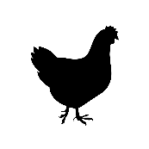Most chicken meat and eggs are produced in low input, low yielding systems with indigenous poultry. Profitability can be increased by feeding supplements and improving health care.

## Current production system

Indigenous poultry supply greater than 70% of demand for chicken meat and egg production in rural areas of Tanzania. Indigenous poultry generally scavenge during the day and are housed at night to reduce losses from predation and theft. There is often very limited supplementary feeding. Egg production is generally low, resulting in lower egg and meat production.

## Issues limiting egg and meat production

### Low growth rates

Caused by inadequate nutrition. Access to supplementary feed is low, and is generally of poor quality.

### Low production

largely caused by inadequate nutrition and high broodiness of low genetic potential indigenous birds.

### High animal mortality

Largely caused by disease and predation through lack of daytime housing.

Using models to understand potential impacts

Bio-economic models can be used to simulate and understand the potential effects of changes to production systems. A baseline simulation is created to match current production systems, and different interventions are tested.

Models show what *could* happen, not what *will* happen, so results need to be interpreted with caution.

## Modelled baseline

* Baseline flock size varied between 2-5 birds for the small flocks (10th percentile) through to 26-35 birds for the large flocks (90th percentile), based on the LSMS Survey (2015) data modelled in VIPOSIM (Udo et al. 2006).
* Six regions of Tanzania modelled.
* Loss of birds to predation varied between flock class but remained consistent across regions.
* Loss of birds to disease varied between flock class and region.
* Loss of birds to unknown losses varied between region only.

## Modelled interventions to increase production and profitability

### Vaccination

All birds vaccinated against Newcastle disease to reduce disease losses. Cost TZS 200/head per season.

### Improved feeding management

Supplementary feeding to produce more eggs and reduce age of first lay. Cost TZS 160/ kg feed.

### Improved housing

Retain flock indoors during the day to reduce predation. Cost TZS 275, 875 and 1400 for each chick, pullet/cockerel and hen/cock per season.

### Control of broodiness

Implementation of control measures to reduce broodiness, thus increasing egg production, at zero cost.

### Combined interventions

Dual combination of the above-mentioned four intervention options, with the exception of combining supplementary feeding with housing.

## Interventions can increase production and profitability

The baseline median profit varied between regions and ranged between ~ TZS1 42,100 and TZS 66,600 per annum. As single intervention options, supplementary feeding increased median profits by 55-74%, relative to the baseline, as a result of the greatest increase in egg production. While housing resulted in the greatest increase in bird offtake, profitability of this option was variable between regions, with profits declining by 14% in the Western region, through to increasing by 30% in the Southern region.

As a dual intervention option, Newcastle disease vaccination combined with supplementary feeding (V + SF) resulted in the greatest increase in profit, with median profits increasing by 64-100%.

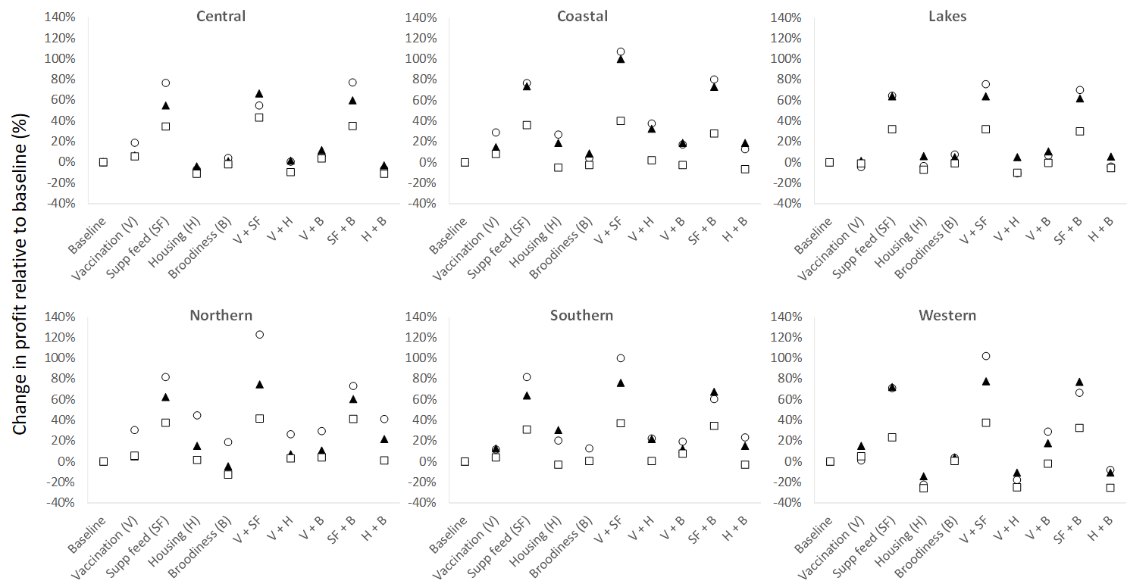

## **Percentage change in profit, relative to the baseline, for each intervention option across the six regions of Tanzania. Small flocks (10th percentile) represented by ⭘, median flocks (50th percentile) represented by ▲, large flocks (90th percentile farms) represented by □.**

**Key messages**

Supplementary feeding was the most profitable single intervention option. The profitability of housing was variable between regions, and potentially unprofitable in some regions. There was marginal financial benefit in controlling broodiness across all regions. Combining supplementary feeding with vaccination increased profitability for most regions, although not necessarily greater than the sum of each option as single intervention options.

As flock size increased from small (10th percentile) to large (90th percentile), the percentage increase in profit, relative to baseline profit, generally declined. This highlights greater benefit of implementing intervention options for small to medium producers.

11 USD ~ 2310 Tanzanian Shilling (TZS; March 2020).

This work was funded by the Bill and Melinda Gates Foundation (Project OPP1134229, Supporting Evidence-Based Interventions to Achieve Agricultural Development Goals [SEBI] LiveGAPS 2).

References: LSMS Survey (2015) <https://microdata.worldbank.org/index.pgp/catalog/2862>; Udo et al. (2006) Modelling the impacts of interventions on the dynamics in village poultry systems. Agricultural Systems 88, 255-269.

For further information

Agriculture and Food

Mario Herrero

t +61 7 3214 2538

e mario.herrero@csiro.au

w https://research.csiro.au/foodglobalsecurity/

CONTACT US

t 1300 363 400

+61 3 9545 2176

e csiroenquiries@csiro.au

w www.csiro.au

