IAT

INTEGRATED ANALYSIS TOOL

for

SMALLHOLDERS

Users Guide
Version R1.38 – Nov 2015

Cam McDonald
on behalf of
CSIRO Ecosystem Sciences

CONTENTS

1. Introduction 4
2. Getting started and Exiting 4
2.1 Loading the parameter set 5
2.2 Saving the current parameter set or output 6
2.3 Creating a new parameter sheet 7
3. Entering/editing parameters 7
3.1 Setting the climate zone, currency, language and start date 8
3.11 Selecting a language 8
3.12 Selecting a currency 8
3.13 Selecting a climate region 8
3.14 Starting date and length of model run 8
3.2 Land settings 9
3.2.1 Farm land units 9
3.2.2 Common land 10
3.2.3 Native pasture harvests/growth months 10
3.3 Labour supply and family structure 11
3.3.1 Non-farm work 11
3.3.2 Hired labour days 12
3.3.3 Hired labour pay rates 13
3.4 Labour activities and permissions 14
3.5 Overheads and living costs 15
3.6 Grain, forage, tree and other crop information 16
3.6.1 Selecting grain crops grown and allocating to land 17
3.6.2 Selecting forage crops grown and allocating to land 18
3.6.3 Selecting tree crops grown and allocating to land 18
3.6.4 Selecting other crops grown and allocating to land 18
3.7 Detailed crop specifications 19
3.7.1 Forage components (tree and other crops only) 22
3.7.2 By-Products (all crops) 22
3.7.3 Grain prices (grain crops only) 23
3.8 Purchased fodder 24
3.8.1 Purchased fodder details 26
3.9 Ruminant animal information 27
3.9.1 Ruminant animal numbers, age and value 27
3.9.2 Ruminant feeding system 29
3.9.3 Ruminant management costs and labour 31
3.9.4 Ruminant supplement feeding 34
3.9.5 Supplement details 34
3.9.6 Ruminant milking and manure composting 35
3.9.7 Ruminants traded 37
3.10 Non-ruminant animal information 39
3.10.1 Details of non-ruminant animals bred 40
3.10.2 Details of non-ruminant animals traded 42
4. Displaying Output 43
4.1 Output sheets 44
4.1.1 Monthly output 44
4.1.2 Annual output 44
4.1.3 Ruminant output 45
4.1.4 Fodder output 45
4.1.5 Labour output 45
4.2 Graphical output 46
4.2.1 Annual Costs/revenue 46
4.2.2 Activity Labour 46
4.2.3 People Labour 46
4.2.4 Fodder balances 46
4.2.5 Ruminant weights 47
4.2.6 Monthly cash flow 47
5. Adding new information to the IAT 47
5.1 Adding a new ruminant or changing the name of an existing ruminant 48
5.2 Adding a new climate region/village or changing the name of an existing region/village 48
5.3 Adding a new soil type or changing the name of an existing soil type 48
5.4 Adding a new currency or changing the name of an existing currency 49
5.5 Adding/changing the name of a non-farm labour type 49
5.6 Adding a new language 49
5.7 Changing a land unit name 49
5.8 Changing a bought (purchased) fodder name 49
5.9 Changing a supplement name 50
5.10 Changing a non-ruminant name 50
5.11 Adding/changing a crop name and details 50
5.12 Changing the name of a ruminant category 50
5.13 Changing the name of an on-farm labour category 51
5.14 Adding new grain/forage crop data to the databases 51
5.14.1 Crop data 51
5.14.2 Forage data 52
6. Trouble shooting 54
6.1 Function buttons do not work when first used 54
6.2 Function buttons do not work after a debug error 54
6.3 Additional help 54

1. Introduction

The IAT (Integrated Analysis Tool) is a decision support tool for smallholders, written in Microsoft© Excel. It is designed to help analyse the impact of any intended intervention strategy on a smallholder farm. The IAT integrates animal, pasture and crop production with labour and land requirements, accounts for revenue and costs, and evaluates these against existing land, labour and financial resources. The tool does NOT find an optimal solution for the best strategy. It is up to the user to vary the inputs to determine which combination of farm activities give the best result for their particular interest (e.g. animal production, labour requirements, financial return). In fact, this is a key purpose of the IAT, to give the user an insight into the impact of particular changes on farm production, profitability or labour demand. For example, if the user changes the area of crop grown, what impact does this have on forage resources, labour requirements, financial return etc.

The output from the IAT is to be used as a guide only. If the output indicates incomes of 10 million (Kip, Rp, VND, etc) and 5 million for two different strategies, this does NOT mean that a farmer will actually earn 10 million or 5 million by implementing the strategies. What it DOES mean, is that the strategy indicating an income of 10 million will probably be a much better strategy than the one which indicates an income of only 5 million.

The IAT consists of a single file (IAT.XLSM) but requires an additional parameter/database file. IAT.XLSM is the main program which contains all the VBA code for operating the tool. The parameter file contains all the input information regarding costs, revenue, labour, etc. for each crop and forage type, or each animal type, along with worksheets containing the databases of crop and forage data. Output is put into worksheets in the IAT spreadsheet but output from particular analyses, along with the input settings used to derive the particular output can be saved to the parameter file. This can be useful for re-looking at different strategies at a later date. Also, the input settings can be reloaded back into the IAT at a later date if the user wishes to explore further options, using the previous strategy as a baseline.

2. Getting started and Exiting

Before opening the IAT, make sure that both the file IAT.XLSM and a parameter/database file (e.g. INDONESIA.XLSX) are in the same folder.

To open the IAT, double click on IAT.XLSM.

Upon opening, you will be presented with the screen as shown in Figure 1. This screen is referred to as the ‘Main Menu’. If this does not fit your screen properly, then, at the top of the screen, click on ‘View’, click on ‘Zoom’, select a suitable size, input your own custom size, or select ‘Fit selection’, then click ‘Ok’.

Before you can run the model you will need to open a parameter file (see below). If the program does not respond when you click on the buttons, you need to Enable Macros (see Troubleshooting).

To EXIT the IAT, click on the ‘QUIT’ button. This will save and close both files.

NB. Before doing any proper analyses, make sure you go through ALL the input forms to ensure you have the parameter settings you want. You do not want to be including crops or animals or plantation trees in your analysis without realising it.

To do an analysis, select all your parameter settings as outlined in the sections below, then, on the Main Menu, click ‘Run SIMULATION’. When the IAT has completed its calculations, the ‘Main Menu’ will reappear, and the results of your analysis can be viewed by clicking the ‘Graphical Output’ button, or selecting the particular output worksheet.

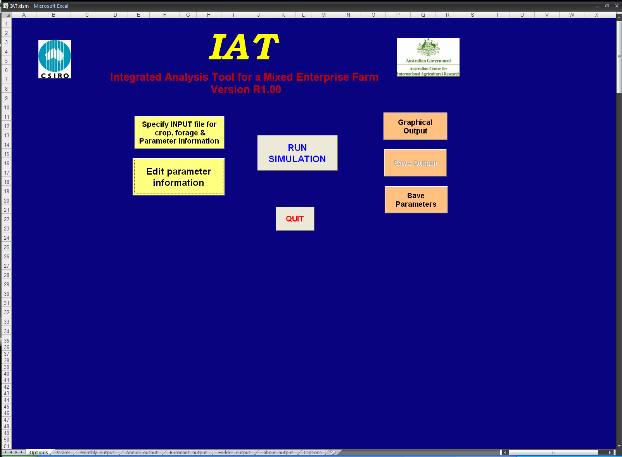

Figure 1. Opening screen (Main Menu) of IAT

2.1 Loading the parameter set

To load parameters, on the Main Menu, click on ‘Specify INPUT file for crop, forage & parameter information’, and form 2.1 will appear. This displays the currently selected workbook. Click on the down arrow of the drop-down menu to select from the available Excel files in the current folder (e.g. Indonesia.xlsx), then click ‘Open file’, or simply click ‘Open file’ to accept the default name displayed.

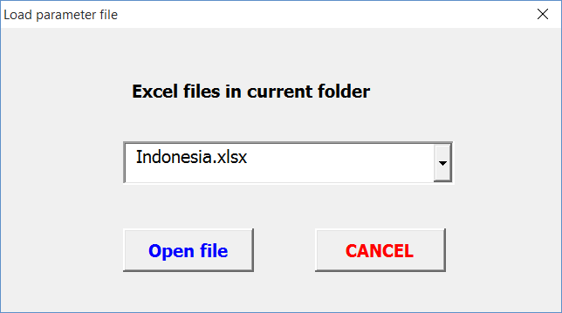

Form 2.1. Input form for name of parameter file (Excel workbook) containing parameters.

You will then be prompted to select the name of a particular worksheet containing all the parameters (Form 2.2). Click on the down arrow of the drop-down menu to select from the available Worksheets (e.g. Base_Params) in the current Excel file, then click ‘Load parameters’, or simply click ‘Load parameters’ to accept the default name displayed. The IAT will then copy the parameter set into the IAT ‘Params’ worksheet. Any subsequent editing of parameters will affect the parameters in the IAT, NOT in the original file.

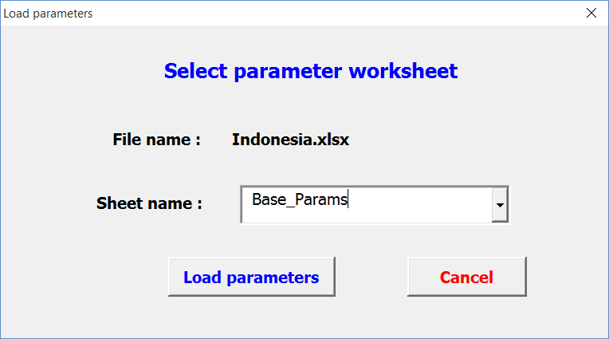

Form 2.2. Input form to enter the name of the particular worksheet containing the desired parameter set.

If you have already done some analyses and have saved the output (see section 2.2), then you can re-load the parameters settings for that analyses, using the same method as outlined above. You may wish to do this if you have tried several strategies and would like to go back to a previous strategy, as a baseline, and make some alterations to it.

2.2 Saving the current parameter set or output

If you have made changes to the parameter settings in the IAT and wish to save these to the original file and worksheet, then click on the ‘Save Parameters’ button. This will overwrite the parameters in the worksheet of the original file, from which the current parameters were loaded. For example, if you loaded your parameters from worksheet ‘Base_run’ of parameter file ‘Vietnam.xlsx’, then clicking the ‘Save Parameters’ button will overwrite the values in the ‘Base-run’ worksheet with those currently in the IAT.

If you want to save the parameters to a different worksheet, then click on the ‘Save Output’ button. This will prompt you for a name for the model run (e.g. Run_1), type in a name and press Enter. All the output sheets and parameter sheet will be copied to new worksheets in the parameter file, identified with the name of the model run.

2.3 Creating a new parameter sheet

Sometimes it is desirable to have 2 different farm typologies that use the same crop and forage database. To do this easily, without altering parameters each time you want to switch between farm types, it is best to create a another parameter sheet within the same parameter file.

The easiest way to create a new parameter sheet within an existing parameter file is to open the parameter file, and add a new worksheet. Then copy the parameter data across from the existing parameter sheet within the file. To do this, click on the top left of the existing sheet (which selects the whole sheet), select Copy (or press Ctrl C), click on the new worksheet and click on cell A1, and select Paste (or press Ctrl V). Give the new sheet a suitable name (right click on the Tab name at the bottom and enter a name), then this new parameter sheet can be selected from the Main Menu as outlined in section 2.1 above.

3. Entering/editing parameters

To edit any parameters, on the Main Menu, click on ‘Edit Parameter information’

The Setup menu shown in Form 3 will be displayed.

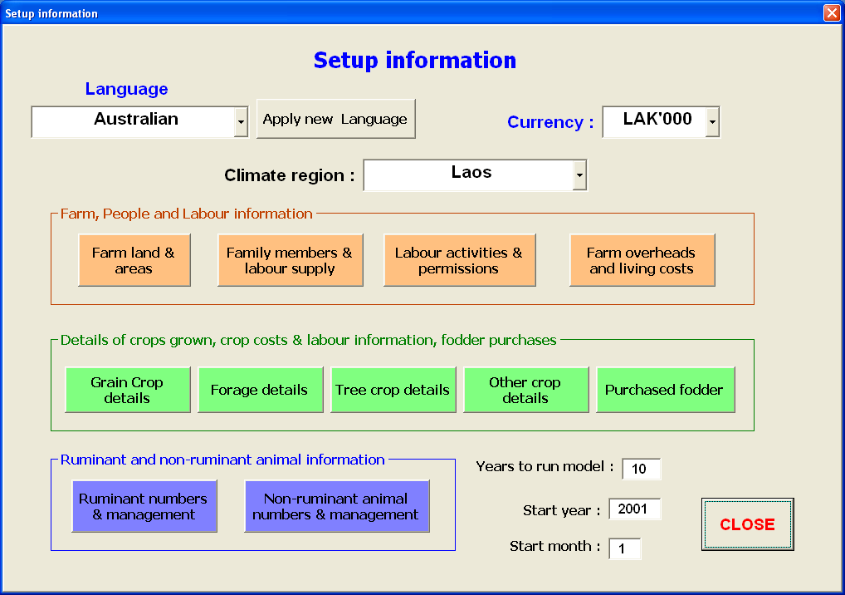

Form 3. Form for Setup menu. All parameters settings/changes are entered via this form.

3.1 Setting the climate zone, currency, language and start date

3.11 Selecting a language

This will change all form and sheet labels to the selected language.

On the ‘Setup information’ form, click on the drop-down box under ‘Language’ (see Form 3). A list of current languages named in the parameters will be shown. Select the desired language, then click ‘Apply new language’. Wait ….. it takes about 25 seconds to happen.

If you wish to add to the list of available languages, or edit the names, see section 5.6.

3.12 Selecting a currency

This will change all relevant prompts and labels to the selected currency. Ensure you specify all costs and prices in the selected currency. This does NOT do any currency conversion, it is merely a label.

On the ‘Setup information’ form, click on the drop-down box next to ‘Currency’ (see Form 3). A list of current currencies named in the parameters will be shown. Select the desired currency.

If you wish to add to the list of available currencies, or edit the names, see section 5.3.

3.13 Selecting a climate region/village

This affects which crops/forages are selected from the database. If you select climate region 2, then the model will look for crop/forage data for that region only. They do not have to be different climate regions, they could be different villages within a region. If there is no data for a crop or forage for a particular climate zone/village, an error message will be created when the model is run, and processing will be aborted.

On the ‘Setup information’ form, click on the drop-down box next to ‘Climate region’ (see Form 3 above). A list of current climate regions/villages named in the parameters will be shown. Select the desired climate region/village.

If you wish to add to the list of available regions/villages, or edit the names, see section 5.2.

3.14 Starting date and length of model run

The IAT uses the actual year and month to select crop/forage information from the database. The database can contain data for years and months before the specified starting date, but it will start at the specified date. Hence crop or forage yields in the starting year, but in an earlier month, will not be included in the analysis. Similarly, the model will continue on a monthly time-step for the specified number of years. Data beyond this time period will not be processed.

On the ‘Setup information’ form, for each of the following prompts, enter a value in the adjoining text box (see Form 3).

Years to run model:

Start year:

Start month:

If there is no data for a crop or forage for a particular year or month within the specified period, an error message will be created when the model is run, and processing will be aborted.

3.2 Land settings

To input settings for land types and areas of different land types, etc, on the ‘Setup information’ form, click on ‘Farm land & areas’. The ‘Farm structure’ input form shown below will be displayed (Form 3.2).

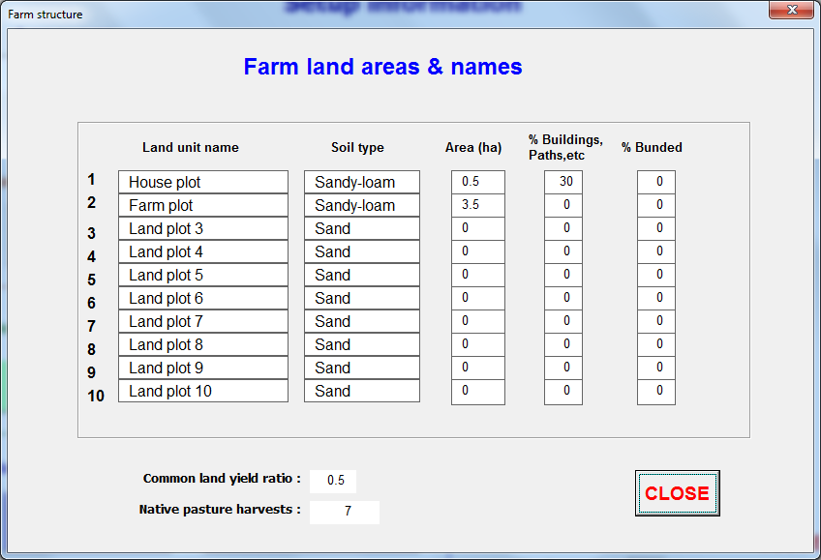

Form 3.2. Input form for land unit parameters.

3.2.1 Farm land units

A farm can have up to 10 different land areas. Each of these can have a different soil type, if necessary, or they can be simply different units of the same soil type. The land units become important later because selected crop/forages are allocated to a land unit. Then, for the soil type for that land unit, specified here, the model searches for the relevant data crop/forage data for that soil type i.e. it searches for the soil type, NOT the land unit. For example, if you specify soil type 3 for land unit 2, then select land unit 2 for a particular crop, the model will search the database for the specified crop on soil type 3.

To edit the names of the land units, see section 5.7. These are merely names and have no effect on the running of the model.

For each land unit on the farm, you need to specify the soil type, the area (ha), the percentage taken up with buildings, roads, paths, etc. (i.e. unusable) for agriculture, and the percentage bunded. Bunds are mounds of soil between rice fields, used to hold water in ponds. The area between the bunds is called the Interbund. The bunded area will be allocated to native pasture, or can have crops/forages planted in it. For example, if a land unit has 1ha, and has 10% taken up by buildings, and 10% bunded, then there is only 0.8ha available for cropping in the Interbund area (see crop specifications), 0.1 ha of land that carries nothing, and 0.1 ha that will become native pasture unless a crop or forage is specified as growing on the bund. Specifying a crop area of 1ha of this land will create an error message, but processing will continue. If there are no bunds then all then land is classified as Interbund.

For each land unit:

Land unit name - select a land unit name from the drop down box
Soil type - select a soil type from the drop down box
Area (ha) – type in an area for this land unit
% buildings, paths – type in a value for the percentage of this land taken up by buildings, etc
% bunded - type in a value for the percentage of this land taken up by bunds

3.2.2 Common land

In many countries farmers have access to common land. This presents a problem when determining available resources. As yet, no real solution has been found for this because the individual farmer has no control of the available resource, and the area available is not known, nor the number of animals drawing on it. To accommodate this problem, a yield for common land is included as a ratio of the on-farm native pasture yield. It is assumed this is an inexhaustible supply. As this resource is used mostly in the dry season, the quality is set at half that of the native pasture. The use of common land allows the farmers to keep their animals alive after they have exhausted their on-farm feed resources, which is basically what happens in real life. [Note: In Zimbabwe, many farmers utilise the common land in the wet season, and save their on-farm forage for the dry season. This strategy is not accounted for in IAT].

Common land yield ratio – enter a value in the adjoining text box, if common land is available. If no common land is available, enter 0.

3.2.3 Native pasture harvests/growth months
Any land not sown to crops or forages, or taken up by buildings, is deemed to be ‘Native pasture’. Hence, native pasture must be included in the ‘Forage Inputs’ sheet of the parameter file, specified as forage number 0 on soil type 1, for each climate zone/village to be analysed. Soil type 1 is used because the native pasture could occur across a range of soil types.
As for sown forages, native pasture can be harvested a number of times per year, if used as cut and carry, or have a number months of growth, if grazed. Hence, for input, the number of harvests per year, or growth per month, must be specified. This can be any number, but because the model runs on a monthly time-step, it is usually no more than 12. Because native pastures are not specified elsewhere, the number of harvests, or growth months, are specified here.
Native pasture harvests – enter a value in the adjoining text box

3.3 Labour supply and family structure

To input the age group, gender and number of people in the family available to do work, on the Main Menu, click on ‘Edit Parameter Information’, then click on ‘Family members and Labour supply’. The input form (Form 3.3) will be displayed. Enter the number of people in each age/gender category, and the total number of days each category has available for work, in each month of the year. This includes both ON-farm and NON-farm work. We assume that work done helping other farmers will be compensated for when the other farmer helps them. Each month is assumed to be 30.4 days, so enter work values based on that length of period. If values for all months are the same, then enter values for each category for month 1, then click on ‘Copy month 1 across’. This will copy the month 1value across all months for each person category.

Priority – this allocates an order of priority for the model to allocate work. Normally work is allocated first to those who can do the least number of activities (e.g. children or elderly), with those who can do the most activities allocated last (e.g. adult males). Hence the priority is normally set to children, then the elderly, then teenagers, then adults, however, users can change this if desired.

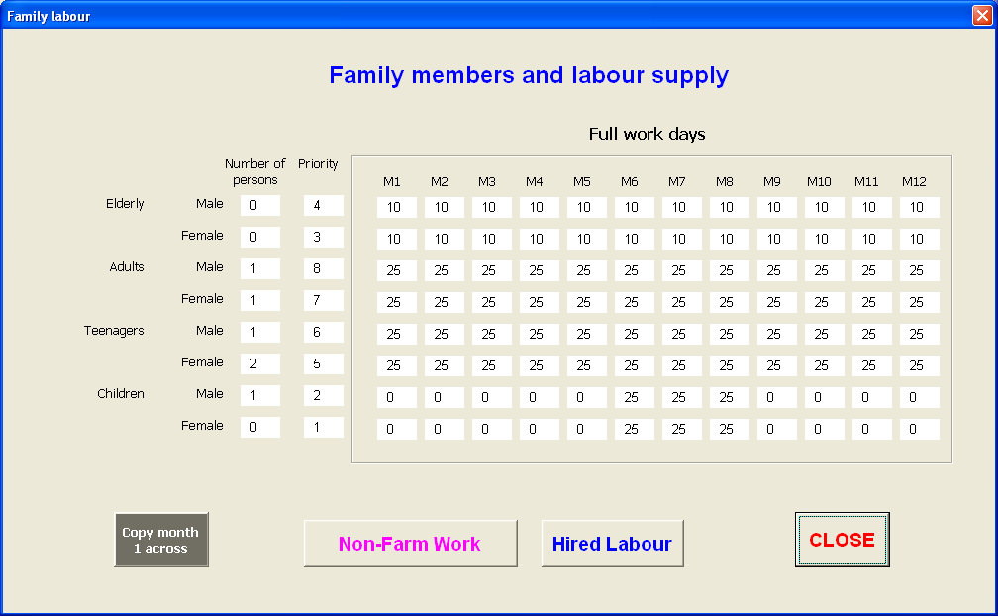

Form 3.3. Input form for family structure and labour pool, as well access to non-farm labour done by family, and labour hired. Note: there is no pay rate for on-farm work for family members.

3.3.1 Non-farm work

There are up to five different activities that can be specified. The same 5 activities apply to all categories of people. To select the activity, click on the drop down box below the ‘Activity’ label. To change the name of any of the categories, see section 5.5.

To enter the number of days of non-farm work (e.g. working in a kiosk, driving a bus) each person category does in each month, select an activity, then enter values for each category for each month. Again, if the value for all months are the same, enter values for month 1 for each category and then click ‘Copy month 1 across’. For each category, enter a pay rate per day. Remember to enter rates using the selected currency. If more than one activity, select another activity and repeat the above process.

The number of days each person spends working off-farm is deducted from the total amount of labour they provide (entered on Form 3.3 above).

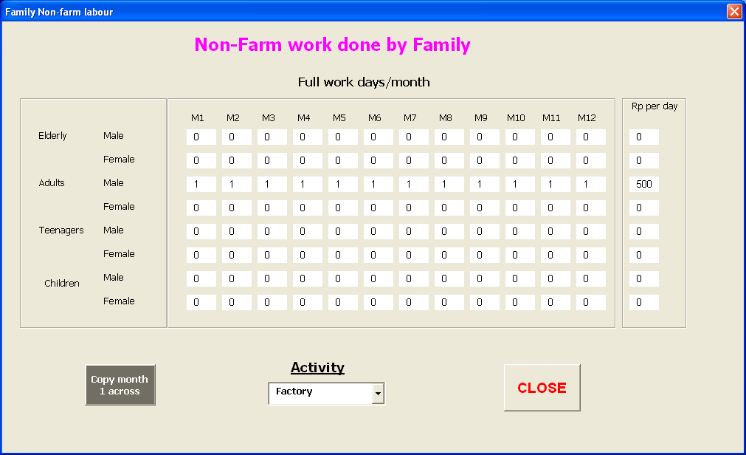

Form 3.3.1 Input form for non-farm paid work.

3.3.2 Hired labour days

This is used to specify the amount of labour a farmer is prepared to hire, the pay rates, and which gender/age category (adult, teenager, or children). Click on ‘Family members and labour supply ’ or on ‘Labour activities & permissions’, then click on ‘Hired Labour’. The input form (Form 3.3.2) will be displayed. For each person category, enter the number of days labour the farmer is prepared to hire in each month. The pay rates are entered on another form (see below).

Labour can be hired at a fixed rate (number of days/month) or can be hired on demand. If the latter is chosen, then labour is hired when and only when there is no family labour available for the particular activity in the particular month.

To choose between these options, click on the box next to the label ‘Labour Hire Fixed (Y) or on demand (N)’. A tick indicates that labour hire is fixed.

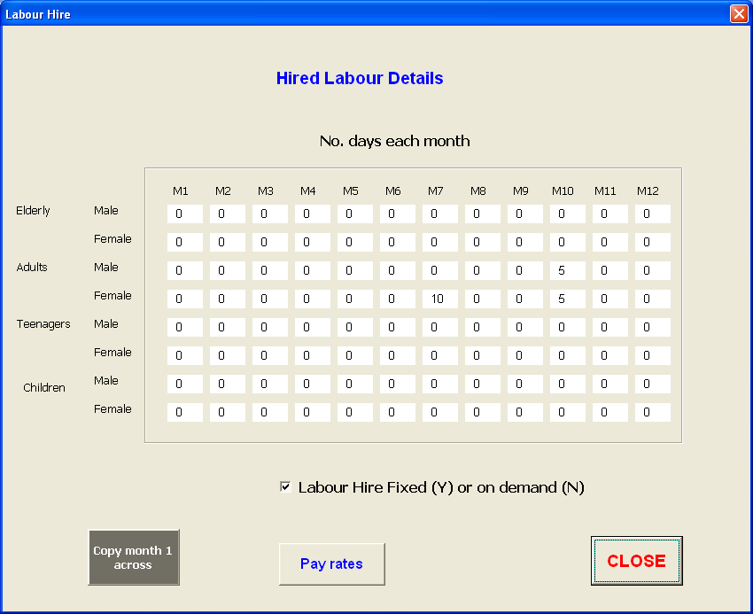

Form 3.3.2 Input form for days hired labour per month, for each person category.

3.3.3 Hired labour pay rates

To enter the pay rate (/day) for hired labour, click on the ‘Pay rates’ button at the bottom of the ‘Labour Hire’ form (Form 3.3.2), and the ‘Pay Rates’ form will be displayed (Form 3.3.3). Remember to enter pay rates in the selected currency.

Pay rates can vary during the year due to peak seasonal demand. To accommodate this, different pay rates can be entered for each month. For each person category, enter the pay rate for farm labour for each month. Again, if the value for all months are the same, enter values for month 1 for each person category and then click ‘Copy month 1 across’.

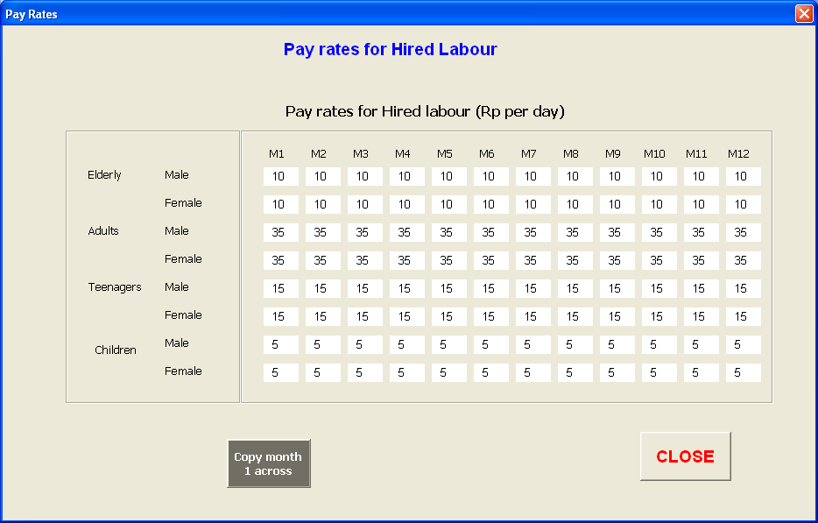

Form 3.3.3 Input form for monthly pay rates for hired labour for each person category.

3.4 Labour activities and permissions

On smallholder farms there are many activities to be completed. Often, particular activities are done by a particular family member. Hence, in considering changes to a farming system it is vital to consider the impacts on family labour and whether or not particular family members have the capacity to do any extra work.

To specify which family members can do the various activities, on the ‘Setup information’ form, click on ‘Labour activities & permissions’. The ‘Labour specifics’ form will be displayed (Form 3.4). For each activity, click on the check boxes under each person category that can do the activity (a tick indicates they can do the activity).

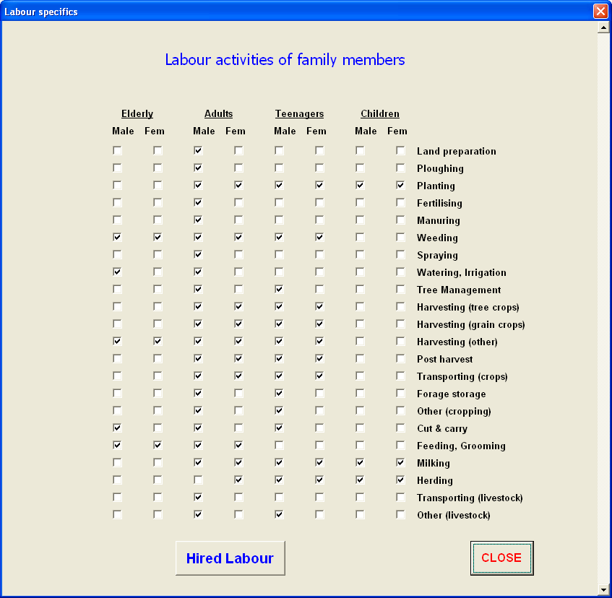

Form 3.4. Input form for labour activity permissions for each person category.

3.5 Overheads and living costs

For any farm, there are considerable overhead costs in running the farm e.g maintenance of equipment, electricity charges, bank fees, government rates and taxes, etc. These costs are entered by clicking on the ‘Farm overheads and & living costs’ button on the ‘Setup information’ form. The ‘Farm Overheads’ form will be displayed (Form 3.5).

For each item on the list, enter an annual cost to the farm, in the currency you have selected, which will be indicated in the title of this form (e.g. RP per year). These values are summed for an overall overhead cost, so if values for individual items are not known, then an overall value can be entered for any one of them.

In order to calculate a monthly cash flow, it is necessary to have an initial cash balance, a monthly living cost, and what interest rate is charged on overdrafts/borrowed money.

Initial cash on hand – this is the amount of money that the farmer has at the start of the analysis period.

Living cost/month – this is the amount of money it costs for the family to live each month. These are extra items they have to buy (e.g. food, clothes, school fees). This does not include any farm costs (e.g. seed or fertiliser), as these values are entered elsewhere in the model.

Interest rate% - this is the interest rate charged on any overdraft or borrowed money. If the monthly cash balance becomes negative, then interest is charged on the negative amount.

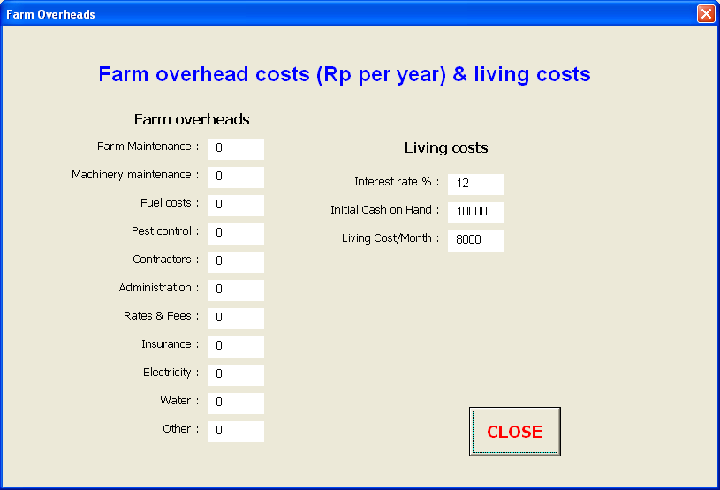

Form 3.5. Input form for farm overheads, living costs and interest rate.

3.6 Grain, forage, tree and other crop information

There are 4 different types of crops that can be grown, and different information is required for each. The main crops are grain crops (e.g. rice, maize) and forage crops (e.g. Panicum, lucerne, lablab, elephant grass). The annual or monthly yields of the crops/forages are stored in the database (see later), and can vary from year to year (or month to month for forages). The other 2 categories are tree crops (e.g. bananas, cashews, coconuts) and vegetable crops (tomato, cucumber, chilli, tobacco). The annual yields of the tree and vegetable crops are specified by the user and will be the same every year.

However the format for entering the data for each crop type is the same. Initially, the user selects which crops are grown on the farm, the area grown and on which land. For each crop the user must specify all the input costs, labour requirements, revenue and home consumption.

3.6.1 Selecting grain crops grown and allocating to land

To select which grain crops are, on the ‘Setup information’ form click on ‘Grain crop details’, and the ‘Crop sequence’ form will be displayed (Form 3.6.1).

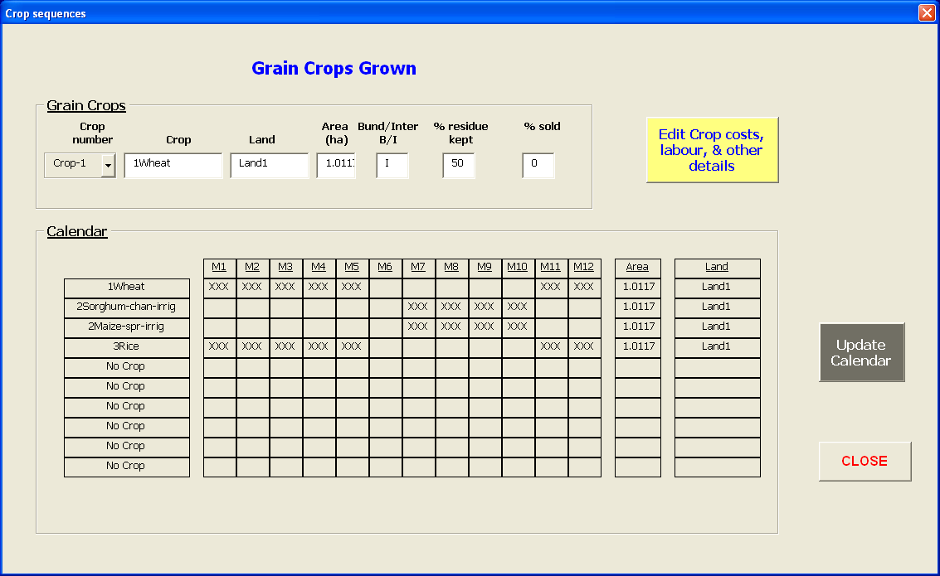

Form 3.6.1. Input form for selecting the sequence of grain crops grown, and the area of land on which it is grown.

Up to 30 different crops can be grown at a time. These are numbered crops 1-30 under the heading ‘Crop number’. The steps are:

Select the Crop number

Select the Crop from the drop down box (currently up to 30 different grain crops can be selected from

Select the Land – this is one of the land types set up in section 3.2 above. Note, by selecting the land type, the model then knows which soil type the crop is being grown on.

Area (ha) – enter the area of crop grown. The model will check the total area of crops/forages grown on any land type and check this against the area of that land type specified in 3.2 above, taking into account bund and interbund areas.

Bund/Interbund (B/I) – indicate whether the crop is to be grown in the interbund area or on the bunds. For grain crops this is usually in the interbund, but for forages and trees it might be on the bund.

% residue kept – the crop residue can be ploughed back, burnt, or kept as forage for livestock. Indicate here what percentage of the crop residue (stover) is kept for livestock. The actual yield of stover will come from the ‘Crop_inputs’ database in the parameter file.

% sold – some farmers sell crop residue or forage (usually forage) if they have more than they need, or they need the cash. Indicate here what percentage of the crop residue is to be sold.

Once all the information above has been entered for each crop, click on ‘Update Calendar’. This will fill in the displayed calendar with the growing period for each crop grown, along with the area of each and the land it is on. This allows for an easy check to see if there is any overlap i.e. using the same land for 2 crops at the same time. If there is an overlap, then you need to select different crops, or edit the approximate sowing and harvest dates for that particular crop (click on ‘Edit Crop costs, labour & other details’ and edit ‘Sowing month’ and/or ‘Harvest month’. Please note, the harvest month is approximate only, the actual harvest month will be taken from the ‘Crop_inputs’ database.

3.6.2 Selecting forage crops grown and allocating to land

Follow the same process as for selecting grain crops. There will be no difference in the inputs to the ‘Crop sequence’ form, but yields and harvest months will come from the ‘Forage_inputs’ database. The approximate harvest date should be for the final harvest. The ‘% residue kept’ will be 90-100 normally, as the forage is being grown for animal feed.

3.6.3 Selecting tree crops grown and allocating to land

Follow the same process as for selecting grain crops. However there are some differences in the inputs to the ‘Crop sequence’ form, and yields and harvest months are specified by the user on the ‘Crop specification’ form (see 3.7 below).

There are 3 differences on the tree selection form: instead of the Area of crop, the number of trees are entered; instead % residue retained, the area per tree is entered; and , because there is no residue retention, there is none sold, so this is disabled.

No. trees – enter the number of trees grown

Sq.m per tree – enter the number of square metres taken up by each tree. For example, if grown along a 1 meter wide bund, with a tree every 10 meters, this value will be 10, if grown in a plantation, with trees every 10 metres in each direction (i.e. a 10x10 lattice) then this value will 100.

3.6.4 Selecting other crops grown and allocating to land

Follow the same process as for selecting grain crops. However there are some differences in the inputs to the ‘Crop sequence’ form, and yields and harvest months are specified by the user on the ‘Crop specification’ form (see section 3.7 below).

There are 2 differences on the other crops selection form: there is no residue retention, and hence there is none to be sold, so both of these are disabled.

3.7 Detailed crop specifications

For each crop grown, whether it is a grain, forage, tree or other crop, there are a number of inputs required for costs, labour, home consumption, sale price, etc. On the ‘Crop sequence’ form, click on ‘Edit Crop costs, labour & other details’, and the ‘Crop Specifications’ form will be displayed (Form 3.7)

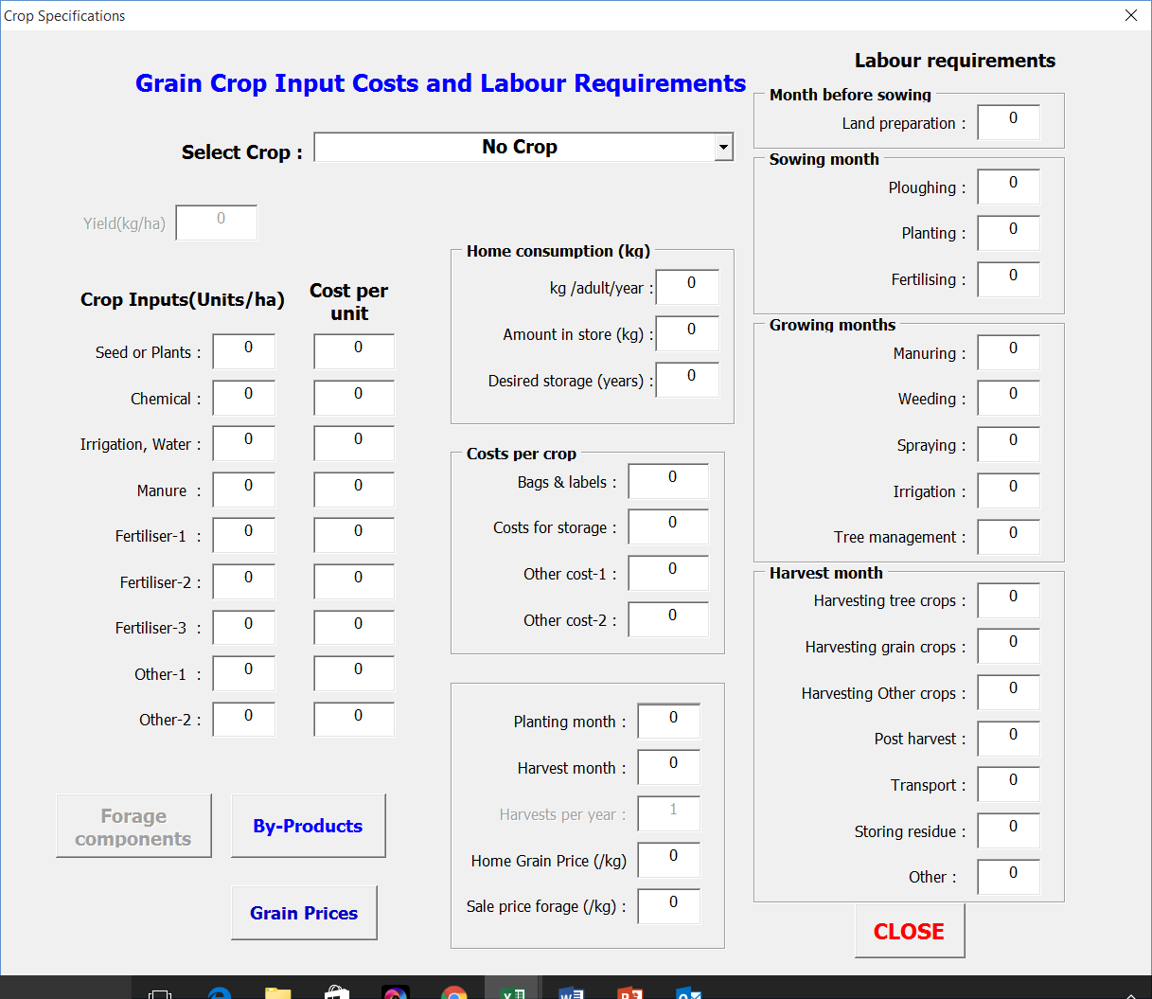

Form 3.7. Input form for detailed crop specifications.

To enter new detailed data or edit existing data for a crop, click on the drop down box next to the “Select crop’ label and select the desired crop. Note – only those crops for the selected type of crop (grain, forage, tree or other) will be shown. For example, if the ‘Crop sequence’ form was opened for grain crops, then if the ‘Crop Specifications’ form is opened, only the grain crops will be displayed in the drop down box.

The same form is used for all crop types, however, some details are not required for some crop types and are disabled when the form is opened for those crop types.

Yield (kg/ha) - this is used for tree and other crops. Enter a value for the annual yield; the same value will be used each year. This prompt is disabled for grain and forage crops because the information will come from the respective databases.

Crop inputs (units/ha) and Cost per unit: (these apply to all crops)

Seed, plants – enter the units/ha of seed or number of units of plants/ha used for planting, and the cost per unit. The units could be kg, with a price per kg, or the units could be bags of seed or boxes of seedlings, with a price per bag or per box.

Chemical – enter the number of units/ha (e.g. litres or drums) of chemical used, and the price per unit

Water, Irrigation - enter the number of units/ha (e.g. kilolitres) of irrigation water used, and the price per unit

Manure - enter the number of units/ha (e.g. bags, kg) of manure used, and the price per unit

Fertiliser 1 - enter the number of units/ha (e.g. kg, bags) of fertiliser (type 1, e.g. NPK) used, and the price per unit

Fertiliser 2 - enter the number of units/ha (e.g. kg, bags) of fertiliser (type 2, e.g. Urea) used, and the price per unit

Fertiliser 3 - enter the number of units/ha (e.g. kg, bags) of fertiliser (type 3, e.g. Superphosphate) used, and the price per unit

Other 1 – If there are other crop inputs, enter the number of units/ha (e.g. kg, bags) of the product used, and the price per unit

Other 2 – If there are other crop inputs, enter the number of units/ha (e.g. kg, bags) of the product used, and the price per unit

It is important that the specifications for each crop or forage match the crops and forages in the ‘Crop Inputs’ and ‘Forage Inputs’ databases e.g. if two crops are maize with nil fertiliser and maize plus fertiliser, then the specifications for the second crop should include a cost and labour requirement for fertilising.

Home consumption:

Amount/adult/year (kg) – if some of this crop is kept for home consumption then enter the number of kg kept, per adult per year e.g. if 0.5 kg per day, then enter 182. The model will determine the total amount to be kept, allowing each adult, elderly and teenager to get the entered value, and each child half this amount. For example, for a value of 182, if the family had 2 adults, an elderly person, a teenager and 2 children, then 910 kg of this crop would be kept for home consumption. If the farmer does not grow this amount, the shortfall will be purchased, with the costs accounted.

Amount in store (kg) – this is the amount the farmer has in store at the start of the model run. This is used in determining how much more needs to be kept e.g. if this is 50 and the annual need is 910, then a further 860 kg needs to be kept.

Desired storage (years) – in some cases, for reasons of food security, farmers like to keep up to 2 years supply of the crop. Again, this is used in determining the amount to be kept e.g. using the values above, for 2 years 1770kg would be needed (2x910-50).

Costs per crop: (these are costs for the whole crop, NOT per ha)

Bags/labels – enter costs for bags and/or labels

Crop storage – enter cost for storage of crop

Other cost-1 – enter cost of any other whole crop cost

Other cost-2 – enter cost of any other whole crop cost

Sowing month – month in which the crop is usually sown. For perennial crops enter a value of -1. This will indicate to the model that there are no planting costs or labour for planting, and other costs and labour are spread over the whole year, excluding the harvest month. If not perennial, then costs are spread over the months from sowing to harvest.

Harvest month – month in which the crop is usually harvested. For forage crops, with multiple harvests, enter the usual month for last harvest. Note, for grain and forage crops the actual month of harvest will come from the database, in which case the entered value is used as a guide only.

Harvests per year – for forage crops only. Enter the number of harvests or growth periods during the year. This can be any number but because the model runs on a monthly time-step, it is usually no more than 12. If greater then 12, the harvest yields will be summed in months where more than 1 harvest occurs.

Home Grain price (/kg) – for grain and forage crops, this is the price paid for grain for home consumption if insufficient is grown on-farm.

Sale price grain (/kg) - For Tree and Other crops, this is the sale price per kg for fruit. For grain crops, this is used to value home consumption. To set the sale price of grain for grain crops, click on the ‘Grain prices’ button (see 3.7.3 below).

Sale price forage (/kg) – sale price per kg of crop residue (grain crops) or forage (forage crops). Residues from tree and other crops are not sold, hence this parameter is disabled for those crops.

NB. Check that the harvest month for each crop or forage matches with the harvest month in the ‘Crop Inputs’ and ‘Forage Inputs’ databases. It may vary by a month e.g. a crop may be harvested in month 9 in some years, and month 10 in other years. The value entered here determines the month labour is allocated for harvesting and post harvest activities, and the months when costs occur.

Labour requirements: (labour requirements for each cropping activity, in man days/ha)

Land preparation – clearing land, or preparing for ploughing

Ploughing

Planting

Fertilising

Manuring

Weeding

Spraying

Irrigation

Tree management

Harvesting tree crops

Harvesting grain crops

Harvesting other crops

(Note: Harvesting of forage crops is accounted for under cut & carry labour)

Post harvest

Transport

Storing residue

Other

Labour for land preparation, ploughing, planting and fertilising is deemed to occur in the month of sowing; harvesting, post harvest, transport, storing residue and other labour are deemed to occur in the harvest month, with manuring, weeding, spraying, irrigation and tree management (if applicable) spread over the intervening months.

3.7.1 Forage components (tree and other crops only)

Some forage can come from leaf, fruit or stem of tree crops (e.g. bananas) or other crops (e.g. cucumbers). This does not apply to grain and forage crops as it is already accounted for in the crop residues/forage yields. To enter data for this, click the ‘Forage components’ button on the ‘Crop Specification’ form, and the ‘Forage from Tree & Other crops’ form (Form 3.7.1) will appear, with the name of the selected crop shown. To select a different crop, return to the ‘Crop Specification’ form. To change from tree crops to other crops, return to the ‘Setup information’ form.

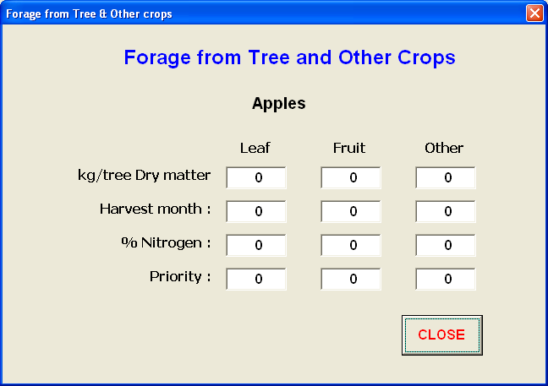

Form 3.7.1. Input form for forage components available from tree and other crops.

For each of the categories, Leaf, Fruit and Other, enter values for:

Kg/tree Dry matter – kg of dry matter per tree harvested (per ha for other crops)

Harvest month – month of harvest (same for all components)

% nitrogen – estimate of N content of the forage component (used to determine the quality of the forage for animal feeding

Priority – this indicates which forage pool (from 1 to 10) the forage component is to be added to (see section 3.9.2 for more information on forage pools)

3.7.2 By-Products (all crops)

Some crops produce a by-product i.e. something other than the grain/fruit or residue for forage (e.g. tree legumes may produce forage as well as building or fencing material from the stems). To enter data for this, click the ‘By products’ button on the ‘Crop Specification’ form, and the ‘Crop By-Products’ form (Form 3.7.2) will appear, with the name of the selected crop shown. To select a different crop, return to the ‘Crop Specification’ form. To change the crop type, return to the ‘Setup information’ form.

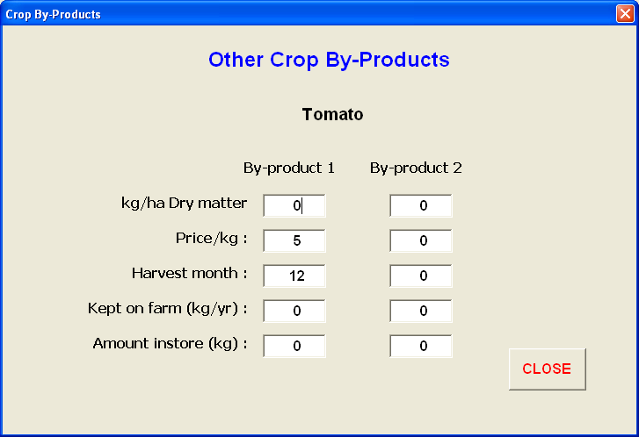

Form 3.7.2. Input form for crop by-products.

For each of two by-products, enter values for: (Note, values for kg/ha dry matter and harvest month for grain and forage crops will come from the database).

Kg/ha Dry matter – kg of dry matter per ha harvested (per tree for tree crops)

Price/kg – sale price per kg of dry matter of by-product

Harvest month – month of harvest

Kept on farm (kg/yr) – total amount kept for home consumption per year. Any excess will be sold at the specified price. This value is for the whole family, NOT per person.

Amount in store – amount already in store at start of model run. This will be taken into account in determining how much has to be kept and how much will be available for sale.

3.7.3 Grain prices (grain crops only)

In some countries the price of grain is low at harvest time, but increases over time after harvest, particularly in the dry season. Many farmers sell grain progressively over time. To enter data for this, click the ‘Grain Prices’ button on the ‘Crop Specification’ form, and the ‘Monthly grain price’ form (Form 3.7.3) will appear, with the name of the selected crop shown. To select a different crop, return to the ‘Crop Specification’ form. To change the crop type, return to the ‘Setup information’ form.

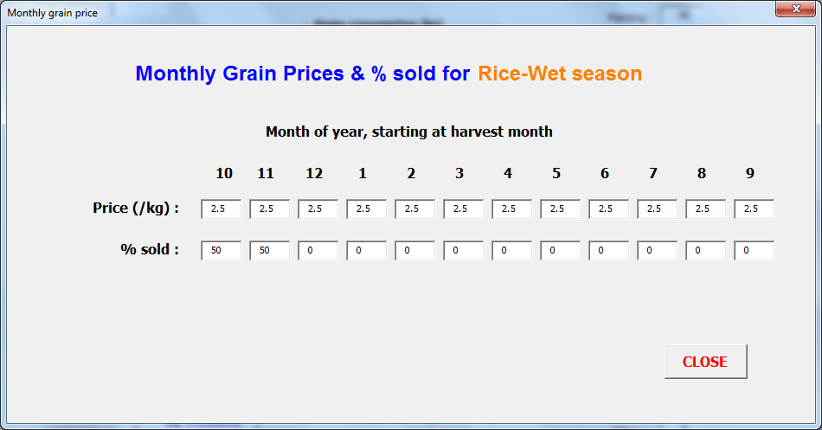

Form 3.7.3. Input form for grain prices (grain crops only).

The numbers along the top of the text boxes represent the month of the year, starting at the harvest month for the particular crop selected.

Price (/kg) – for each month of the year, starting at the harvest month, input the expected price that would be received for selling grain in the particular month

% sold - for each month of the year, starting at the harvest month, input the percentage of the grain harvest to be sold in the particular month (these values should sum to 100)

3.8 Purchased fodder

Up to 10 different fodders can be purchased within a year. These can be purchased either on a fixed basis, in a fixed month, or can be purchased as and when required i.e. when there is a fodder deficit on the farm (all fodder pools are empty). To enter data for purchased fodder, click on the ‘Purchased fodder’ button on the ‘Setup information’ form, and the form shown in Form 3.8 will appear.

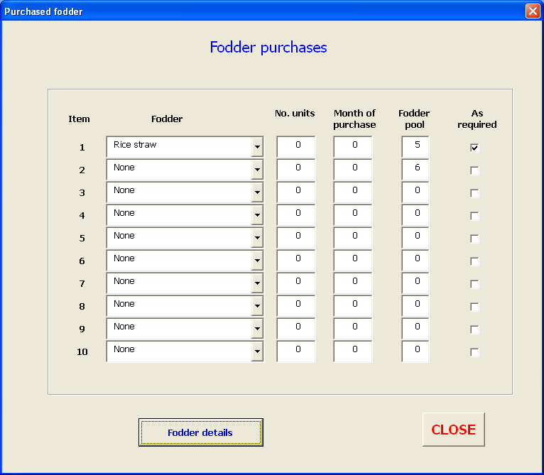

Form 3.8. Input form for purchased fodder.

For each fodder lot (up to 10), enter the following data:

Fodder – select the particular fodder from the drop down menu.

No. units – enter the number of units purchased at a time. If purchased as required, then this is assumed to be 1

Month of year – enter month purchased (for fixed purchases). If purchased as required then this will be ignored

Pool 1-10 – enter the fodder pool the purchased fodder will be added to (see section 3.9.2 for more information on fodder pools)

As required – tick this box if you want fodder purchased only when the fodder pools are empty. If there is more than 1 fodder listed for purchase, then one unit of each will be purchased (i.e. 1 unit of each and every fodder, at a time) until any fodder deficit for the particular month is overcome.

To edit the names of the bought fodders, see section 5.8. However, remember to change the specifications below (section 3.8.1), to match the new fodder.

3.8.1 Purchased fodder details

To determine the amount, cost and quality of purchased fodder, detailed information is required. This is entered by clicking on the ‘Fodder details’ button on the ‘Purchased fodder’ form. The ‘Purchased fodder details’ form (Form 3.8.1) will appear.

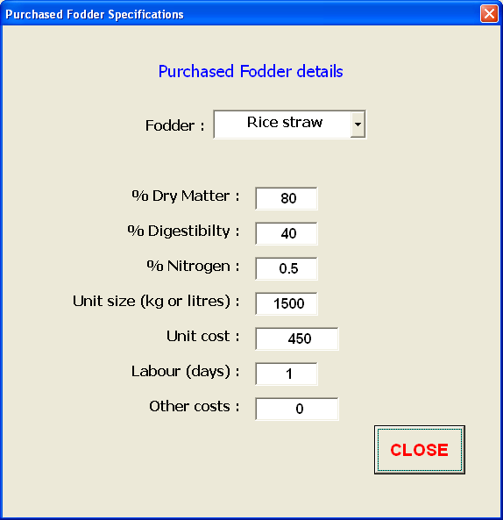

Form 3.8.1. Input form for detailed specifications of purchased fodders.

Fodder – click on the drop down menu and select the desired fodder.

% dry matter – enter an estimate of the % dry matter for the fodder

% digestibility – enter an estimate of the % digestibility for the fodder

% nitrogen – enter an estimate of the % nitrogen for the fodder

Unit size (kg or l) – enter the weight (kg) or volume (l) of the purchased units (e.g. bales, or drums)

Unit cost – cost of per unit

Labour – number man days to obtain the purchased fodder

Other costs – any other costs (this is an overall cost not a cost per unit)

3.9 Ruminant animal information

To input information on the number of ruminant animals a farmer has, the type of animals (cattle, sheep, goats, etc.) and class of animals (cows, bulls, calves), management, milking and supplementary feeding, on the Main Menu, click ‘Ruminant numbers & management’. The ‘Ruminant animals’ input form (Form 3.9.1) will be displayed.

3.9.1 Ruminant animal numbers, age and value

Animals are grouped into 17 categories, sucklings (animals less than the specified weaning age, weaners (animals aged between the weaning age and 12 months), breeders aged from >1 to <15 years old, male animals from >1 to <15 years old, and breeding sires. Male and females are in individual year categories up to 5 year old, then grouped in ages 6-10 and 11-15 years. For sucklings and weaners, each category is divided into male and female. What is input here is the number of animals in each category at the start of the analysis.

Note: Because of the low animal numbers on most smallholder farms, the IAT works in fractions of animals. For example, if there are only 2 cows and the calving rate is 80%, then 1.6 calves are born. While this is not possible physically, it allows better comparisons to be made. This is another reason why the absolute values indicated by the IAT should be taken only as a guide for comparison.

Breed or ruminant type

To select the desired breed of cattle or other ruminant type, click on the drop-down box below the ‘SELECT BREED’ heading. Names of ruminants should NOT be changed without recalibration of the model. This is because the ruminant coefficients for growth, gestation and mortality are specific to the named breed/ruminant type. If it is known that these parameters are the same (or very similar), then changing the name would be acceptable. Alternatively an additional ruminant type could be added to the list (see section 5.1).

To check what ruminants are currently included in the parameters, click on ‘Herd Summary’ and form 3.9.1 Summary will be displayed. This is useful to check that no unwanted ruminant types are included. This form does show any ruminants traded (see section 3.9.7)

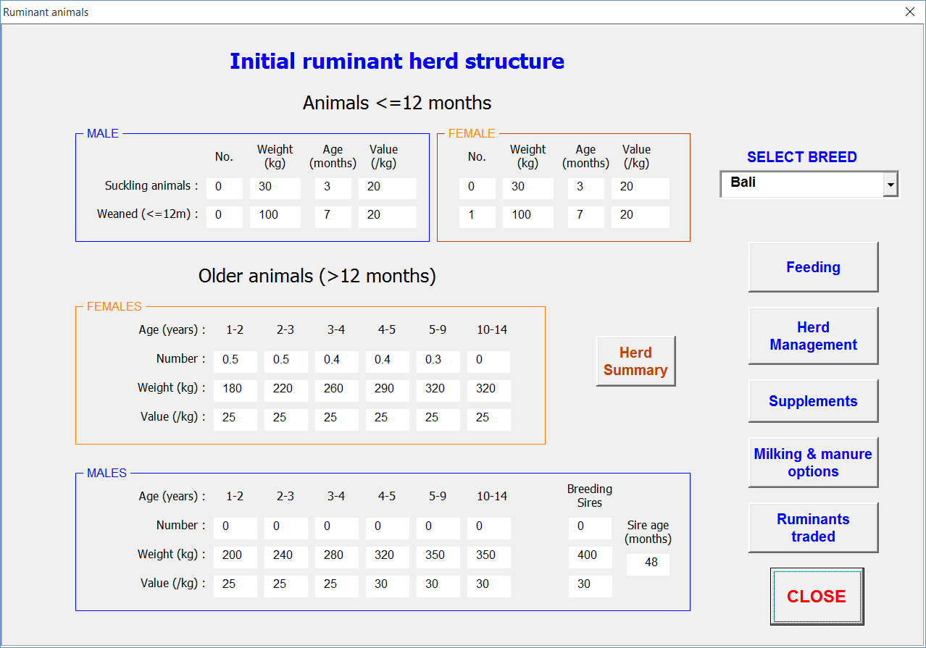

Form 3.9.1 Input form for ruminant animal numbers at start of run.

Animals <=12 months old

NB. In order to maintain all cows with similar calving dates, it is advisable to have either sucklings or weaners, but NOT both

For each category of animal <=12 months old (male and female sucklings or weaners), enter the following:

No. – enter the number of animals
Weight (kg) – enter the weight of the animals
Age (months) – enter the age of the animals
Value (/kg) – enter the price/kg liveweight for these animals if they were to be sold

Animals >12 months old

For each category of animal >12 months old (male and female), enter the following:

No. – enter the number of animals
Weight (kg) – enter the weight of the animals
Value (/kg) – enter the price/kg liveweight for these animals if they were to be sold

Except for breeding sires, the age of these animals will be determined by the age of the sucklings/weaners and the minimum mating age for breeding females. For example: if sucklings are 4 months old, and the minimum mating age is 27 months, then the breeding animal must be 31 months old, or some multiple of 12 months plus 31 i.e. 43, 55, etc. This is why it is important to start with either sucklings or weaners, but not both. The grouped categories (i.e. 5-9 and 10-14) will all have the same weight but their average age will be determined from the age of the 4-5 year-old animals, and their individual ages will be spread over the 5 years. The total number of animals will be apportioned equally across the 5 years.

Sire age (months) – enter age of sires (all sires are deemed to be the same age)

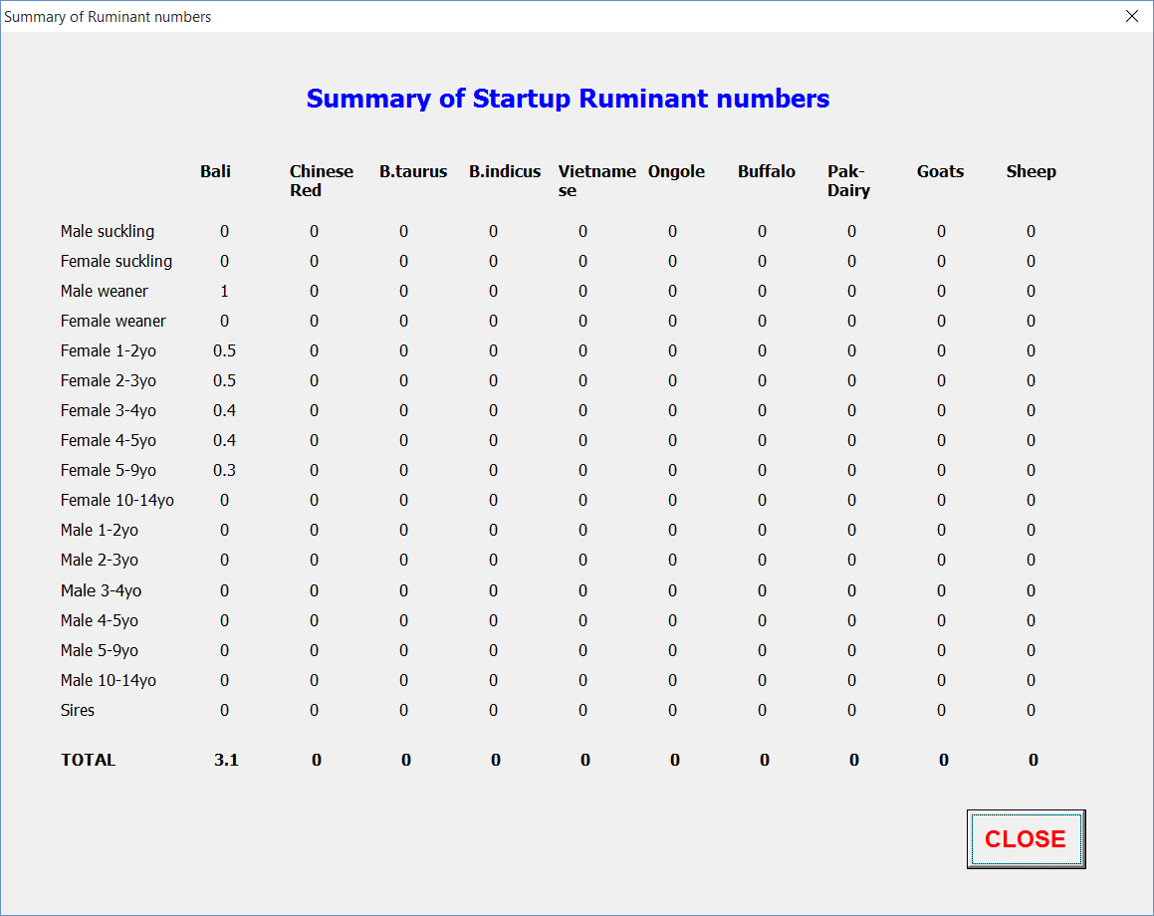
Form 3.9.1 Summary. Display form for ruminant animal numbers for all ruminant types at start of model run.

3.9.2 Ruminant feeding system

To specify the ruminant feeding system (grazing, cut and carry, or both), on the ‘Ruminant animals’ form, click on ‘Feeding’. The ‘Ruminant feeding’ input form (Form 3.9.2) will appear.

If not already selected, select the desired breed of cattle or other ruminant type by clicking on the drop-down box next to the ‘SELECT BREED’ heading. The current settings for that breed/ruminant type will be displayed.

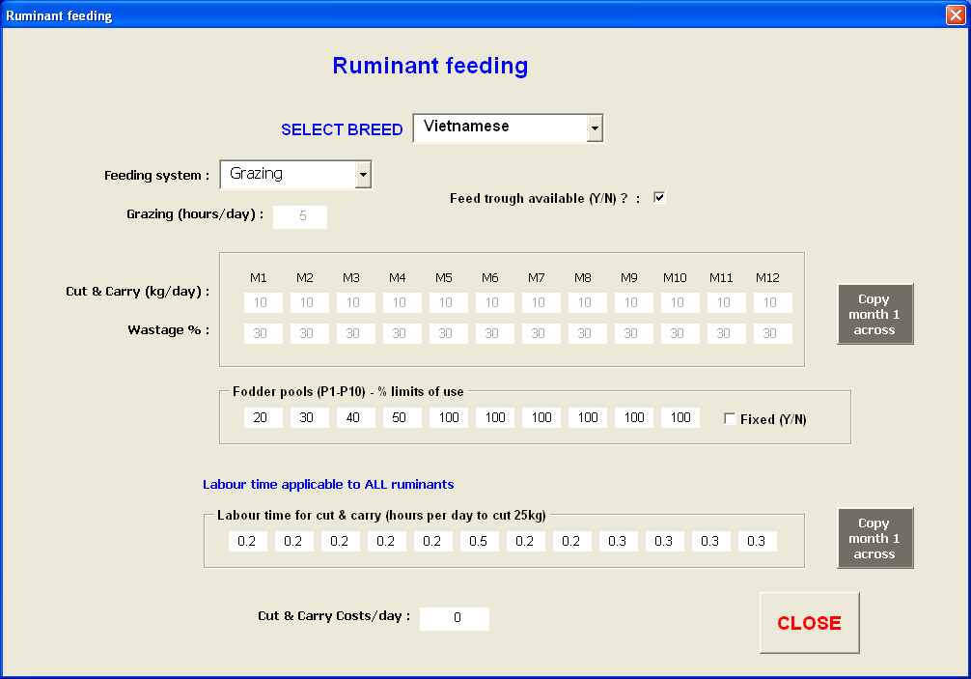

Form 3.9.2. Input form for ruminant feeding systems, cut and carry amounts, and labour requirements for cut & carry, rationing of fodder pools.

Feeding system – click on the drop down box next to the heading and select one of the 3 options. Depending on the system selected, other options will be displayed or disabled. If ‘Cut & carry’ is selected then all feed for this animal type will be supplied by cut and carry methods. If ‘Grazing’ is selected then all feed will come from grazing.
Grazing (hours/day) - If ‘Both’ has been selected as the feeding system, then the parameter for the number grazing hours per day will be enabled. This determines the potential animal intake based on a normal grazing day of 8 hours. Enter the number of hours per day animals are tethered or herded for grazing (maximum of 8).
Feed trough available(Y/N) – If cut & carry is merely dumped on the ground, then inevitably, there will be wastage due to trampling, etc. However, if a feed trough is available, it is assumed that there is no wastage.

Cut & carry

Cut & Carry (kg/day) – enter the number kg/day (dry weight) of cut & carry forage fed to the selected breed/animal type, in each month. This is the total amount fed to all animals of this breed/ruminant type (excluding ‘Trade’ animals, see section 3.9.7). M1 to M12 represent the months January to December. If the values are the same for all months, enter a value for M1 and click ‘Copy month 1 across’.
Wastage % - if there is no feed trough, this parameter will be enabled. Enter an estimate for the percentage of cut & carry wasted.
Fodder pools (P1-P10) - % limits of use

There are 10 fodder pools from which forage for feeding animals can be taken. Crop residue and forage crop harvests are allocated to the various fodder pools (priority), as determined by the user, in the databases for crop and forage yields, and selected by the user on the input form for tree and other crop forage components. While different crops can be allocated to any of the fodder pools, if the best quality fodder is to be rationed in any way, then the best quality forage should be allocated to fodder pool 1 (priority 1), with lower quality forage to pool 2, and so on. Rice or maize straw might be allocated to pool 5 or 6, depending what other forage is available (see Reference manual for more complete description).

% limits of use - For each pool (1-10) indicate the maximum percentage that can be fed to animals e.g. if 20kg/day is fed to animals, and you limit the use of pool 1 to 20%, and pool 2 to 50%, then 4kg will be taken from pool 1, 10kg from pool 2, and the remaining 6kg from other pools, assuming there is sufficient feed in the pools. Set the limit to 100% if there is no limit on the pool.

Fixed – If some pools are limited, then these limits can be fixed or flexible. If fixed, then if there is no other fodder available, the feed taken from the pool will still be limited, and any shortfall will be purchased (if applicable) or the farm will show a fodder deficit. If this box is not ticked, then the limits are flexible. In which case, if there is no other feed available, the farmer will exceed the specified limit in order to feed their animals.

Labour rate for cut & carry

This rate is applicable to all breeds/ruminant types, and is the time taken to cut 25kg dry matter.

Hours/day to cut 25kg – for each month (M1 to M12) enter the time taken to find, cut and collect 25 kg dry matter. This could vary considerably during the year if feed is not available on the farm or close by. If the value is the same for all months, enter a value for M1 and click ‘Copy month 1 across’. The model will determine the actual time taken based on this value and the amount of cut & carry specified above.

Cut & carry costs/day – if there are any cut & carry costs (e.g. transport), then enter the cost per day here.

3.9.3 Ruminant management costs and labour

To specify the ruminant management parameters (weaning, culling, mating age, etc), on the ‘Ruminant animals’ form, click on ‘Herd management’. The ‘Ruminant management’ input form (Form 3.9.3) will appear.

If not already selected, select the desired breed of cattle or other ruminant type by clicking on the drop-down box next to the ‘SELECT BREED’ heading. The current settings for that breed/ruminant type will be displayed.

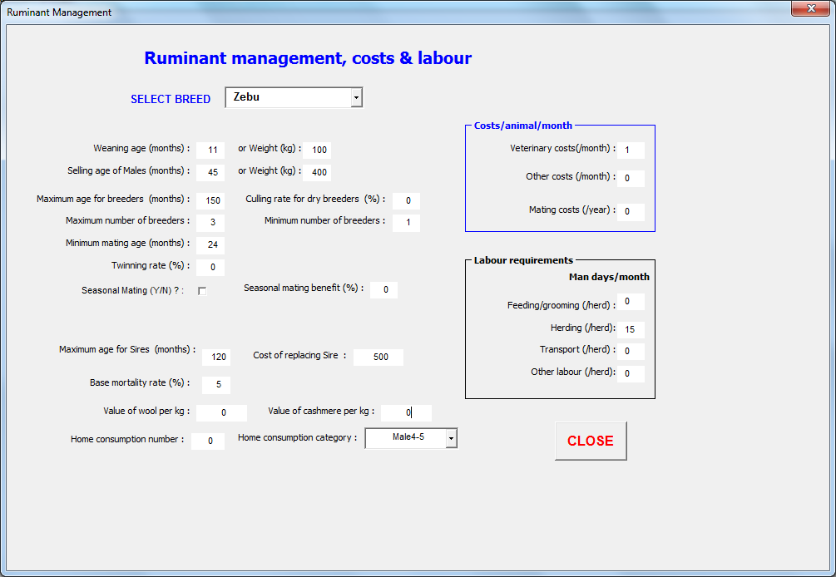

Form 3.9.3. Input form for ruminant management, costs and labour.

Weaning age (months) – enter the age at which suckling animals are weaned, ‘or Weight (kg)’, the weight at which animals are weaned. The model will wean animals when they reach the specified age or weight, whichever comes first.

Selling age (months) – enter the age at which animals are normally sold, ‘or Weight (kg)’, the weight at which animals are sold. The model will sell animals when they reach the specified age or weight, whichever comes first.

Maximum age for breeders (months) – age at which breeding animals are culled because of age (normally 10 years, 120 months). Animals can be kept longer if desired, and the average age of breeders in the 9-10 category will exceed 10 years.

Culling rate for dry breeders (%) – indicate the percentage of dry breeders that will be culled. The conception or birthing rate is determined at the due date for parturition (birthing). The percentage of breeders which do not give birth, can be culled, and will be replaced by young females, if available. For example, if the birthing rate is 70%, and the culling rate is 50%, then 15% of breeders will be culled and replaced. Note: once birthing rate (ignoring twinning) drops below 67%, then there will be insufficient young females to replace all dry breeders, so culling rate has to be reduced below 100%, or other females will need to be purchased.
Maximum number of breeders – maximum number of breeders the farmer wants to keep. If this value is higher than the number of breeders indicated at the start, then young females will be kept until the desired number is reached. This allows the user to increase the number of cows over time. This is applicable if some intervention has produced an increase in the forage available. The farmer may not have the resources to buy more cows immediately, so they can build up gradually. This will lower their income in the early years as they will have fewer animals to sell.
Minimum number of breeders – minimum number of breeders the farmer wants to have. If this value is lower than the number of breeders on hand, then young females will be kept until the desired maximum number is reached, or all young females are kept, but no females will be bought. If this number is greater than the number of breeders on hand, including young females, then young females will be purchased. This allows the user to set a minimum number of breeders to maintain a viable herd.

Minimum mating age (months) – minimum age at which young females are mated. Often this is determined by the age at which they normally have their first birth, and subtracting the gestation period.

Twinning rate (%) – for sheep and goats, twins are common, so there can be a birthing rate in excess of 100%, even though not all breeders gave birth. Enter an estimated value for twinning, as a percentage of the conception rate. The model determines the conception rate, then adds the twinning rate to determine the birthing rate (%birth rate=%conception rate + %conception rate*%twinning rate/100). The percentage of breeders which did not conceive can still be culled, even though the birthing rate may be over 100%.

Seasonal mating (Y/N) – most small holders use free mating (cows mate during the dry season when free grazing crop residues, and mate only if there happens to be a bull around). This leads to poor conception rates due to seasonal timing and cow condition and long periods between pregnancies due to lack of bull availability. Using seasonal mating has been shown to increase conception rates by at least 10%, often more, and sets the inter-birthing interval to 12 months.

Seasonal mating benefit (%) – the % conception rate will be increased by this amount if ‘Seasonal mating’ has been selected

Maximum age for sires (months) – age at which breeding sires are to be culled and replaced. Sires will be sold at the specified price/kg when they reach this age.

Replacement cost for Sire – cost of replacing sires. This is the cost per animal.

Base mortality rate (%) – this the base mortality rate for the herd, even if animals are well fed, and proper animal husbandry practices are followed (normally 3-5%)

Value of animal wool per kg – sale price per kg for animal wool

Value of cashmere per kg – sale price per kg for animal cashmere

Home consumption number – number of animals of the selected breed/ruminant type killed for home consumption. It is assumed all animals killed will be from the 1 category.

Home consumption category – category of animal of the selected breed/ruminant type killed for home consumption. Select animal category from the drop down menu.

Costs per animal

Veterinary cost (/month) – average cost of veterinary services per animal per month

Other costs (/month) - average of any other costs per animal per month

Mating cost (/year) – average cost of mating services per breeder per year

Labour requirements (man days/month)

The following values are for the whole herd (of the selected breed/ruminant type), not per animal.

Feeding/grooming – man days per month spent feeding (excluding cut & carry) and/or grooming animals.

Herding – man days per month spent herding animals

Transport – man days per month spent transporting animals

Other labour – man days per month doing other activities for the selected breed/ruminant type

3.9.4 Ruminant supplement feeding

To specify the ruminant supplements fed, on the ‘Ruminant animals’ form, click on ‘Supplements’. The ‘Supplementary feeding of Ruminants’ input form (Form 3.9.4) will appear.

Up to 30 different supplements can be selected from, however only 5 different supplements can be fed to a particular breed or ruminant type at any one time.

If not already selected, select the desired breed of cattle or other ruminant type by clicking on the drop-down box next to the ‘SELECT BREED’ heading. The current settings for that breed or ruminant type will be displayed.

Supplement – click on the drop down menu under the ‘Supplements’ heading to select a particular supplement to be fed.
Kg or litres fed – for each ruminant category, enter the quantity (in kg or litres) fed per animal per day. It is assumed that all animals older than 1-2 years will be fed the same amount.
Start month – month of the year in which supplementary feeding commences (January=1)
End month – month of the year in which supplementary feeding ceases (January=1)
Lactation only – if this box is ticked then breeders are fed supplement only during their period of lactation

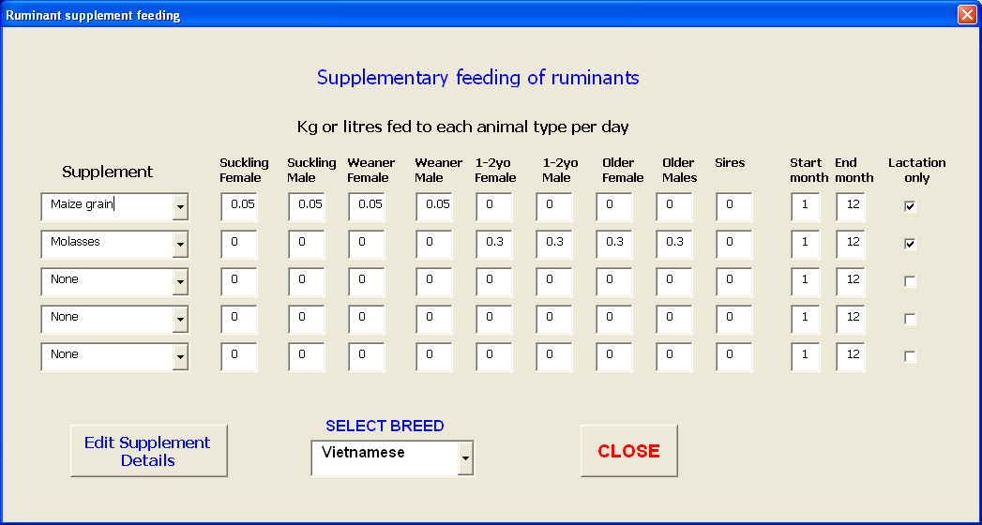

Form 3.9.4. Input form for feeding of supplements to ruminants

3.9.5 Supplement details

To determine the benefits and costs of supplements, detailed information is required. This is entered by clicking on the ‘Edit Supplement details’ button on the ‘Supplementary feeding of Ruminants’ form. The ‘Supplement details’ form (Form 3.9.5) will appear.

Supplement – click on the drop down menu and select the desired supplement. To change the name of a supplement, see section 5.9. However, remember to change the specifications below, to match the new supplement.

% dry matter – enter an estimate of the % dry matter for the supplement

% digestibility – enter an estimate of the % digestibility for the supplement

% nitrogen – enter an estimate of the % nitrogen for the supplement

Unit size (kg or l) – enter the weight (kg) or volume (l) of the purchased units (e.g. bales, or drums)

Unit cost – cost of per unit

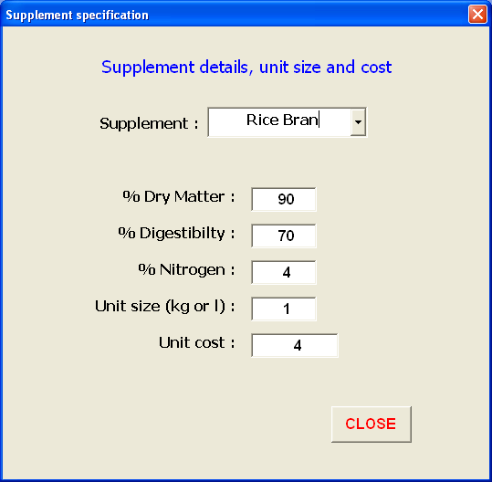

Form 3.9.5. Input form for supplement detail specifications

3.9.6 Ruminant milking and manure composting

In some smallholder situations (e.g. Pakistan) cattle or buffalo are milked, and/or manure is collected, composted and sold or used on the farm.

To enter data for milk and manure collection, click on the ‘Milking & manure options’ button on the ‘Ruminant animals’ form, and the ‘Milking & manure composting options’ form will appear (Form 3.9.6).

If not already selected, select the desired breed of cattle or other ruminant type by clicking on the drop-down box under the ‘SELECT BREED’ heading. The current settings for that breed/ruminant type will be displayed.

Milking Options

Breeders milked (Y/N) - tick this check box if breeders for the selected breed/ruminant type are to be milked. If not milked, all other parameters are ignored.
Value of milk/litre – price per litre received by farmer for milk
Home consumption L/day – litres of milk per day used for home consumption
Milking labour (hrs/breeder/day) – time taken to milk each breeder
Costs per cow/month – any extra costs per cow per month (this is not supplements or fodder)
Maximum production (litres/breeder/day) – this is the maximum milk production per breeder per day during the lactation period. This generally occurs around day 30 of the lactation period, and slowly decreases after that.
Period of milking (months) – number of months cows are milked
Percentage of breeders milked – in some cases not all breeders are milked.

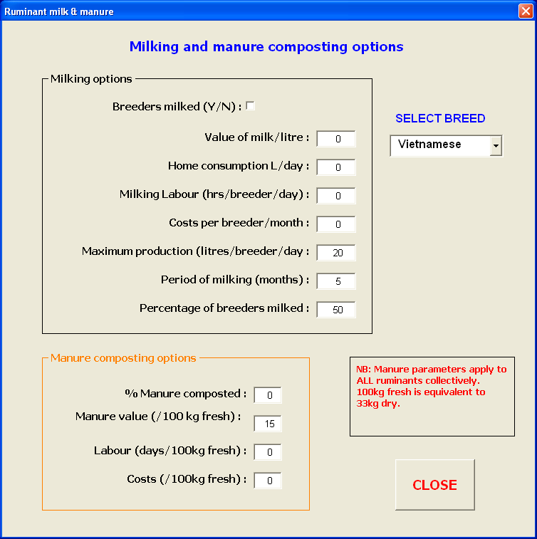

Form 3.9.6. Input form for ruminant milk and manure parameters.

Manure composting options

The model determines the amount of ruminant manure produced, based on the intake of the animals and the average digestibility of the forage supply.

% manure composted – not all manure will be available for composting. Enter an estimate of the percentage of the total amount that will be available for collection
Value (/100kg fresh) – manure is generally sold by the bag in a ‘fresh’ form i.e. not dried. Hence it is easier to get a price for fresh composted manure than dry.
Labour (days/100kg fresh) – manure needs turning over every so often, and needs bagging for sale. An estimate can be determined from the total time spent on manure turning and bagging and the number of bags produced.
Costs (/100kg fresh) – often some additives are combined with the manure to improve the composting process. Enter a price for the additive. Again, an estimate can be obtained from the total cost and the number of bags produced.

3.9.7 Ruminants traded

All the previous information provided for ruminants was for breeding ruminants. Some smallholders also buy and sell animals (trade) each year.

To enter information on ruminants traded during the year, click on ‘Ruminants traded’ on the ‘Ruminant animals’ form, and the ‘Details of Ruminant animals Traded’ form (Form 3.9.7) will appear.

Up to 10 trades can be completed within in any one year. Each trade can be a different cattle breed or ruminant type and/or animal category. It is assumed that the same trades will be done each year of the model run. Growth rates of the purchased animals are determined using the same animal growth model used for breeding animals. To see a summary of what ruminants are traded, click on ‘Trade Summary’ and form 3.9.7 Summary will be displayed, showing numbers of any animals traded for the 10 possible trade activities.

Select trade – click on the drop down menu to select the trade number (1-10)
Feeding system – click on the drop down menu to select the feeding system used for the selected cattle breed or ruminant type
Breed of animal – click on the drop down menu to select the cattle breed or ruminant type for the selected trade.
Category of animal - click on the drop down menu to select the category of animal within the selected breed or ruminant type.
Number of animals traded – number of animals purchased
Initial weight (kg) – weight of animals at time of purchase
Age at purchase (months) – age of animals at time of purchase
Purchase price (/kg LWT) – purchase price, per kg liveweight
Month of purchase – month of the year animals purchased (January = 1)
Sale criteria (months) – number of months animals kept, unless they reach sale weight prior to this
Sale criteria (weight) – weight (kg) animals must reach before sale, unless the sale month is reached prior to animals attaining this weight.
Cut & carry weight – kg of cut & carry forage fed to these animals per day (kg for all animals of this type, not per animal). Fodder pool priority will be the same as for breeding animals and labour will be determined based on the time specified for cut & carry for breeding animals. Similarly, any supplements specified earlier for the selected breed/ruminant type and animal category, will be applied to the traded animals as well.

Costs per animal/month

Feed – costs/animal/month for any extra feed purchased for these animals. This does not include supplements or bought fodder specified elsewhere

Veterinary – average cost of veterinary services per animal per month

Transport – average cost of transport per animal per month

Other - average of any other costs per animal per month

Labour requirements (man days/month)

Feeding – man days per animal per month spent feeding (excluding cut & carry) animals.

Herding – man days per herd per month spent herding the selected trade animals

Transport – man days per herd per month spent transporting the selected trade animals

Other labour – man days per herd per month doing other activities for the selected trade animals

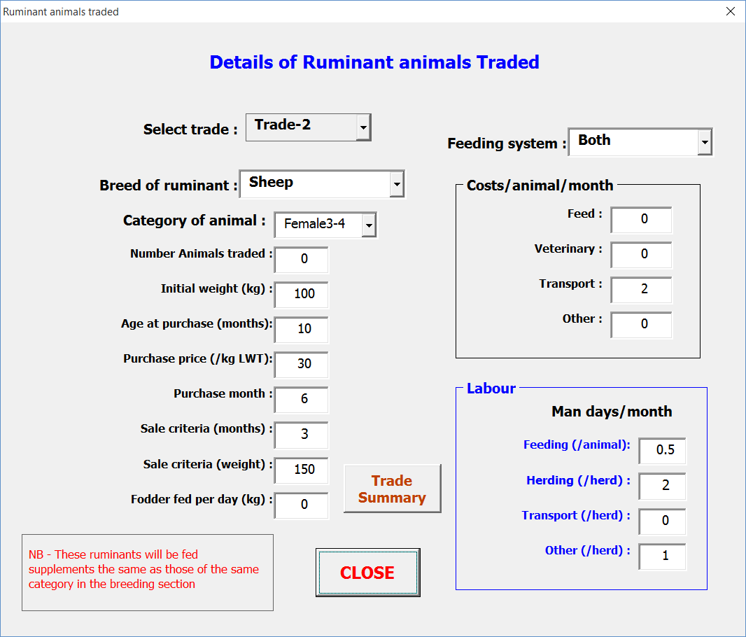

Form 3.9.7. Input form for information regarding ruminant animals traded (bought and sold) during the year.

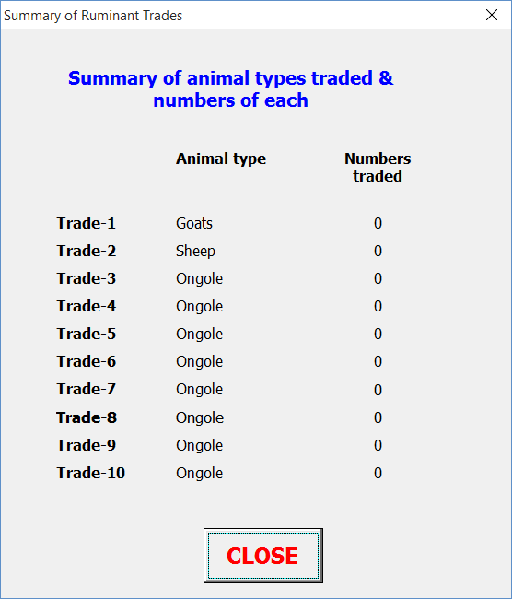

Form 3.9.7 Summary. Display form for information regarding ruminant animals traded (bought and sold) during the year.

3.10 Non-ruminant animal information

Non-ruminant animals (e.g. pigs, chickens) can be kept for breeding and/or can be traded. However, unlike ruminant animals, there is no growth or reproduction model for these animals. The user must specify the reproduction rate for breeding animals, and their sale price, and purchase and sale prices if animals are traded.

It is assumed that the same number of animals and the same reproduction rate occur every year. Hence the costs and revenue from these activities will be the same every year. The same applies to any non-ruminant animals traded.

To enter details regarding non-ruminant animals, click on the ‘Non-ruminant animal numbers & management’ button on the ‘Setup information’ form. The ‘Non-ruminant animals’ form (Form 3.10.1) will appear.

To check what non-ruminants are currently included in the parameters, click on ‘Non-ruminant Summary’ and form 3.10.1 Summary will be displayed. This is useful to check that no unwanted non-ruminant animals are included. This form does shows both non-ruminants kept for breeding and non-ruminants traded (see section 3.10.2)

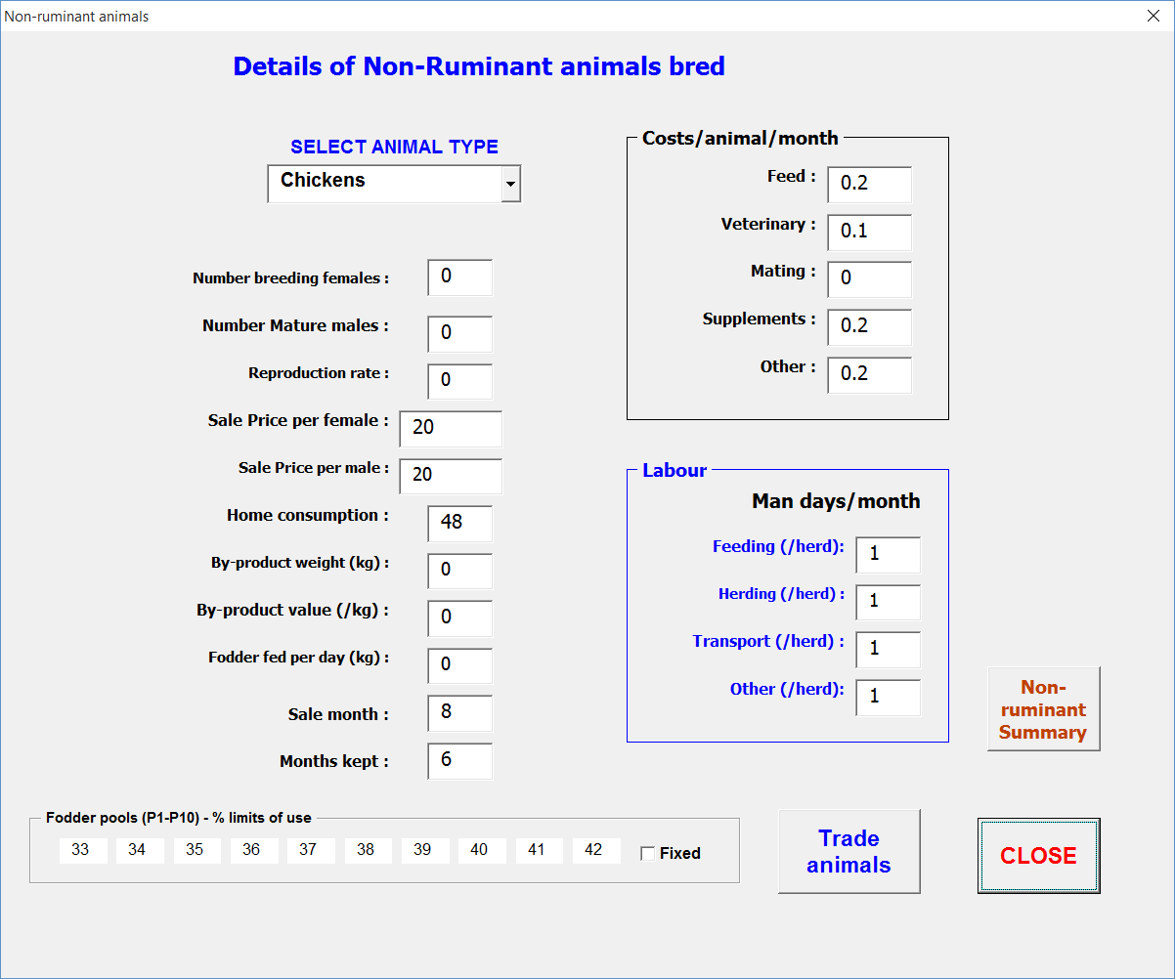

Form 3.10.1. Input form for parameters for breeding non-ruminant animals, such as pigs and chickens.

3.10.1 Details of non-ruminant animals bred

SELECT ANIMAL TYPE - select an animal type from the drop down menu under the ‘SELECT ANIMAL TYPE’ heading. To change the names of the listed animals, see section 5.10.
Number breeding females – enter the number of breeding females kept. This, along with the reproduction rate will determine the animal production for the year.
Number mature males – enter the number of mature males kept for mating purposes. This affects the feeding costs only.
Reproduction rate – number of juveniles bred by each breeding female per year. Currently the model is not set up to handle multiple breeding cycles within 1 year, so if more than one breeding event per year, either add the two together or have a second category of breeder i.e. chickens1 and chickens 2. However, if adding together, all the sales will occur in the same month, whereas, with 2 categories, sales can be in different months but there will double the number of breeders. It is assumed that half the number of bred animals will be female, and half the number male.
Sale price per female – sale price of females sold (price for whole animal, not per kg)
Sale price per male – sale price of males sold (price for whole animal, not per kg)

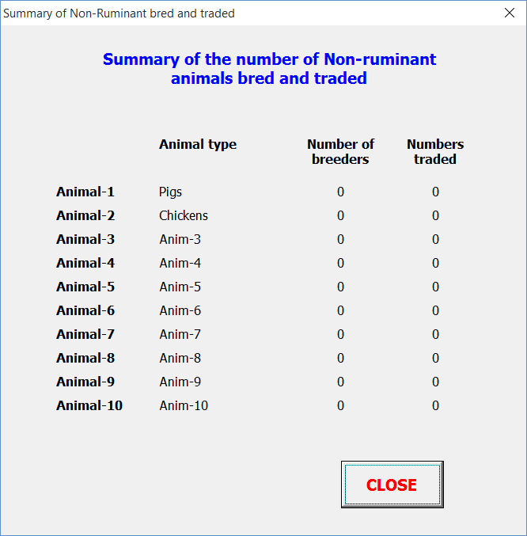

Form 3.10.1 Summary. Display form for showing non-ruminant animals (such as pigs and chickens) kept for breeding or traded.

Home consumption – number of animals used for home consumption
By-product weight (kg) – weight of any by-product produced from this activity. This is the total amount produced for all these animals (not per animal).
By-product value (/kg) – value of by-product per kg
Fodder fed per day (kg) – Amount of farm fodder fed to these animals per day. This is the total for all these animals from the fodder pools (see below for any rationing).
Sale month - Month of the year when growing animals are sold (January=1)
Months kept – number of months growing animals are kept before sale. This, and the sale month, determine the months in which fodder, costs and labour are allocated for juveniles.

Fodder pools (P1-P10)

For a more detailed description of the fodder pools, see section 3.9.2 above.

% limits of use - For each pool (1-10) indicate the maximum percentage that can be fed to these animals e.g. if 20kg/day is fed, and you limit the use of pool 1 to 20%, and pool 2 to 50%, then 4kg will be taken from pool 1, 10kg from pool 2, and the remaining 6kg from other pools, assuming there is sufficient feed in the pool. Set to 100% if there is no limit on the pool.

Fixed – If some pools are limited, then these limits can be fixed or flexible. If fixed, then if there is no other fodder available, the feed taken from the pool will still be limited, and any shortfall will be purchased (if applicable) or the farm will show a fodder deficit. If this box is not ticked, then the limits are flexible. In which case, if there is no other feed available, the farmer will exceed the specified limit in order to feed their animals.

Costs per animal/month

For costing, it is assumed that breeding females and adult males are kept all year. Juveniles, which each count as half an animal, are included in the months they are kept only.

Feed – costs/animal/month for any extra feed purchased for these animals. This does not include supplements or bought fodder specified elsewhere.

Veterinary – average cost of veterinary services per animal per month

Mating – average cost for mating services per breeder per year (if applicable)

Supplements – average cost of supplements per animal per month

Other - average of any other costs per animal per month

Labour requirements (man days/month)

Feeding – man days per animal per month spent feeding animals (excluding cut & carry).

Herding – man days per herd per month spent herding these animals

Transport – man days per herd per month spent transporting these animals e.g. for sale

Other labour – man days per herd per month doing other activities for these animals

3.10.2 Details of non-ruminant animals traded

All ‘non-ruminant’ animals can be traded, however, the model allows for only one trade per animal type per year. It will be assumed that the same number of animals is traded every year, for the same purchase and sale price. If there is more than 1 trade of the same animal type each year, then a second category of animal needs to be created e.g. Pigs1 and Pigs2

To enter details regarding non-ruminant animals traded, click on the ‘Trade animal’ button on the ‘Non-ruminant animals’ form, and the ‘Non-ruminant Trade animals’ form (Form 3.10.2) will appear.

SELECT ANIMAL TYPE – if not already selected, select an animal type from the drop down menu under the ‘SELECT ANIMAL TYPE’ heading.
Number animals traded – enter the number of animals purchased.
Purchase price – price paid to buy animals (whole animals, not per kg)
Purchase month – month in which animals are purchased (January=1)
Sale price – sale price of animals (price for whole animal, not per kg)
Sale month - month of the year when animals are sold (January=1). This, combined with the purchase month, determine the months in which fodder, costs and labour are allocated for these animals
Fodder fed per day (kg) – Amount of farm fodder fed to these animals per day. This is the total for all these animals from the fodder pools. The same rationing is applied as that for breeding this animal type.

Feeding costs per animal per month, descriptions are the same as for breeding animals of this type (section 3.10.1)

Labour (man days per month), descriptions are the same as for breeding animals of this type (section 3.10.1).

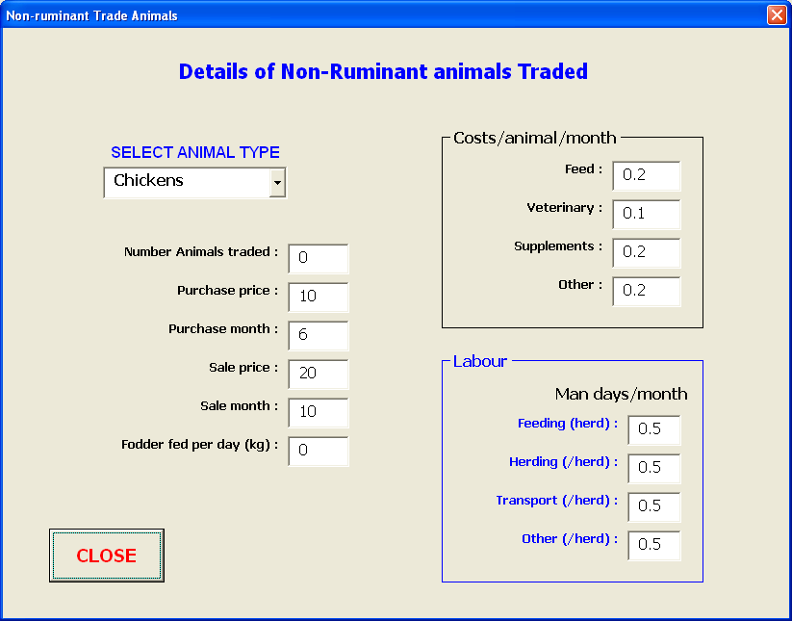

Form 3.10.2. Input form for non-ruminant animals traded

4. Displaying Output

Every time a user runs a new scenario, by clicking the ‘RUN SIMULATION’ button on the Main Menu, the IAT will pause briefly as it runs, then show brief glimpses of the output sheets as it writes the output, and then return to the Main Menu.

Output can be viewed in 2 ways:
- by going directly to each of the 5 output sheets (Monthly_output, Annual_output, Ruminant_output, Labour_output, and Fodder_output)
- by viewing the graphical output. On the Main Menu, click on ‘Graphical Output’.

4.1 Output sheets

4.1.1 Monthly output

This sheet provides the monthly whole farm values for:
Cash in – all revenue received
Cash out – all costs
Cash balance – previous balance + revenue – all costs
Labour costs – cost of hired labour
Overheads – monthly average
Interest – interest charges on overdraft if cash balance negative

For each crop grown:
Costs
Revenue
Value of home consumption
Number kg remaining in store, if kept for home consumption
Number of days labour spent on the crop

For each ruminant type:
Costs
Revenue
Milk production (litres)
Value of any home consumption
Number of days labour spent on the animals

For whole farm:
Total cost of bought fodder
Total number of days labour for cut and carry

For each ’non-ruminant’ animal type:
Costs
Revenue
Value of any home consumption
Number of days labour spent on the animals

For whole farm:
Total Methane production
Total ruminant Manure produced
Total amount of composted manure produced
Total fodder usage
Cost of any home consumption shortfall

4.1.2 Annual output

This sheet provides the annual cost, revenue, value of home consumption (HomeCon), and gross margin (GM-HC, gross margin ignoring the value of home consumption) for :

Each crop grown (grain, forage, tree, or other)
Each ruminant breed/type kept
Each non-ruminant animal kept
For the whole farm

The annual cost of Bought fodder is listed separately as it is difficult to realistically attribute the cost to any of the animal activities in particular.

4.1.3 Ruminant output

For each ruminant category (juveniles, weaners, breeders, etc), for each ruminant breed/type kept, monthly values are listed for:

Weight (kg)
Number of animals
Age (months)

4.1.4 Fodder output

For each of the 10 fodder pools, monthly values (kg of fodder, not kg/ha) are listed for:

Fodder input to the pool (kg), plus total input
Fodder output from each pool, plus total output
Fodder balance of each pool at the end of the month, plus total balance

4.1.5 Labour output

Labour activities

For each of the 16 crop labour activities and 6 animal labour activities, monthly values (in man days) are given for:

Total demand/need for the whole farm
Balance for the month – this is the balance of labour required for each activity. If it is 0, then all the demand has been met, if it is non-zero, then there is a shortfall of labour for that activity.

People categories

For people category (male and female, elderly, adult, etc), monthly values are given for:

Supply – the number of days labour each category could provide
Non-farm – the number of days each category had committed to non-farm labour
Balance – number of surplus days labour for each category after deducting the non-farm labour and meeting any on farm demand. If the value is positive, then they had surplus time, if zero, then either the category did not provide any labour, or it was all used.
Hired – number of days of hired labour for each category. If hired labour was set as fixed, this will be the number of days specified by the user. If not fixed, then it will be the number of days required to meet demand.
Hired-Bal – the balance of labour for each hired category after adjusting for demand.
Whole farm

Whole farm monthly values for:

All crop activities
All animal activities
Whole family supply
Whole family off-farm labour
Whole family balance (supply, less off farm, less on farm demand)
Total hired labour

4.2 Graphical output

To view output in graphical form, on the Main Menu, click on ‘Graphical Output’. The ‘Graphs’ form (Form 4.2) will appear.

To view graphical output, click on the drop down menu next to one of the headings and select the particular item of interest, then click the ‘Show graph’ button adjacent to the drop down menu.

4.2.1 Annual Costs/revenue

To view annual costs, revenue, home consumption and gross margin (as per the ‘Annual output’ sheet described above, click on the drop down menu next to the heading “Annual Cost/Revenue’.

4.2.2 Activity Labour

To view monthly labour demand and balance for each activity, as per the ‘Labour output’ sheet described above, click on the drop down menu next to the heading ‘Activity Labour’. This graph will show the demand, and any outstanding balance. If the demand has all been met, then the balance will be zero.

4.2.3 People Labour

To view monthly labour demand and balance for each people category, as per the ‘Labour output’ sheet described above, click on the drop down menu next to the heading ‘People Labour’. This graph will show the outstanding balance for the selected category, and any hired labour for that category.

4.2.4 Fodder balances

To view monthly fodder input, output and balances for each fodder pool or the whole farm, as per the ‘Fodder output’ sheet described above, click on the drop down menu next to the heading ‘Fodder Balances’. This graph will show the values in kg (not kg/ha)

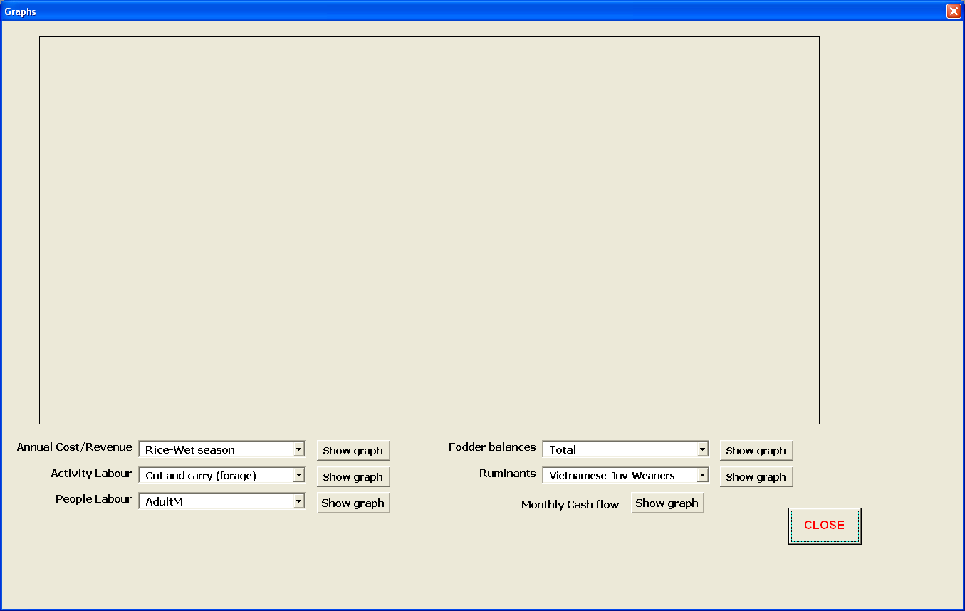

Form 4.2. Form to display output data graphically

4.2.5 Ruminant weights

To view monthly live weights for each animal category for each ruminant breed/type, as per the ‘Ruminant output’ sheet described above, click on the drop down menu next to the heading ‘Ruminants’. The ruminant categories are grouped into 3 groups: juveniles and weaners (male and female); all older females; all older males.

4.2.6 Monthly cash flow

Click on the ‘Show graph’ button next to the heading to display the monthly cash in, cash out and cash balance for the whole farm, as described for the ‘Monthly output’ sheet above.

5. Adding new information to the IAT

At times you will want to add new crops, forages or language information to the IAT. This can be done by direct access to the worksheet databases only. Some can be single entries, but others require information over the number of years in the analysis.

5.1 Adding a new ruminant or changing the name of an existing ruminant

The ruminant ‘name’ is merely a name for the convenience of the user, but the model uses the ruminant ‘number’ to select the relevant coefficients and specifications from the ‘Params’ sheet. Currently the IAT allows for up to 20 ruminants for any particular parameter set.

N.B. If changing ruminant names, remember that the matching data in the ‘Params’ sheet, for the particular ruminant selected, may no longer be relevant. For example, if renaming a breed of cattle to a sheep, then the expected mature weight and the gestation period will be different. Similarly, if adding a new ruminant, new coefficients and specification values will need to be added. The specifications can be entered via the input forms, but the coefficients have to be entered directly on the ‘Params’ sheet and should be done only by someone competent in parameterising ruminant growth, fertility and mortality.

To add a new ruminant name to the list, or change the name of an existing ruminant, go to the ‘Params’ sheet in the IAT and edit the names in column B, rows 5 to 24. Remember to click ‘Save parameters’ on the Main Menu to save the new ruminant names to the attached parameter file.

5.2 Adding a new climate region/village or changing the name of an existing region/village

The climate zone ‘name’ is merely a name for the convenience of the user, but the model uses the zone ‘number’ to select crop and forage data from the databases. Currently the IAT allows for up to 20 climate zones for any particular parameter set. To add a new zone to the list, or change the name of an existing zone, go to the ‘Params’ sheet in the IAT and edit the names in column E, rows 5 to 24. Note which number is next to this new zone as you will need this number when specifying new data in the crop and forage databases. Remember to click ‘Save parameters’ on the Main Menu to save the new zone names to the attached parameter file.

N.B. If changing zone names, remember that the matching data in the crop and forage databases, for the particular zone number, may no longer be relevant.

5.3 Adding a new soil type or changing the name of an existing soil type

The soil type ‘name’ is merely a name for the convenience of the user, but the model uses the soil type ‘number’ to select crop and forage data from the databases. Currently the IAT allows for up to 20 soil types for any particular parameter set. To add a new soil type to the list, or change the name of an existing soil type, go to the ‘Params’ sheet in the IAT and edit the names in column K, rows 5 to 24. Note which number is next to this new soil type as you will need this number when specifying new data in the crop and forage databases. Remember to click ‘Save parameters’ on the Main Menu to save the new soil type names to the attached parameter file.

N.B. If changing soil type names, remember that the matching data in the crop and forage databases, for the particular soil type number, may no longer be relevant.

5.4 Adding a new currency or changing the name of an existing currency

The currency ‘name’ is merely a name for the convenience of the user. Currently the IAT allows for up to 20 currencies for any particular parameter set. To add a new currency to the list, or change the name of an existing currency, go to the ‘Params’ sheet in the IAT and edit the names in column H, rows 5 to 24. Remember to click ‘Save parameters’ on the Main Menu to save the new currency names to the attached parameter file.

N.B. If changing currency names, remember that the matching costs and prices for all crops, forages, animals, etc, may no longer be relevant.

5.5 Adding/changing the name of a non-farm labour type

The non-farm labour ‘name’ is merely a name for the convenience of the user. Currently the IAT allows for up to 5 non-farm labour types for any particular parameter set. To add a new labour type to the list, or change the name of an existing labour type, go to the ‘Params’ sheet in the IAT and edit the names in column N, rows 5 to9. Remember to click ‘Save parameters’ on the Main Menu to save the new non-farm labour names to the attached parameter file.

5.6 Adding a new language

Currently there are only 2 languages, English and Bahasa Indonesia, but the IAT can have up to 9 languages. If you want to add another language then there are 2 things you need to do: add the language name, and then add text for every button, heading and prompt in the IAT, in the new language (don’t worry, you only have to do it once).

Adding a new language name – select the ‘Params’ worksheet and edit the names in column Q, rows 5 to 13. Remember to click ‘Save parameters’ on the Main Menu to save the new currency names to the attached parameter file.

Adding the new language for prompts etc – select the ‘Captions’ worksheet, go to the first empty column (column F if this is the 3rd language), add the language name in row 2, and then for each row (3 to end) in the worksheet, type in the appropriate text for the new language, so that the text will have the same meaning in the new language as it does in English and Bahasa Indonesia.

5.7 Changing a land unit name

The land unit ‘name’ is merely a name for the convenience of the user. To change the name of a land unit, go to the ‘Params’ sheet, and scroll down column B until you find ‘Land specifications’ and edit the name/s below the heading. Up to 10 names are available. Remember to click ‘Save parameters’ on the Main Menu to save the new crop names and specifications to the attached parameter file.

5.8 Changing a bought (purchased) fodder name

The bought fodder ‘name’ is merely a name for the convenience of the user. To change the name of a bought fodder, go to the ‘Params’ sheet, and scroll down column B until you find ‘Bought fodder specs’ and edit the name/s below the heading. However, remember to check/change the specifications to make sure they are suitable for the new fodder. Up to 10 names are available. Remember to click ‘Save parameters’ on the Main Menu to save the new crop names and specifications to the attached parameter file.

5.9 Changing a supplement name

The supplement ‘name’ is merely a name for the convenience of the user. To change the name of a supplement, go to the ‘Params’ sheet, and scroll down column B until you find ‘Supplement specifications’ and edit the name/s below the heading. However, remember to check/change the specifications to make sure they are suitable for the new supplement. Up to 30 names are available. Remember to click ‘Save parameters’ on the Main Menu to save the new crop names and specifications to the attached parameter file.

5.10 Changing a non-ruminant name

The non-ruminant ‘name’ is merely a name for the convenience of the user. To change the name of a non-ruminant animal, go to the ‘Params’ sheet, and scroll down column B until you find ‘Other animals’ and edit the name/s below the heading. However, remember to check/change the specifications to make sure they are suitable for the new animal. Up to 10 names are available. Remember to click ‘Save parameters’ on the Main Menu to save the new crop names and specifications to the attached parameter file.

5.11 Adding/changing a crop name and details

To add the name of a new crop (grain, forage, tree or other) go to the ‘Params’ sheet, and scroll down column B until you find ‘Grain crop specifications’ (substitute Tree, Forage or Other in place of ‘Grain’ for those crops) and add the name to the existing names below the heading. Up to 30 names/crops can be entered for Grain and Forage crops, and up to 10 for Tree and Other crops. The crop specification information can be entered directly into the ‘Params’ sheet, to the right of the new name, or can be entered via the ‘Crop specification’ input form (see section 3.7 above). Similarly, a crop name can edited/changed using the same method, however, remember to check/change the specifications to make sure they are suitable for the new crop. Remember to click ‘Save parameters’ on the Main Menu to save the new crop names and specifications to the attached parameter file.

Make a note which number is next to any new grain or forage crops as you will need this number when specifying new data for the crop in the crop database (see 5.10 and 5.11 below).

5.12 Changing the name of a ruminant category

N.B. These ‘names’ should not be changed as the categories have specific meaning in the model.

This refers to category names such as juveniles, weaners, etc. However, animals move from category to another, and hence these names should not be changed. For example, juveniles (categories 1 and 2) become weaners (categories 3 and 4) at weaning age, then weaners become 1-2 year old females and males (categories 5 and 14) after 12 months.

5.13 Changing the name of an on-farm labour category

N.B. These ‘names’ should not be changed as the categories have specific meaning the model.

This refers to category names such as planting, harvesting, etc. However, labour is done at specific stages during the growth of a crop, and hence these names should not be changed. For example, ploughing and planting labour is allocated to the month of sowing, while harvest labour is allocated to the harvest month, and some are distributed across the intervening months.

5.14 Adding new grain/forage crop data to the databases

For food grain crops similar to rice or maize, you will need information on yields of grain and stover biomass, as well as nitrogen content of the biomass, and the harvest date (month of the year), as well yields of by-products (if any), the harvest year, and an allocation to a fodder pool (priority number). You will need as many years of data as you wish to analyse. For forage crops, you will need data for individual harvests during the year. The crops are identified by the climate zone, the soil type, the crop number and the year. If the data is for a new food crop, you will need to add a new crop name and details (see section 5.7).

To enter the necessary data, open the desired parameter workbook, select the ‘Crop_inputs’ sheet (Figure 2) or ‘Forage_inputs’ sheet (Figure 3), and scroll to the bottom.

5.14.1 Crop data

The name of the sheet in the parameter file MUST be ‘Crop-inputs’.

Climate zone – (column A) the region/village number in which the crop is grown
Soil No. – (column B) the number of the soil type to which the crop data refers
CropNo – (column C) the crop number. Have a different number for each crop or variant of a crop e.g. rice fertilised, rice unfertilised, etc.
Crop name – (column D) (optional crop name) not needed by the model, used merely for ease of finding data.
Year_no – (column E) the year sequence, normally 1 to ‘n’ (again, this is not used by the IAT, it is merely for ease of finding data).
Year – (column F) the actual harvest year. This is used by the model to find the relevant data.
Month – (column G) the harvest month for the crop (December=12).
Grain_wt – (column H) the yield of grain from the crop, expressed in kg/ha. If you have data expressed in some other units, convert to kg/ha for entering in the database.
Stover_wt – (column I) the biomass of the crop residue (excluding grain), expressed in kg/ha. Again, if you have data expressed in some other units, convert to kg/ha for entering in the database.
Stover_%n – (column J) the nitrogen content (%) of the crop residue (i.e. excluding the grain) at harvest time. This is used in determining the quality of the crop residue for animal feed.
Priority – (column K) the fodder pool into which the any crop residue will be input. Currently there are 10 fodder pools in the model, and feeding can be rationed (limited) from the individual fodder pools. All residues can go into one pool, or if the user wishes to track the use of particular crops, then each crop (up to 10) can go into a different pool.
ByProd1 - (column L) the yield of the first of 2 by-products from the crop, expressed in kg/ha. If you have data expressed in some other units, convert to kg/ha for entering in the database.
ByProd2 - (column M) the yield of the second of 2 by-products from the crop, expressed in kg/ha. If you have data expressed in some other units, convert to kg/ha for entering in the database.

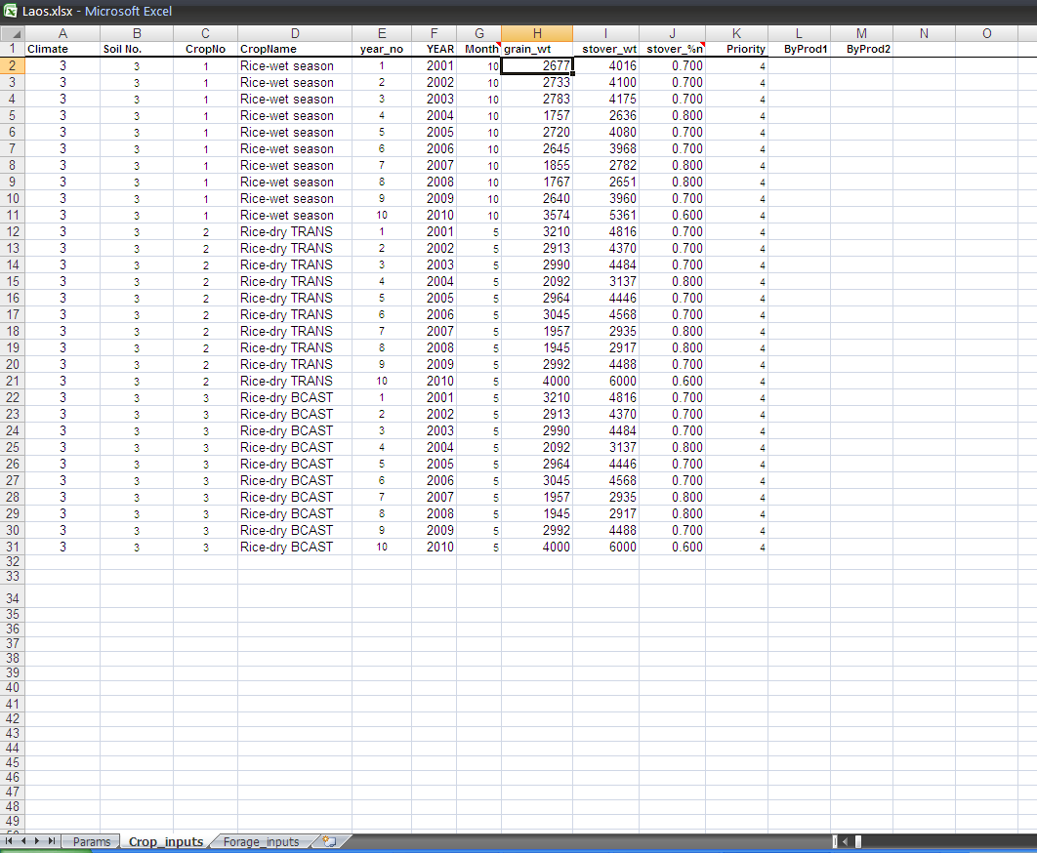

Figure 2. Layout of data in the grain crop database.

5.14.2 Forage data

The name of the sheet in the parameter file MUST be ‘Forage-inputs’.

Climate zone – (column A) the region/village number in which the crop is grown
Soil No. – (column B) the number of the soil type to which the crop data refers
CropNo – (column C) the crop number. Have a different number for each crop or variant of a crop e.g. rice fertilised, rice unfertilised, etc.
Forage name – (column D) (optional crop name) not needed by the model, used merely for ease of finding data.
Year_no – (column E) the year sequence, normally 1 to ‘n’ (again, this is not used by the IAT, it is merely for ease of finding data).
Year – (column F) the actual harvest year. This is used by the model to find the relevant data.
Cut_no – (column G) the number of the harvest (1..n)
Month – (column H) the harvest month for the forage crop (December=12).
Harvested_wt – (column I) the biomass of the harvested forage, expressed in kg/ha. Again, if you have data expressed in some other units, convert to kg/ha for entering in the database.
Forage_%n – (column J) the nitrogen content (%) of the crop residue (i.e. excluding the grain) at harvest time. This is used in determining the quality of the crop residue for animal feed.
Priority – (column K) the fodder pool into which the any crop residue will be input. Currently there are 10 fodder pools in the model, and feeding can be rationed (limited) from the individual fodder pools. All residues can go into one pool, or if the user wishes to track the use of particular crops, then each crop (up to 10) can go into a different pool.
ByProd1 - (column L) the yield of the first of 2 by-products from the crop, expressed in kg/ha. If you have data expressed in some other units, convert to kg/ha for entering in the database.
ByProd2 - (column M) the yield of the second of 2 by-products from the crop, expressed in kg/ha. If you have data expressed in some other units, convert to kg/ha for entering in the database.

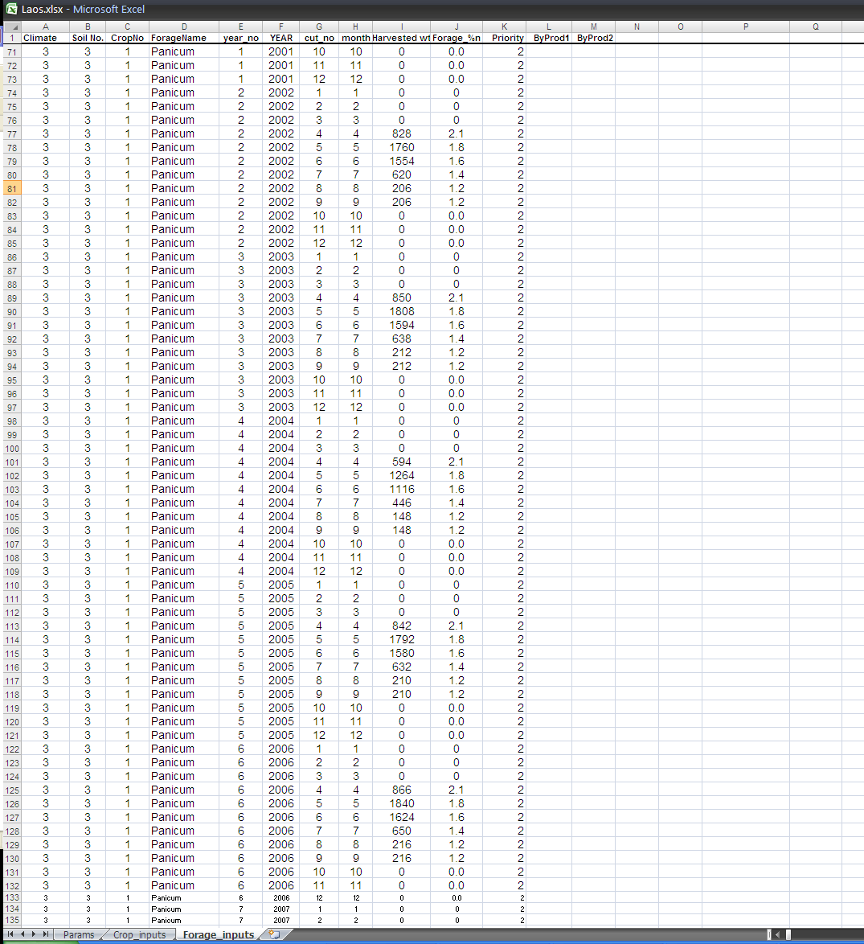

Figure 3. Layout of data in the forage crop database.

6. Trouble shooting

6.1 Function buttons do not work when first used

If none of the function buttons work when you try to use the IAT the first time, then it is probably because the macros have not been enabled. If you clicked enable when opening the program, but it still does not work, then you need to change the security setting in Excel. You will only need to do this once because it is a security setting in Excel and has nothing to do with the IAT. To change your security setting in Excel:

For Excel 2007:

If in Full Screen mode, click on the green Excel icon in the top left hand corner of the screen, then click restore.

Click Developer, Macro Security, Macro Settings
Select Enable all macros level of security
Click Ok

Close the IAT and Excel, then re-open it, and everything should work.

6.2 Function buttons do not work after a debug error

If the program has stopped while running and given an error message which includes a button with ‘Debug’ on it, then the program will have paused and you will have to reset it.

For Excel 2007:

Click Developer, Visual Basic
This will open a new window
Click Run, Reset
Then close the window

6.3 Additional help

For additional help on using the model, more detailed explanation of the functioning of the model, or to report any errors detected in the model, please contact:

Di Prestwidge
CSIRO Ecosystem Sciences
Email: di.prestwidge@csiro.au

