Foot and Mouth Disease Ready project Surveillance subproject information for pilots
Project overview
To strengthen Australia’s preparedness to deal with an emergency animal disease incursion, such as Foot and Mouth Disease (FMD) a recent initiative is the ‘Improved surveillance, preparedness and return to trade for emergency animal disease incursions using foot-and-mouth disease as model’ project (FMD Ready project). This project has four complementary subprojects:
1) Rapid diagnostics and vaccination strategy preparedness
2) Farmer-led partnerships for improved surveillance
3) Decision support tools for decision-making during outbreaks
4) Analytical tools to determine the path of farm-to farm disease transmission
This project is supported by Meat & Livestock Australia (MLA), through funding from the Australian Government Department of Agriculture and Water Resources (DAWR) as part of its Rural R&D for Profit programme; producer levies from Australian FMD susceptible livestock (cattle, sheep, goats and pigs) industries; and Charles Sturt University. The project also leverages significant in-kind support from the research partners.
The research partners for this project are the Commonwealth Science and Industrial Research Organisation (CSIRO), Charles Sturt University (CSU) through the Graham Centre for Agricultural Innovation, the Bureau of Meteorology (BOM) and the Australian Department of Agriculture and Water Resources, supported by Animal Health Australia (AHA). The project commenced in July 2016 and will conclude in June 2020.
Subproject 2: Farmer-led partnerships for improved surveillance
The issue of animal health surveillance in Australia is a complex one due to the number of stakeholders involved, including producers, private and government veterinarians, industry groups, rural communities and service providers, state/territory and national governments, and international trade partners. Each of the stakeholders have different resources and priorities and the intersection of these result in a level of complexity that can hinder constructive and engaging relationships from developing. Consequently, animal health surveillance in Australia, which requires constant vigilance and continuing improvement, can remain static and closed to opportunities for innovative problem solving.
The ‘Farmer-led partnerships for improved surveillance’ subproject adopts an Agricultural Innovations Systems (AIS) approach to consider through stakeholder partnerships, how animal disease monitoring and reporting in Australia might be improved.

Agricultural Innovations Systems (AIS) introduction
Traditional approaches to agricultural innovation and extension in Australia have relied on the linear process of research driven changes and a top down approach of adoption by persuasion from government and research agencies to producers. In contrast, the AIS approach sees innovation as requiring interaction between multiple stakeholders and a sharing of knowledge and experience. This involves the formation of new partnership platform to new or existing networks, to have open reflective discussions and innovative approaches to solving common problems.
AIS was introduced at the beginning of the 2000s to understand and promote innovation in agriculture in developing countries. It also has been applied in developed countries successfully including in New Zealand and the Netherlands. See the reading list below for examples.
AIS uses innovation platforms (IP) or multiple stakeholder partnerships. IPs are the working groups of the AIS. They are formed by bringing together stakeholders that are affected by and involved in an issue. In the context of this project the focus will be on animal health surveillance and may include farmers, government representatives, private veterinarians and industry representatives. For issues that need to be addressed across for example local, state and national levels, local IPs can link with IPs at higher levels, making legislative and governance innovative change possible.
What will an Innovation Platform (IP) pilot look like?
The ‘Farmer-led partnerships for improve surveillance’ subproject will be establishing local IP pilots across Australia in each of the four main FMD susceptible industries across Australia: beef, dairy, sheep and pork. Because IPs rely on a partnership process to bring about needed technological, social, behavioural, economic and institutional change , the pilot IPs themselves will create and test possible solutions to the complex problem of improving animal health surveillance, rather than relying on a top down approach. Each pilot will be established using the following 4 phases, and is illustrated in Figure 1.
Phase 1: Analyse system and initiate IP. Researchers from the subproject will initiate engagement with stakeholders via existing networks with the aim of understanding the current animal health system. They will also explore what works well and what does not work well in relation to current inspection, detection and reporting activities in the region and how IP participants think it could be improved.
The first IP workshop will be organised, with researchers facilitating the discussion of shared problems and opportunities and establishment of goals. The IP will have the initial goal of considering any possible improvements that might be made to animal health and disease monitoring and reporting.
From the stakeholder workshop, a first draft plan of action listing the priority areas of focus and timelines will be created.

Phase 2: Consolidate areas of focus and plan innovative strategies. As the IP pilot progresses through action plans and workshops, via facilitation by the research team, knowledge is shared and developed and innovative technical, behavioural and institutional options and strategies to address prioritised challenges and opportunities are negotiated. Local solutions are the focus but higher scale (regional, state national) challenges that require policy and/or industry-level interventions can also be identified. Capacity building opportunities (training, shared experiences etc) and communication needs required to run the IP will also be identified. Innovative options and strategies are translated into action plans for testing and implementation.

Phase 3: Implement innovative options and strategies. Implement capacity building and establish incentives (if required) for testing and implementation of innovative options and strategies. Clear and simple communication strategies to support implementation and dissemination of activities, outputs and outcomes will be established, based on stakeholder requirements. Monitoring and evaluation frameworks will be implemented, as well as learning from the success or failure of implemented options and strategies. Pathways for scaling out to other industry groups and up to regional/state/national levels are also established

Phase 4: Monitor progress, evaluate, learn and adapt strategies. This phase runs concurrently with other phases. The IP process and outcome indicators are under constant revision, informed by the trials of innovative options and strategies. Progress is monitored, results are assessed, with reflection and learning informing adjustments to option and strategies as needed.

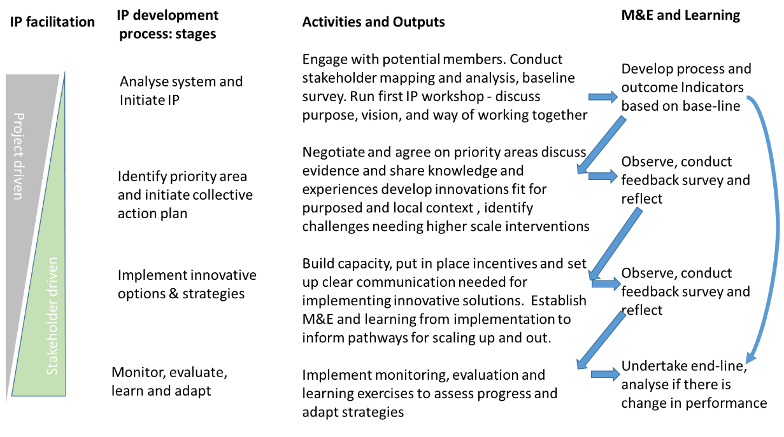
Figure 1. IP pilot establishment and progress
What will be required of participants?
The IP pilot will initially be organised and facilitated by the research team, with support from local industry and producer groups. The long term goal of a successful pilot is sustainability, with locally trained facilitators, and the IP being used as a tool to consider any relevant complex issues.
The pilot IP will meet no less than 4 times each year, with the pilots starting early 2018 and running for 18-24 months. The FMD RP finishes in 2020.
Locally based support is vital for the running of the pilot, including advice as to how to contact potential stakeholders and the best avenue for invitation and engagement. Logistical advice including workshop venue and seasonality of workshops is also needed for the successful establishment of a pilot.
What are the expected benefits for those who participate in the IP pilot?
The overall outcome for the sub-project is to enhance partnerships among stakeholders involved in surveillance for early detection of disease introduction and spread. This will facilitate fewer, less damaging and more readily controlled, outbreaks.
The expected benefits for those who take part in a pilot include:
- Devising new ways of recognising and promoting good surveillance and biosecurity practices carried out by all pilot participants
- Enhancing partnerships to devise and test possible innovative solutions to disease surveillance and animal health issues that are specific to local producer groups or regions
- Strengthening and expanding local networks to enable a stronger ‘local voice’ to engage in problem solving with a broader range of key people important to this issue. This may involve surveillance of endemic diseases such as foot rot, lice, or liver fluke, or emergency animal diseases such as foot and mouth disease
- Creating opportunities for better communication of animal health and disease management issues and solutions needing attention at local, state and/or national levels
Reading list
BOOGAARD, B., SCHUT, M., KLERKX, L., LEEUWIS, C., DUNCAN, A. & CULLEN, B. 2013. Critical issues for reflection when designingand implemeting Research for Development in Innovation Platforms. Report for the CGIAR Research Program in Integrated Systems for the Humid Tropics. The Netherlands.
Schut, M., Andersson, J. A., Dror, I., Kamanda, J., Sartas, M., Mur, R. & Velasco, C. 2017. Guidelines for Innovation Platforms in Agricultural Research for Development
TURNER, J. A., WILLIAMS, T., NICHOLAS, G., FOOTE, J., RIJSWIJK, K., BARNARD, T., BEECHENER, S. & HORITA, A. 2017. Triggering system innovation in agricultural innovation systems: Initial insights from a community for change in New Zealand. Outlook on Agriculture, 46, 125-130.

