# Information for decision-making to decrease waste leakage

## Developing data, information and decision-support tools to reduce waste and pollution.

### The challenge

### Plastic is lost into the environment through a myriad of pathways, ranging from intentional dumping to accidental loss. Interventions by government, industry, and institutions can be challenging due to a lack of consistent, reliable information to support responses.

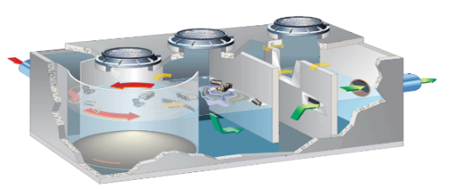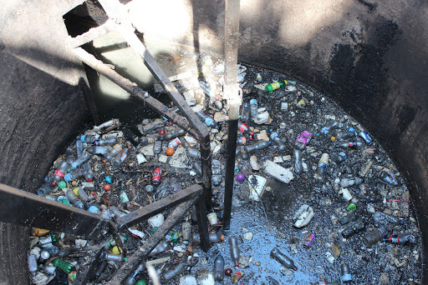

### Similarly, the variation in material types, availability, and flows through the supply chain inhibits innovation. Waste recyclers face contamination and variation in their waste streams, making efficient recovery, recycling and incineration difficult.

### Our response

### We have developed significant capability to measure plastic lost into the environment, and translate this data into actionable information. We integrate field data collection, geo-spatial analysis, statistical inference, and policy evaluation to provide support to decision-makers at scales from local government to international advisory bodies.

### Our expertise has helped set global standards for data collection and reporting. It supports standardised measurements that can assist in evaluating the impact and effectiveness of established and proposed decisions, ranging from new urban developments to shifts in economic incentives for recycling. We have worked in major urban areas across 14 countries to develop large scale monitoring systems that can inform responses to the growing pollution problem.

### We integrate sensor design, data processing and transmission, and evaluation of cost-effective responses to aid government and industry in making the most effective decisions possible with the resources available. An example includes working with the infrastructure industry to design an efficient system for collection of plastic waste from stormwater drains, a major source of plastic pollution entering the marine and freshwater environment.

The benefits

Our focus is on developing decision-support tools, underpinned by reliable and repeatable information that can assist partners in taking effective action to reduce plastic waste and increase interception of plastic that would otherwise end up as pollution in the environment.

### The integration of new, low-cost data collection methods, such as automated sensors, with analytical tools from machine learning and optimisation, will provide options for addressing waste and pollution, while generating new opportunities for Australian businesses and innovators.

As Australia’s national science agency   
and innovation catalyst, CSIRO is solving   
the greatest challenges through   
innovative science and technology.

For further information

CSIRO Oceans and Atmosphere

Denise Hardesty

+61 3 6232 5276

Denise.hardesty@csiro.au

csiro.au/plastics

Contact us

1300 363 400

+61 3 9545 2176

csiroenquiries@csiro.au

csiro.au