# Monitoring plastic pollution with AI

Australia’s National  
Science Agency

As part of our work to understand the sources, sinks and transport dynamics of plastic pollution from land to the ocean, we have developed machine learning and computer vision models in collaboration with Microsoft to monitor the flux and abundance of litter in rivers and stormwater drains.

### The power of AI

Machine learning and computer vision are subsets of artificial intelligence (AI) that allow computers to understand the content of digital images. We have leveraged on powerful Microsoft technologies such as Custom Vision and Azure Machine Learning to build our dataset and develop our workflow.

With cameras placed under bridges or on poles near waterways, we are able to detect and classify litter items that are floating on the surface. We can infer their abundance and distribution and inform waste managers and policy makers in their efforts to identify litter hotspots and develop safe, smart and less expensive waste management systems.

### Our data

Our dataset currently comprises of more than a million images from rivers and stormwater drains in Australia, the United Kingdom, Sri Lanka and Bangladesh.

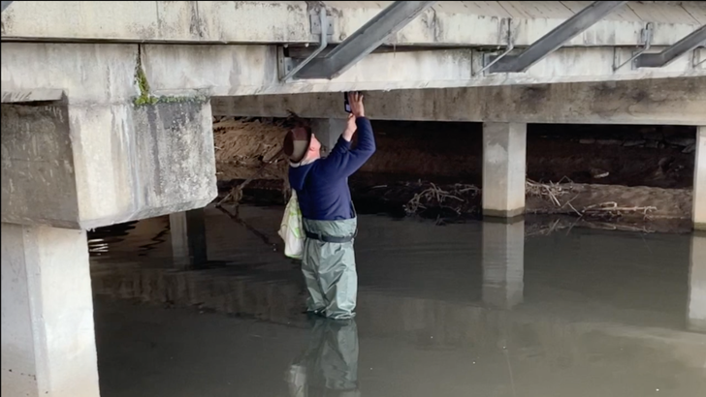 CSIRO researcher Chris Wilcox setting up a trail camera to monitor litter flux in a stormwater drain in Hobart.

From the images collected, we have labelled thousands of items across more than 30 categories and created a dataset that is unique in scope and size.

### Our models

### Litter comes in many different colours, shapes and sizes. To retain flexibility to monitor different river settings and maximise the transferability of our models to new locations, we have developed two different workflows to detect and identify litter items.

One workflow consists of a single object detection model, where all categories of litter are represented. The other consists of an object detection model followed by a classification model. These workflows are being optimised for IoT devices and will allow us to obtain litter counts in near-real time.

Example of near-real time object detection and classification.

Contact us

1300 363 400

+61 3 9545 2176

csiroenquiries@csiro.au

csiro.au

As Australia’s national science agency   
and innovation catalyst, CSIRO is solving   
the greatest challenges through   
innovative science and technology.

CSIRO. Unlocking a better future for everyone.

For further information

CSIRO Oceans and Atmosphere

Denise Hardesty

+61 3 6232 5276

Denise.hardesty@csiro.au

csiro.au/plastics

For further information

CSIRO Oceans & Atmosphere

Dr Britta Denise Hardesty

+61 3 6232 5276

denise.hardesty@csiro.au

research.csiro.au/marinedebris