AccuRate Thermal Comfort Version 1.2.3.23 Operation Notes

Dong Chen
July 2023

CSIRO Energy
Commonwealth Scientific and Industrial Research Organisation (CSIRO)
Private Bag 10, Clayton South, Victoria 3169, Australia

1. INSTALLING ACCURATE HOME THERMAL COMFORT V1.2.3.23
Please install AccuRate Home thermal comfort v1.2.3.23 under the C drive directly, for example in c:\AccuRateHomes_ThermalComfort_4Scratch\. If you use AccuRate for energy star rating, you may want to install this special versions of AccuRate in the same computer. Please following the instruction at the end of this document (the Appendix) for installing multiple AccuRate versions in the same computer.

It should be noted that this special AccuRate version can only work with scratch file generated by another NatHERS software, such as the commercial AccuRate Home, BERSpro, FR5, or HERO. It cannot be used for NatHERS energy star rating purpose.

2. RUN ACCURATE THE FIRST TIME
AccuRate can be run with the icon  at your desktop. Or you can double click AccuRate.exe to start AccuRate as shown below.
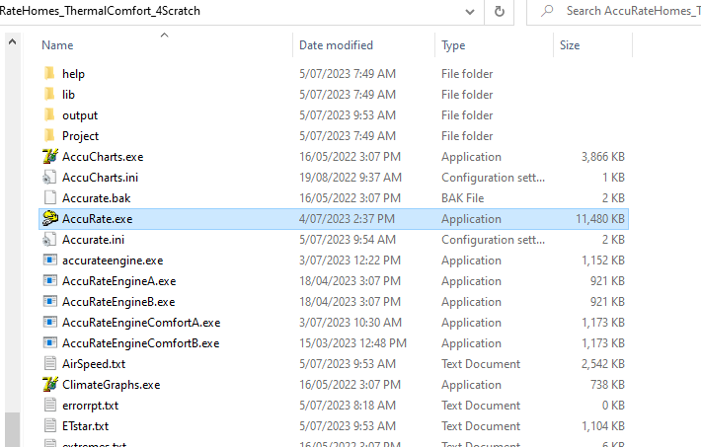
When you run AccuRate the first time after installation, there will be a pop-up window as below. It requires a License Code to unlock AccuRate. Please send me (Dong Chen at Email address: Dong.Chen@csiro.au ) the Machine ID as circulated below. I will send you the unlock code.

After unlocking AccuRate, please close AccuRate, the unlock code is saved automatically after AccuRate closes.

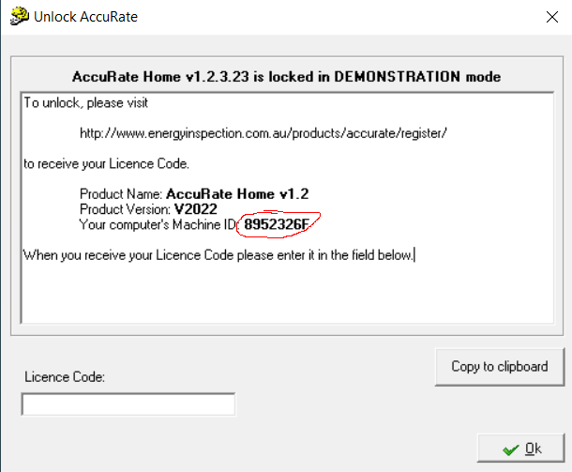

3. COPY SCRATCH FILE
After starting AccuRate, please use the left side bar Open Project button to open the 500Dummy.PRO project. This dummy project should be used for all your thermal comfort rating simulations.
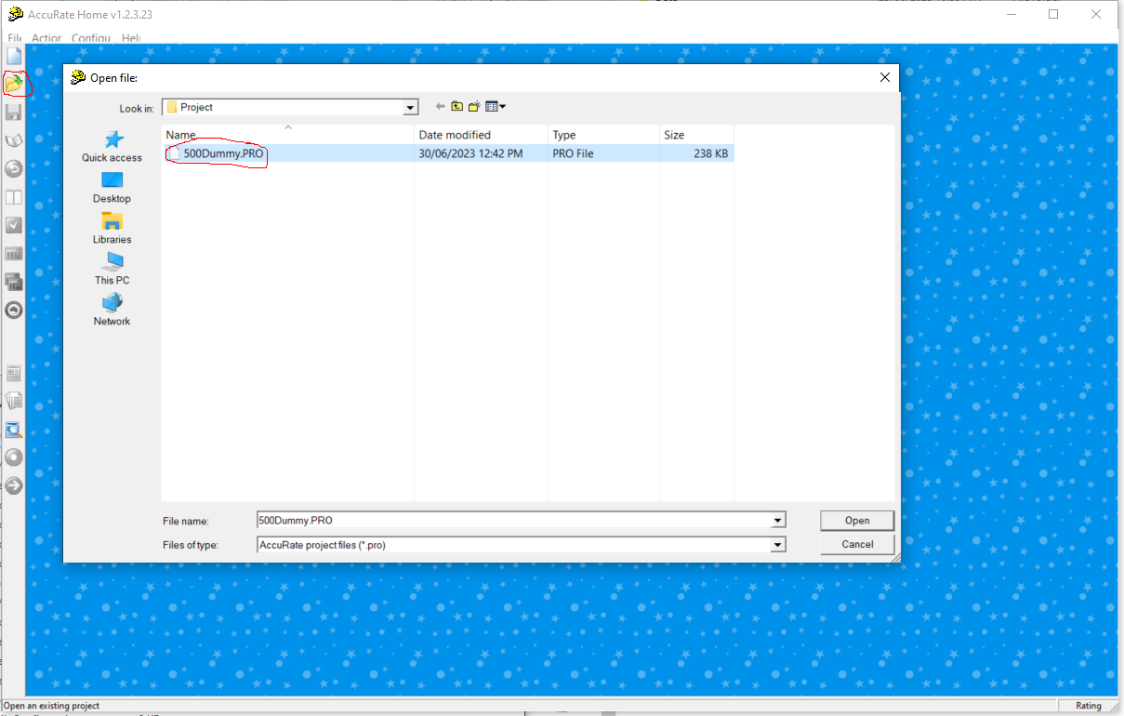
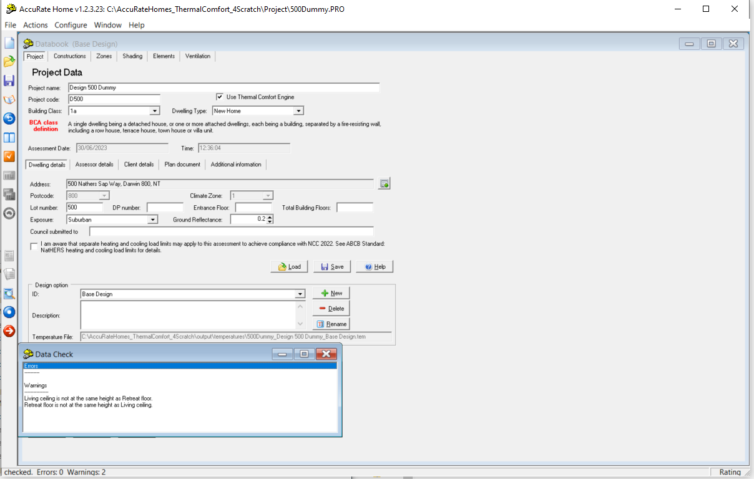
As mentioned in Section 1, this special AccuRate version can only work with scratch file generated by another NatHERS software, such as the commercial AccuRate Home, BERSpro, FR5, or HERO.

3.1 BERSpro User
After any BERSpro simulation, the scratch file of the latest BERSpro simulation is at the C:\Users\Public\Documents\BersPro44\BersData directory as shown at the right side File Explorer window below. Please copy the scratch file into the root directory of AccuRate Home Thermal Comfort as show by the arrow (if you use File Explorer, you can just click and drag).

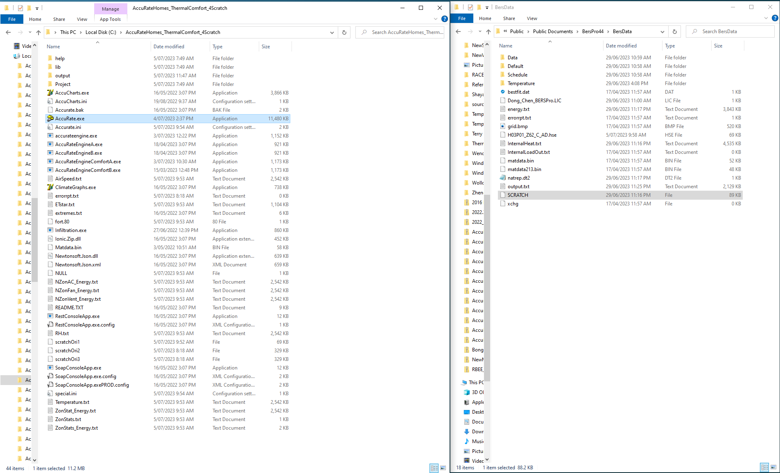

3.2 AccuRate User
If you use the scratch file from a commercial version of AccuRate, the scratch file is at the output directory of the commercial version of AccuRate, e.g. in
C:\AccuRateSustainabilityV2.4.3.21_Commercial-3\output\scratchs\.

Please copy the scratch file into the root directory of AccuRate Home Thermal Comfort as show by the arrow (if you use File Explorer, you can just click and drag).

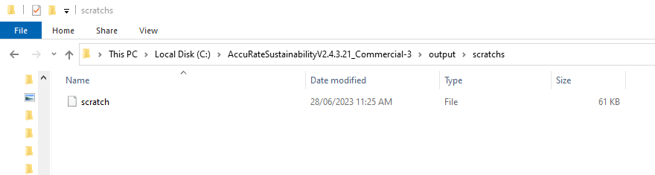

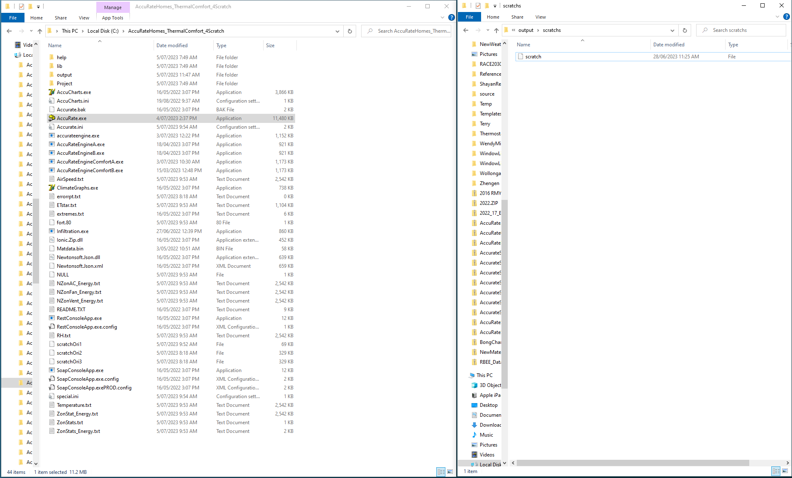
3.3 FR5 User
If you use the scratch file from FR5, the scratch file is under
C:\Users\yourname\AppData\Local\FirstRate5\calc\calc1.

Please copy the scratch file into the root directory of AccuRate Home Thermal Comfort as show by the arrow below (if you use File Explorer, you can just click and drag).

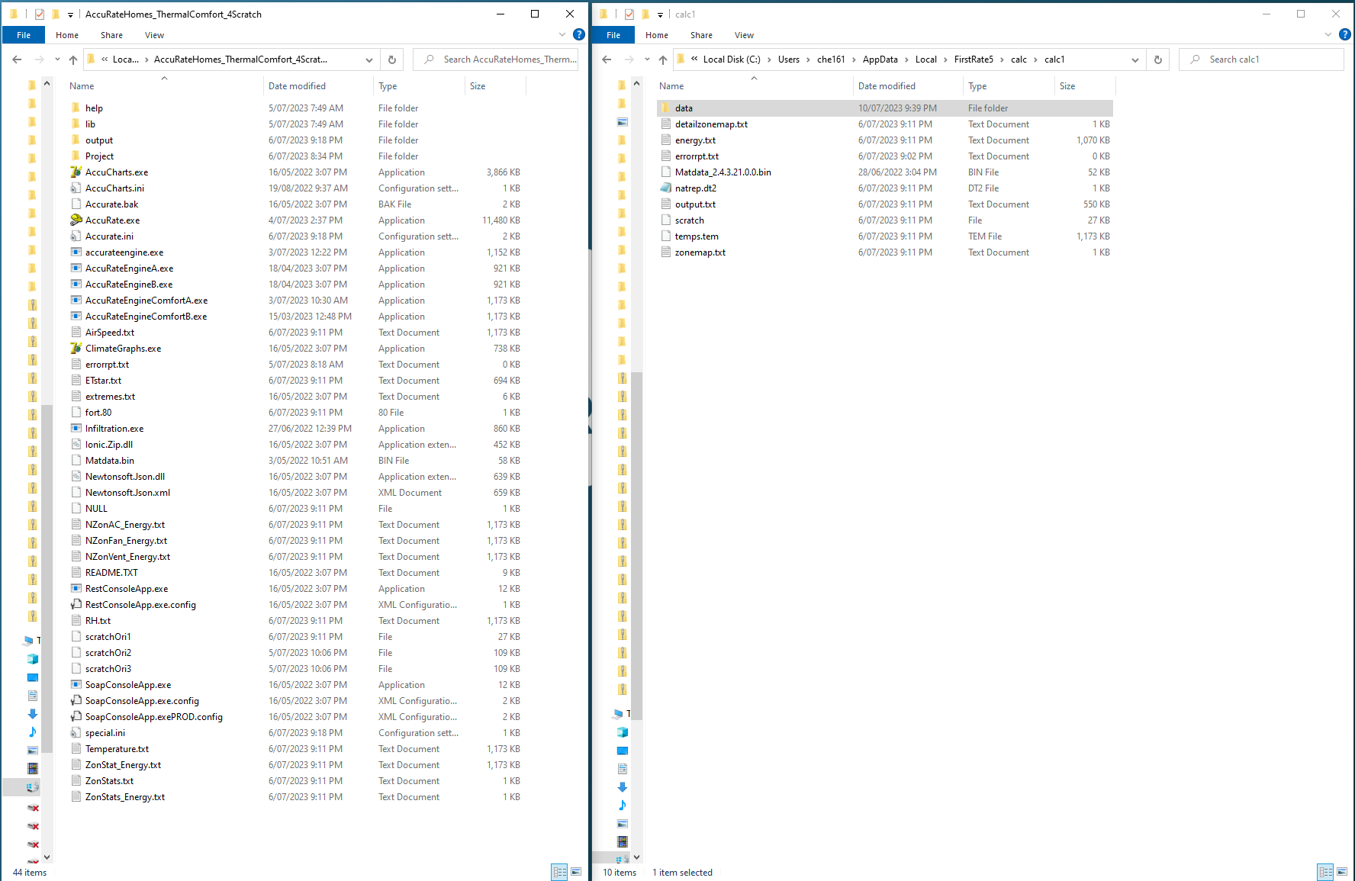

3.4 HERO User
If you use the scratch file from HERO, you need to untick the default setting which deletes the scratch file every time you run HERO simulation.
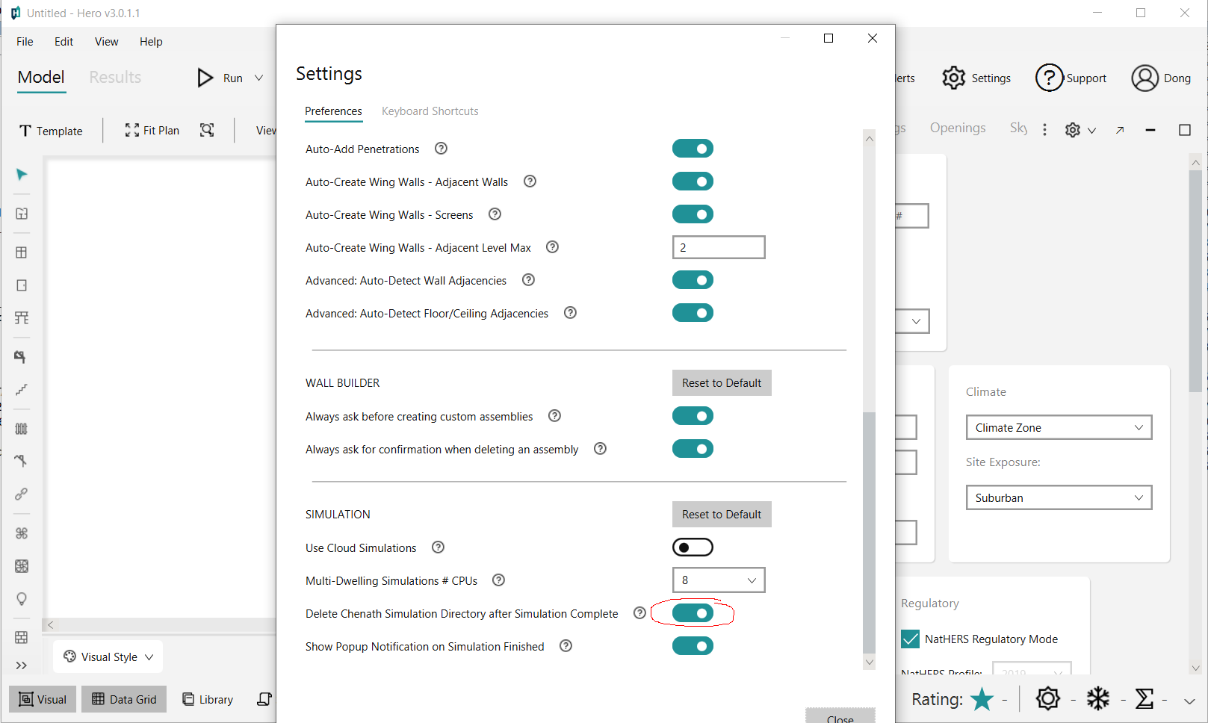

Now, after each simulation, there will be a directory created which has the latest scratch file inside. Please make sure the intended scratch file is in the latest directory created. Please copy the scratch file into the root directory of AccuRate Home Thermal Comfort as shown by the arrow below (if you use File Explorer, you can just click and drag).

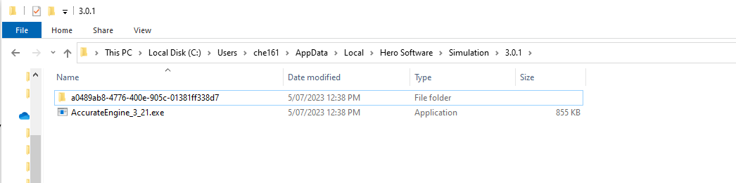

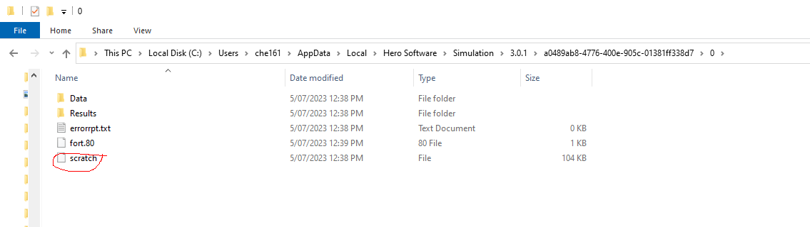

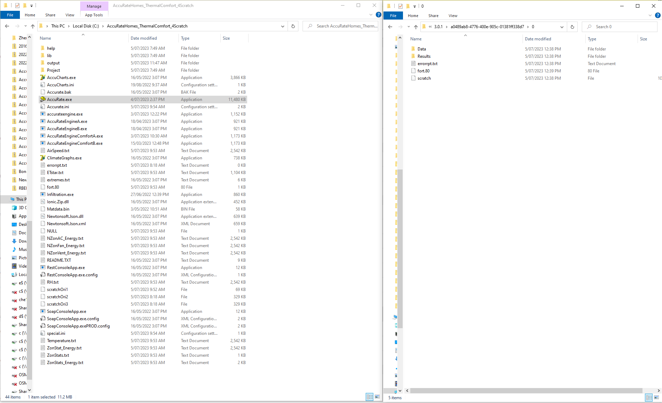

4. RUN ACCURATE THERMAL COMFORT
Now, the scratch file has been copied into the directory of the AccuRate Thermal Comfort version.

If you want to show the results to your client, you may want to change the address of the project via the Project|Dwelling Details|Dwelling Address Details by clicking the right button as shown below. This address will be shown in the Thermal Comfort Rating Certificate.

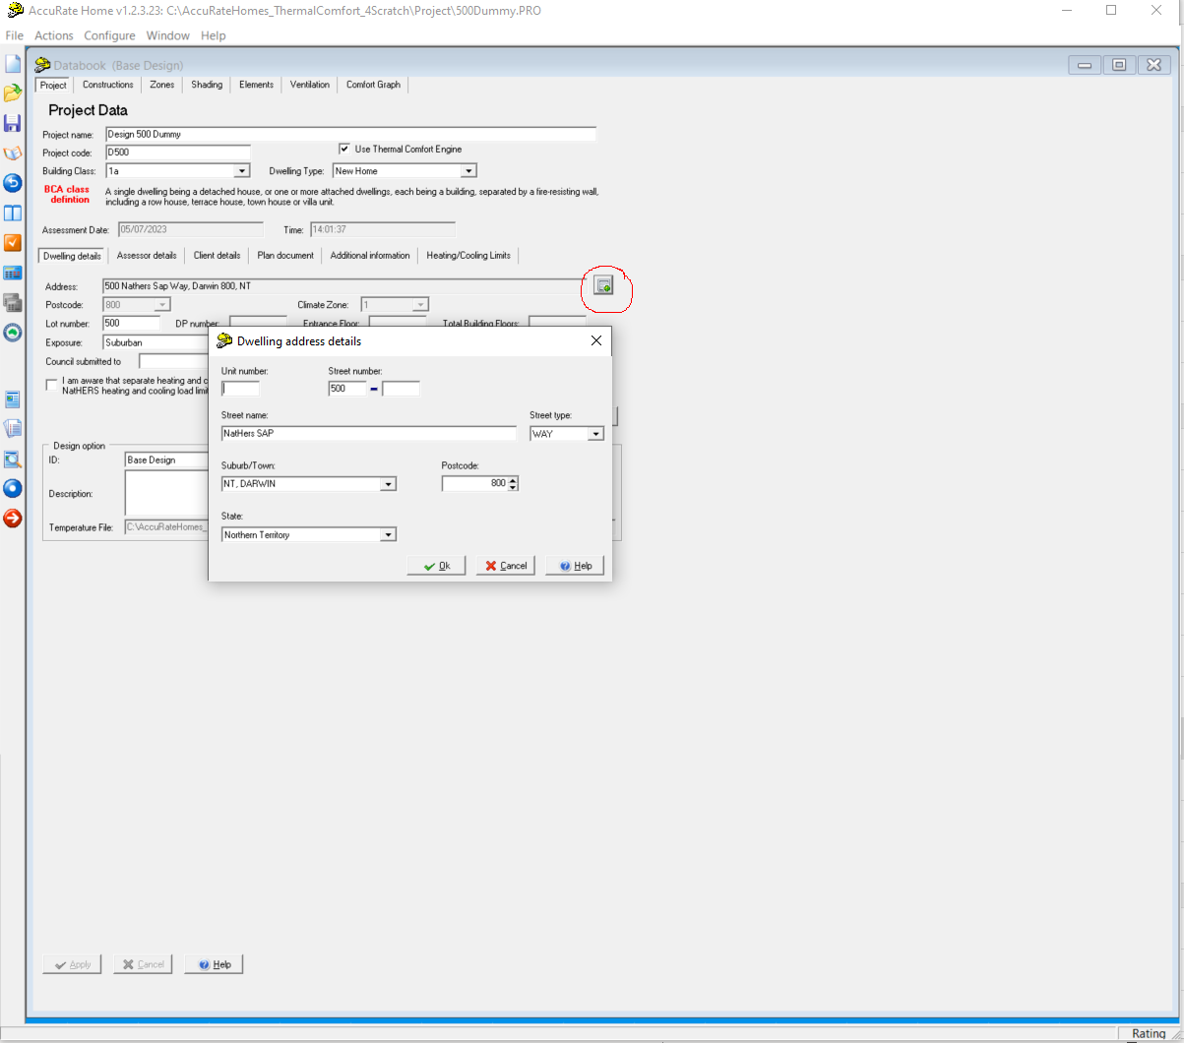
Now, please click the Check button (at the leftside bar of AccuRate as shown below) followed by the Simulation button just below the Check button to run the simulation.
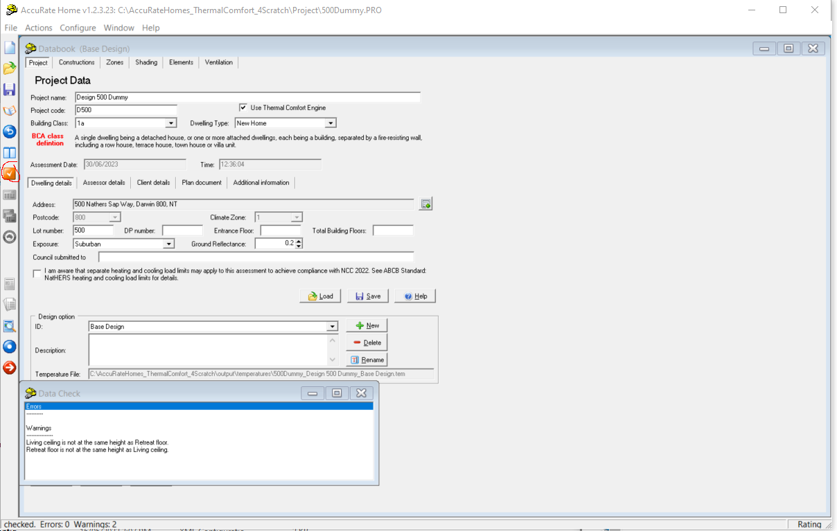

After the simulation run completed, the Comfort Graph page appears which has the thermal comfort information of the current design described in the scratch file.

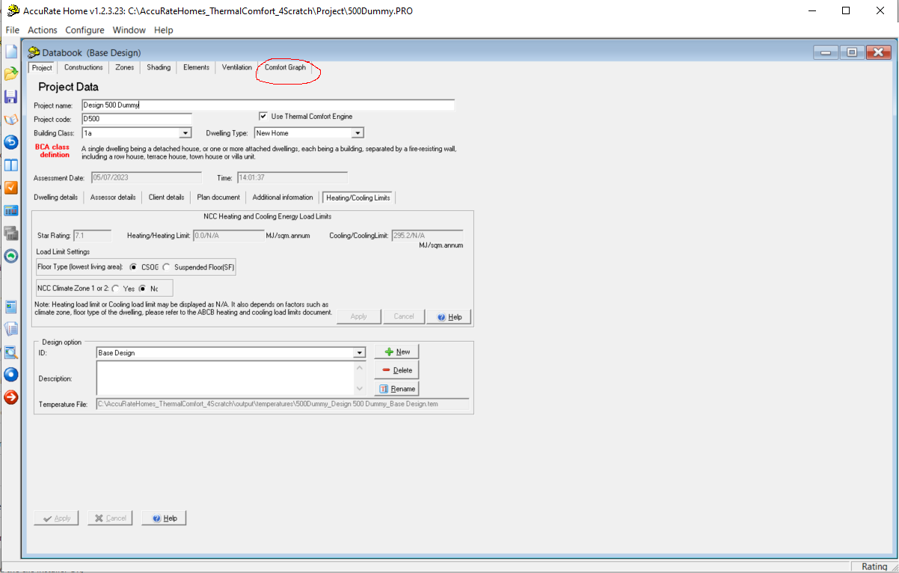

Now you can toggle through the Comfort Graph page to see the Comfort Rating Certificate, the individual room comfort rating plot, the percentage of comfort plot for occupied hours in a whole year and other related information.

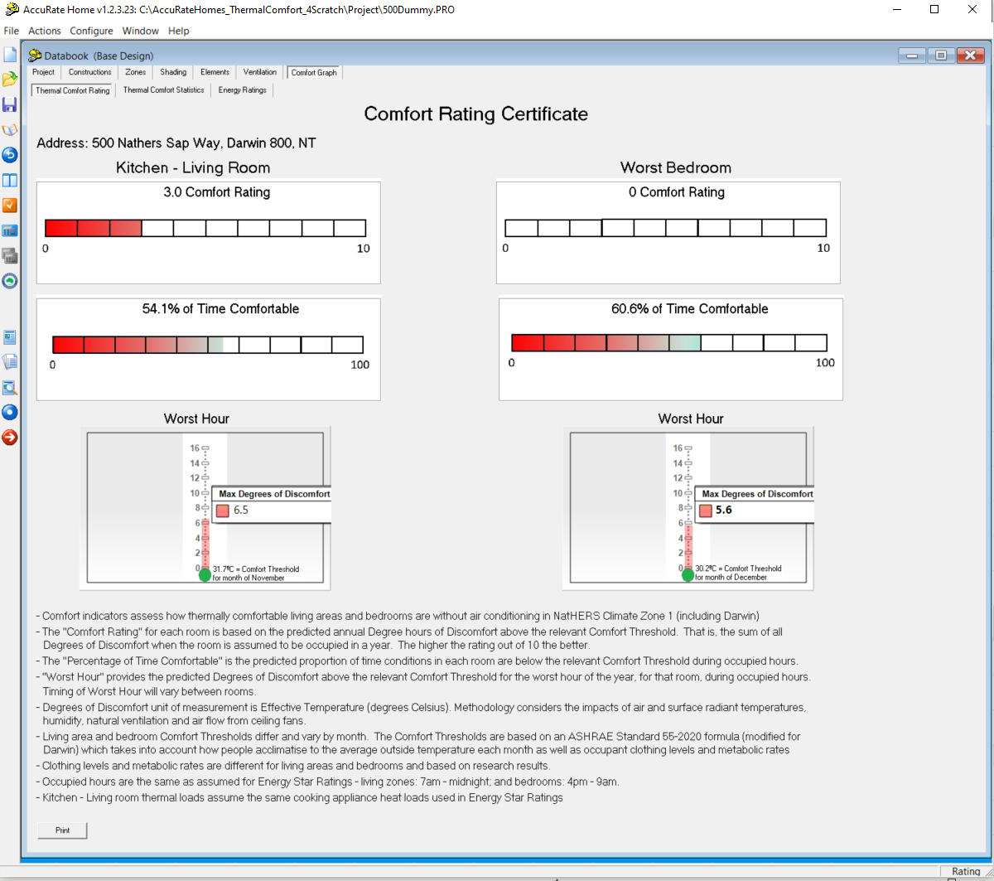

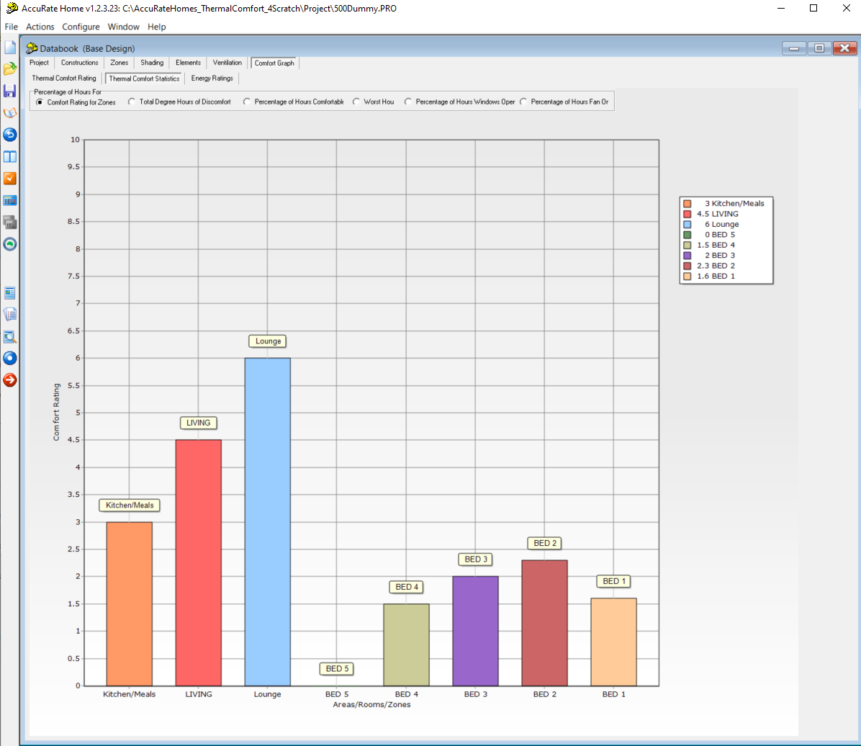
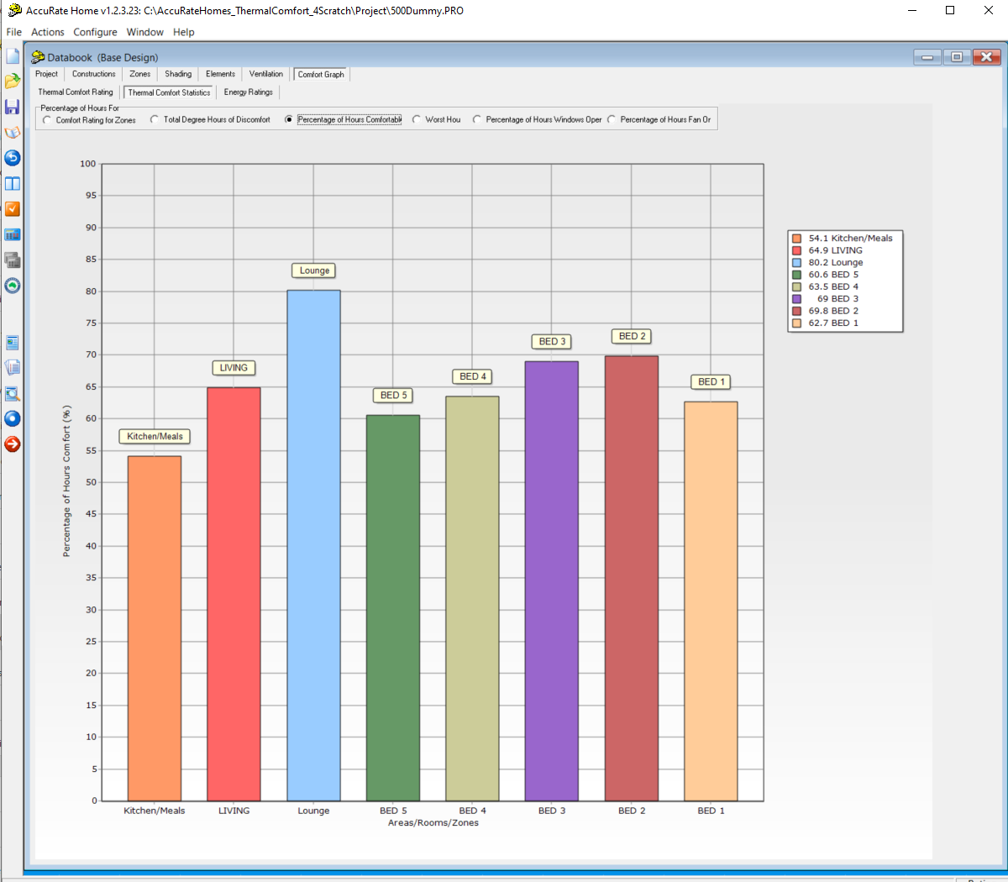

APPENDIX: Install Multiple Copies of AccuRate Sustainability in one Machine

You can install another copy of AccuRate Sustainability in your computer, in fact, multiple copies by the following procedure:

- Rename the original AccuRate or AccuRate Sustainability directory: say from c:\AccuRate to c:\AccuRateSustainabilityOld

- Uninstall the original version from the ControlPanel⏐ Programs to uninstall AccuRate Sustainability.

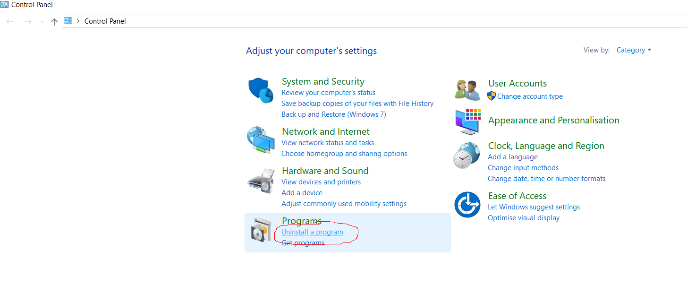

- Install the new AccuRate Sustainability in c:\AccuRateNew (Please make sure that the new directory name is different to the old AccuRate directory name) or in another directory (but not in c:\AccuRateSustainabilityOld and c:\AccuRate).

This does not remove the original copy. Now, you can rename your original directory name back to previous name (this is now required with AccuRateSustainability V2.3.3.13SP3 after). You can run both copies at the same time. Of course for safety, you should make a copy of the content in the original directory.

If there is any issue, please contact Dong Chen at Email: Dong.Chen@csiro.au

