Implementing Circular Economy Standards in the APEC Region
Guidance and Recommendations Report
April 2024

Acknowledgements
This report was produced by Standards Australia and CSIRO. The authors would like to acknowledge the support of the Australian Department of Foreign Affairs and Trade in the development of this report. The authors would also like to thank the participants of the surveys, workshops, interviews and case study videos, as well as reviewers (Dr Deborah Lau, Dr Andrea Walton, Ms Michaela Cosijn, and Dr Cathryn O’Sullivan) for their important insights and perspectives.

Standards Australia is an independent, non-government, not for profit organisation. We are the economy’s peak non-government standards development organisation.
The work of Standards Australia and our staff, stakeholders, members and contributors enhances Australia’s economic efficiency, international competitiveness and contributes to a safe and sustainable environment for all Australians.
Standards Australia’s vision is to be a global leader in trusted solutions that improve life – today and tomorrow.
As Australia’s science agency, we solve the greatest challenges through innovative science and technology.
We are thinkers, problem solvers, leaders. We blaze new trails of discovery. We aim to inspire the next generation.
We collaborate with industry, government, universities and research organisations to turn big ideas into disruptive solutions.
We use collaborative research to turn science into solutions for food security and quality; clean energy and resources; health and wellbeing; resilient and valuable environments; innovative industries; and a secure Australia and region.
We are creating a better future. We are CSIRO.

Table of Abbreviations
APEC Asia-Pacific Economic Cooperation
CSIRO Commonwealth Scientific and Industrial Research Organisation
DFAT Department of Foreign Affairs and Trade
DIN German Institute for Standardization
DKE DKE German Commission for Electrical, Electronic & Information Technologies
ISO International Organization for Standardization
OECD Organisation for Economic Co-operation and Development
SCSC Sub-Committee on Conformance and Standards
SDO Standards Development Organization
UN SDGs United Nations Sustainable Development Goals
UNEP United Nations Environment Programme
VDI Association of German Engineers

Executive summary
A circular economy presents a departure from the traditional linear economic model of take-make-waste, which has exacerbated global challenges such as breaching six out of nine planetary boundaries, including biodiversity loss and environmental pollution (Richardson et al. 2023). This alternative economic approach aims to sustain a continuous flow of resources by reclaiming, retaining, or enhancing their value, all while fostering sustainable development (ISO 2023a, ISO/DIS 590041). Moreover, a circular economy creates fresh economic prospects through novel materials, products, business models, value chains, and trade avenues. Given these potential benefits, there is significant interest among the Asia-Pacific Economic Cooperation (APEC) economies in transitioning towards a circular economy.
This project stems from the recommendations of the 13th APEC Sub-Committee on Conformance and Standards (SCSC) conference to share circular economy case studies and develop standards guidance for the APEC region. Funded by the Australian Department of Foreign Affairs and Trade (DFAT), Standards Australia implemented this project in collaboration with the Commonwealth Scientific and Industrial Research Organisation (CSIRO). The aim of the project is to increase the uptake of circular economy standards and participation in the circular economy in the APEC region by enhancing knowledge of good practice among standards and conformance bodies, regulatory agencies, businesses, and other relevant stakeholders. This project comprises five components implemented in 2023 and 2024:
- A desktop review of the standards and policy landscape for circular economy in APEC.
- A workshop to co-produce knowledge on the role of standards to support barriers, and recommendations to increase uptake of circular economy standards and practices.
- A pre- and a post-workshop survey to measure impacts of the previous two components.
- Interviews with experts involved in standards development and implementation to supplement the knowledge co-production at the workshop.
- Short videos produced by workshop participants to share case studies of standards being used to help drive circularity in the APEC region.
This report summarizes the key project findings.
Standards are important to society, the economy and environment for their many benefits, such as improving safety, reducing information asymmetry, promoting international trade and market access, fostering innovation, helping governments to pursue public policy objectives, and enabling economies of scale. There was consensus among the workshop and interview participants that standards are a key enabler of circular economy transition by:
- Setting foundational definitions and principles.
- Building and maintaining consumer trust.
- Ensuring minimum quality and safety of new products.
- Creating and strengthening markets for secondary materials.
- Enhancing enabling technologies for circular economy.
- Embedding circular economy principles in product design.
- Providing market access to new producers.

There is a growing collection of domestic and international standards relating to circular economy. Analyzing one of the most comprehensive global databases for standards relevant to circular economy revealed that there were 559 international standards relating to circular economy as of 2022. When mapped to the United Nations Environment Programme (UNEP) 9R framework, recycling was the most prominent category of standards relating to circular economy. The other higher order R-strategies such as reuse, repair, refurbish, remanufacture and repurpose had the lowest proportion of associated standards. When mapped to industries and products, electrotechnology and information and communications technology (ICT), construction and infrastructure, and plastics had relatively more circular economy standards developed compared to batteries, packaging, and textiles. These results highlight opportunities for which R-strategies and industries need to develop more circular economy standards.
During the workshop and interviews, participants identified barriers to the adoption of circular economy standards and participation in the circular economy in the APEC region. These barriers relate to: (1) standard gaps, development and access; (2) markets, value chains and labor; (3) policy and regulation; and (4) socio-cultural aspects (Figure 1). The participants also suggested recommendations for how key actors such as standards development organizations, industry, governments, and international/regional organizations can support a greater uptake of circular economy standards and practices (Figure 1). These recommendations tap into the diverse roles played by key actors in relation to standards development, application in industry and intersection with other governance tools such as policy and regulations. While standards are an important governance tool for driving desirable outcomes in society, there are other levers such as policy, regulation, investment and culture that also need to be activated appropriately and synergistically. As the APEC region contains great diversity in political, economic, social, cultural and environmental landscapes, it is understood that these recommendations need to consider the specific context of each economy and adapt to local nuances.
Survey results showed the project successfully raised participants’ awareness of international circular economy standards and how to incorporate circular practices into their economies. While the project addressed two of the identified recommendations, more ongoing investment in capacity building, policy harmonization, and the development of sector-specific guidance on circular economy standards and best practice is needed. The needs and challenges of the small and medium enterprise sector are also important to consider in future actions because they account for over 98% of enterprises in most APEC economies.

Figure 1. Barriers and recommendations to uptake of circular economy standards and practices perceived by the workshop and interview participants
Barriers
Standard gaps, development and access
- Lengthy standards development processes
- Limited access to standards
- Conflicting standards in other sectors
- Gaps in current standards
- Barriers to integrating latest scientific and technological advancement
- Uncertainty around data sharing practices for traceability
Markets, supply chains and labour
- Resource limitations of smaller economies
- Resource limitations of smaller enterprises
- Limited traceability and transparency within value chains
- Gaps in workforce capability relating to circular economy
Policy and regulation
- Gaps in circular economy policy and regulations
- Disparate data sharing, privacy, and traceability policy and regulations
- Regulatory burden for secondary materials
Socio-cultural and knowledge
- Limited coordination on circular economy transition
- Varying priorities, financial capabilities and regulatory landscapes among the APEC members
- Limited awareness of circular economy related standards
- Perceptions of competing sustainability objectives
- Cultures of mistrust and risk aversion

Recommendations
Industry
- Implement comprehensive value chain mapping
- Increase involvement in standards development
- Take leadership to influence greater adoption
Standard development organisations
- Increase micro, small and medium enterprise representation on technical committees
- Improve collaboration to integrate a system perspective
- Design standards based on principles
- Identify accelerated pathways among existing standards
- Develop interim economy-wide standards
- Complement other sustainability priorities and metrics
- Support capacity development efforts
Governments
- Ensure policy and regulatory coherence
- Increase participation in standards development committees
- Simplify and strengthen extended producer responsibility
- Develop comprehensive guidelines and roadmaps
- Embed in existing practices, guidelines, and systems
- Invest in capacity building of end users
- Monitor progress toward circular economy practices and incentivize adoption
International and Regional Organisations
- Facilitate best practice sharing
- Develop unified guidelines and roadmaps with flexibility to accommodate local context
- Monitor member economies’ progress

1. Introduction
To address environmental concerns and increasing pressures on natural resources, economies are beginning to turn to the circular economy model to mitigate climate change and address global environmental challenges such as biodiversity loss, waste, and pollution. Over the past century, widespread industrialization and population growth have led to corresponding surges in material extraction, consumption, and waste production. The amount of virgin resources mobilized between 2000 and 2015 already exceeds half of those extracted in the 20th century. The World Bank estimates that by 2050, global demand for virgin resources is expected to at least double again, while waste production is projected to increase by 70% to over 3 billion tonnes (Kaza et al. 2018; World Bank 2022). A circular economy represents an opportunity to rethink existing production and consumption models by designing out waste and pollution, keeping products and materials in use for as long as possible, and regenerating natural systems (Ellen MacArthur Foundation n.d.). A circular economy also creates fresh economic prospects through novel materials, products, business models, value chains, and trade avenues. Given these potential benefits, there is significant interest among the Asia-Pacific Economic Cooperation (APEC) economies in transitioning towards a circular economy.
This project stems from the recommendations of the 13th APEC Sub-Committee on Conformance and Standards (SCSC) conference to share circular economy case studies and develop standards guidance for the APEC region. Funded by the Australian Department of Foreign Affairs and Trade (DFAT), Standards Australia implemented this project in collaboration with the Commonwealth Scientific and Industrial Research Organisation (CSIRO). The aim of the project is to increase the uptake of circular economy standards and participation in the circular economy by enhancing knowledge of good practice among standards and conformance bodies, governments, businesses, and research organizations in the APEC region.
APEC is a regional economic forum established in 1989 to leverage the growing interdependence of the Asia-Pacific. APEC’s 21 members aim to create greater prosperity for the people of the region by promoting balanced, inclusive, sustainable, innovative and secure growth and by accelerating regional economic integration. The SCSC was established in 1994 to help reduce the negative effects that differing standards and conformance arrangements have on trade and investment flows in the Asia-Pacific region. A circular economy will create new trade and investment opportunities in the global value chain, where many APEC economies play important roles as suppliers and markets. Standards can play a significant role in the transition to a circular economy by creating a common framework, building trust in circular products and value chains, and providing guidance for circular business practices.
While there are currently several definitions, a circular economy can be broadly understood as an economic model that aims to redefine growth, focusing on positive society-wide benefits. The Ellen MacArthur Foundation defines circular economy as a system that entails gradually decoupling economic activity from the consumption of finite resources and designing waste out of the system. Underpinned by a transition to renewable energy sources, the circular model builds economic, natural, and social capital (Ellen MacArthur Foundation n.d.). Complementing this understanding, the Organisation for Economic Co-operation and Development (OECD) conceptualizes the circular economy into three different elements (McCarthy, Dellink and Bibas 2018):
- Narrowing resource flows through resource efficiency – Aiming for more efficient use of natural resources, materials, and products along the value chain;
- Slowing resource loops – Aiming for more durable products through eco-design and an increased lifetime through reuse and repair; and
- Closing resource loops – Aiming at minimizing raw material extraction and waste output through improved end-of-life sorting, treatment, and increased material recovery.
According to the current draft of the International Organization for Standardization standard (ISO/DIS 59004), developed by the Technical Committee on Circular Economy (TC 323), circular economy is defined as “an economic system that uses a systemic approach to maintain a circular flow of resources by recovering, retaining, or adding to their value, while contributing to sustainable development” (ISO 2023a). This foundational standard, along with complementary standards in the ISO 59000 series, is designed to harmonize the understanding of the circular economy and support its implementation and measurement (ISO 2023b).
This project contributes to the SCSC’s goals and recommendations to enhance the uptake of circular economy in the APEC region by implementing five components in 2023 and 2024:
- A desktop review of the standard and policy landscape for circular economy in APEC.
- A workshop to co-produce knowledge on standards’ roles to support, barriers and recommendations to increase the update of circular economy standards and practices.
- A pre- and a post-workshop survey to measure impacts of the previous two components.
- Interviews with experts involved in standards development and implementation to supplement the knowledge co-production at the workshop.
- Short videos produced by workshop participants to share case studies of standards being used to help drive circularity in the APEC region.
This report summarizes the key information distilled from these project components, organized by the main topics: ways in which standards support a circular economy transition (Section 2), existing international standards relevant to a circular economy (Section 3), the circular economy policy landscape in the APEC region (Section 4), barriers (Section 5), key actors (Section 6), and recommendations to increase the uptake of circular economy standards and practices (Section 7). Section 8 concludes the report, with the results from the surveys and methods included in the appendices.
2. Ways in which standards support a circular economy transition
Standards are important to society, economies and the environment for their many benefits – e.g., improving safety, reducing information asymmetry, promoting international trade and market access, reducing transaction costs, enhancing the interoperability of technologies and fostering innovation, helping governments to pursue public policy objectives, and enabling economies of scale (Yamaguchi 2021; Standards Australia 2012). International standards development organizations such as the International Organization for Standardization (ISO) are responsible for bringing together experts from industry, academia, government, and consumer groups to develop voluntary standards. ISO defines a standard as a “document established by consensus and approved by a recognized body, that provides, for common and repeated use, rules, guidelines or characteristics for activities or their results, aimed at the achievement of the optimum degree of order in a given context” (ISO 2004). Standards are a form of governance tool that is used to steer system level change such as circular economy transition (Flynn, Hacking and Xie 2019).
Circular economy transitions require a system scale shift in how materials move through our production and consumption systems and in global value chains (Barrie and Schröder 2022; Ellen MacArthur Foundation 2021). To achieve system scale shifts, enough stakeholders including governments, private sectors and consumers need to adopt the new regime based on new norms, practices and structures. A new regime involves the establishment of new definitions, principles, rules, practices, metrics, characteristics, and models, among others, for which standardization is one of the processes to build consensus around these new elements.
There was consensus among the workshop and interview participants that standards are a key enabler of circular economy transition. Participants’ perspectives on the various ways that standards support the circular economy transition are summarized below:
Set foundational definitions and principles. Standards are vital for the circular economy transition because they set agreed definitions and principles, and these are foundational components. Presently, circular economy means different things to different people. The ISO 59000 series provides a common framework for everyone to align their definition to achieve common understanding. Standards can also create universal guidelines for processes and practices such as those around data collection, life cycle analysis, and workflows. The knock-on benefits of having a critical mass adopting common processes and practices include greater ability to scale production and collaborate across networks and borders, and increased data comparability and sharing of information.
Build and maintain consumer trust. Standards empower consumers to distinguish between products and services based on environmental performance and reduce greenwashing through the creation of standards-based labeling schemes. Standards provide a mechanism for building transparency and accountability in a process and a label – key to engendering trust among consumers and everyone along the value chain. Standards set the rules for tracking and tracing materials and measuring the circularity of a product through a complex value chain. These rules ensure that labels have the same meaning and that underpinning information and processes are reliable.
Ensure minimum quality and safety of new products. Standards are used to ensure minimum quality and safety of secondary materials and new products made from refurbishment, repurposing, or from recycled content. As circular economy drives the use of secondary materials, manufacturers need certainty that these feedstocks meet the required purity and quality. Standards can also encourage responsible use of chemicals in products such as textiles, and these chemicals influence how the textiles can be reused, upcycled, and recycled. When introducing a new product, standards provide a trusted mechanism for regulators to ascertain that the product is safe to use.
“Existing standards are not adequate to address government’s and industry’s hesitation to introduce a new product when there is no way of proving that the quality is going to be safe for people. Standards are particularly important for products that are used for food or when it comes to items that have an aspect of safety. To be able to scale up the production of those products, there needs to be enough volume at the right quality.”
Participant 15 works with plastic innovation in Southeast Asia
Create and strengthen markets for secondary materials. Standards help create new markets and drive demand for secondary raw materials by establishing quality and performance criteria that increase consumer confidence in conforming materials and processes. Standards can be used to level the playing field for secondary materials against virgin materials by providing a mechanism for the resource recovery sector to show that their products have the same quality as virgin materials.
Enhance enabling technologies for circular economy. Standards enhance the interoperability of existing enabling technologies (e.g., blockchain, Internet of Things) to support new circular business models and circular value chains where materials loops are narrowed and closed.
Embed circular economy principles. Standards are seen as an important tool to embed circular economy principles in product design and to close material loops. Standards can be used to popularize circular design such as making a product more durable and easier to repair, refurbish, repurpose, recycle, or compost. These pathways help to close material loops of the production and consumption in our economy.
Provide market access to new producers. Standards can provide access to markets that producers would not normally have access to, and therefore facilitate international trade and build new value chains aligned with the circular economy transition. For example, businesses trading with verifiably sustainable fiber standards for textiles are given access to global markets that unsustainable fibers would not normally have access to. Standards can be used to disseminate circular economy requirements to help small and medium enterprises gain access to markets that demand circular products and services and increase resource efficiency. Standards and certification can also help businesses to differentiate their products on the shelf, and commercial opportunities can incentivize industries to adopt standards.

3. Circular economy related international standards
The existing international standards related to circular economy were mapped based on a global dataset curated by the German Institute for Standardization (DIN), the DKE German Commission for Electrical, Electronic & Information Technologies (DKE), and the Association of German Engineers (VDI) in 2022 (DIN, DKE and VDI 2023). One of the most comprehensive databases of standards relevant to circular economy in the world, it was generated from a broad-based search covering 280 sets of rules with over 700,000 current references to scan for existing standards relevant to circular economy. Standards Australia filtered the database for international standards, which totaled 559 (Table 1). ISO has developed the most (259) international standards related to circular economy, more than three times as many standards as produced by other standards development organisations.
Table 1. List of organizations that developed circular economy related standards
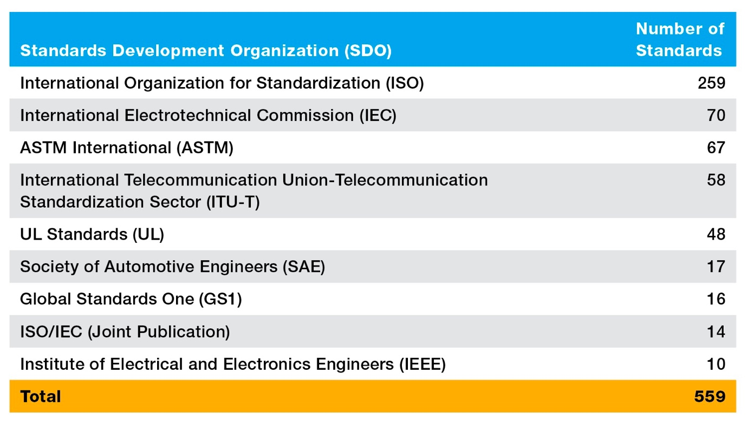
Circular economy related standards and the 9R framework
The standards in this global dataset were classified into the 9R framework of the United Nations Environment Programme (UNEP 2019 based on Potting et al. 2017) by a panel of standards experts. Researchers have proposed other frameworks to organize an increasing number of standards relating to circular economy (examples, Avila-Gutierrez et al. 2019; Pumsleitner 2020; Reslan et al. 2022; Weissinger 2022). Among these classification schemes, the 9Rs framework is a widely recognized conceptual model based on keeping materials in use at their highest value for as long as possible. It follows a prioritized hierarchy, starting from strategies with high circularity (associated with a lower “R” number, such as “Refuse”, “Rethink” and “Repair”) and descending to those with lower circularity (corresponding to a higher “R” number, such as “Recycle” and “Recover”). As an example, repairing a broken laptop is favored over recycling it, as repair not only extends the product lifespan but also conserves the energy that would otherwise be expended in the recycling process.

Figure 2. Circular economy related standards categorised by the 9R strategy
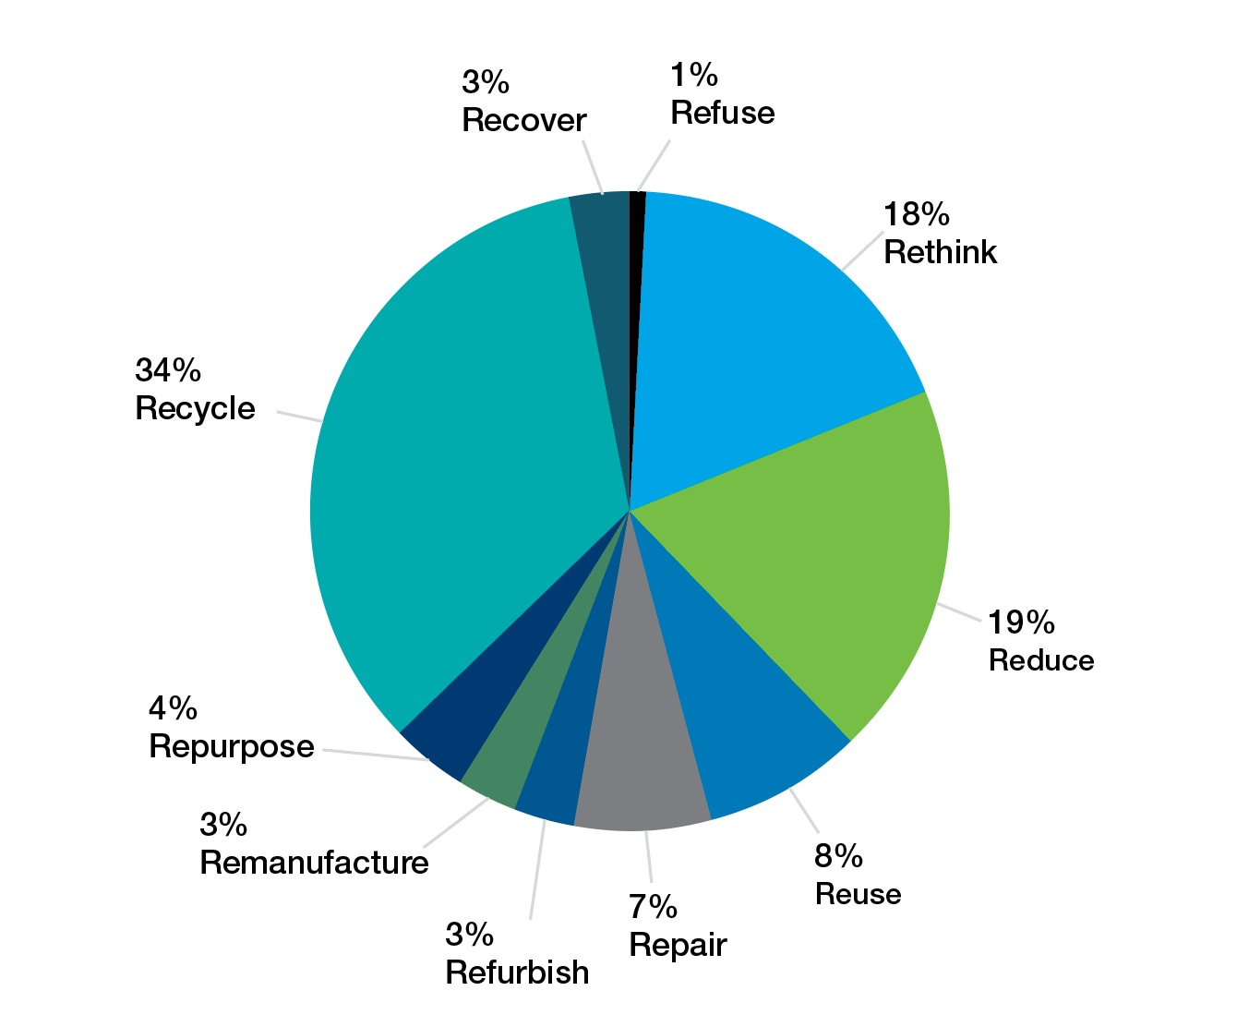
Source: Prepared by analysing dataset from DIN, DKE, VDI (2023).
Recycling is the most prominent category of standards (34%) relating to circular economy (Figure 2) when mapping these standards to the 9R framework. The results reflect a focus on waste management and recycling in earlier circular economy policies and strategies. Only 208 of the 559 circular economy related standards were categorized into the 9R strategies. The other higher order R-strategies such as reuse (8%), repair (7%), refurbish (3%), remanufacture (3%), and repurpose (4%) have the lowest proportion of standards associated with them. An example of a reuse standard is SAE J2997 – Standards for Battery Secondary Use, which standardizes the testing and identification of batteries for safe reuse. Standards for these R-strategies may be more complex to implement than those in the lower order because they require more transformative changes in material, product design and production, and along the value chain. While these strategies are essential for achieving a circular economy, the data suggests that the higher order R-strategies have been less emphasized in standards development, which highlights an opportunity to develop more standards in these areas. The relatively higher percentages of standards corresponding to rethink and reduce strategies can be a sign that understanding of circular economy is expanding beyond recycling.

Circular economy related standards for products and sectors
Of the 559 circular economy related standards, 389 standards (70%) were related to one or more of the following products or sectors: batteries, electrotechnology and ICT, packaging, plastics, textiles, and construction and infrastructure (Figure 3). It is unclear how standards relating to organic materials such as wastewater and agricultural by-products are categorized in this classification scheme. It is also worth noting that the total number of categorized standards (514) exceeds the total count of unique standards (389), which indicates that many standards apply to multiple industries and sectors, reflecting the interrelated and cross-cutting nature of these topic areas. The varying number of standards across products and sectors could also indicate that some industries have been progressing towards a circular economy for longer periods of time.
Figure 3. Circular economy related standards by product or sector
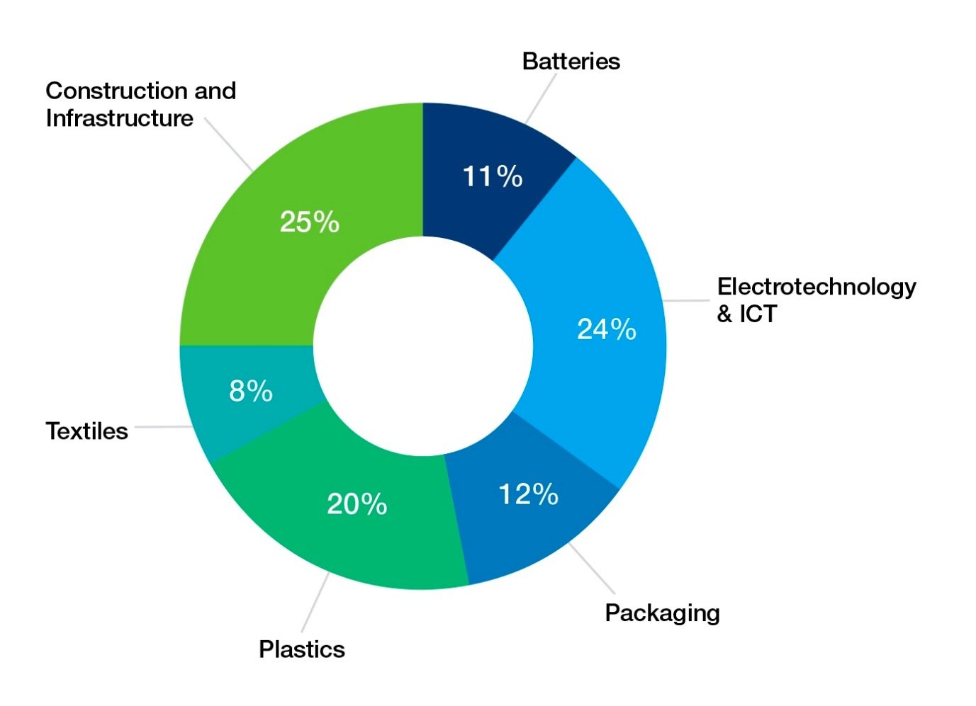
Source: Prepared by analysing dataset from DIN, DKE, VDI (2023).
Some circular economy standards are not specific to a product or sector but relate to a management system or a circular economy broadly. The OECD noted two broad approaches that circular economy related standards can take: 1) standardizing the organizational and management aspects of a circular economy; and 2) standardizing products that serve towards circular economy objectives (Yamaguchi 2021). Indeed, there are 263 international standards in this dataset not specific to a sector, but about digitization, business models and management aspects of circular economy. Weissinger (2022) pointed out the importance of standards relating to the circular economy system as these standards influence system-wide changes and provide guidance for overarching policy decisions, system design, and macro-level strategies that promote the shift from a linear to a circular economy. Furthermore, standards are only one of many governance tools for driving a just transition to the circular economy. Other governance tools such as policy and regulation also need to be activated appropriately and synergistically to drive desirable outcomes.
4. Circular economy policy in the APEC region
Domestic circular economy policy has been emerging in the APEC region for two decades, and this landscape is changing rapidly. We reviewed domestic circular economy and related policy among APEC economies using the data from circulareconomy.earth developed by Chatham House (Chatham House 2023). We assessed which policy instruments exist related to circular economy in the APEC region and the extent to which they are used by governments to enable the transition to a circular economy. It should be noted that the circulareconomy.earth database is illustrative and does not include an exhaustive list of policies. The review of the circular economy related policy within APEC economies showed that 60% of policies related to waste management while only 3% were fiscal policies (Table 2).
Table 2. Categorization of policy instruments related to circular economy in the APEC region

Policy Type: Domestic circular economy policy
Description: Includes any domestic circular economy policies already in place as well as domestic green growth or sustainable development strategies which integrate circular economy principles.
Examples:
- Circular Economy Promotion Act, China (2009)
- Framework Act on Resource Circulation, Republic of Korea (2016)
- Roadmap for a Circular Chile by 2040, Chile (2021)
Database coverage: 27%

Policy Type: Extended producer responsibility policy
Description: Relates to policies that place the responsibility for the environmental impacts of products throughout the product life cycle onto producers and is often applied to the collection, processing, and re-utilization of waste.
Examples:
- National Television and Computer Recycling Scheme, Australia (2011)
- Extended Producer Responsibility Act of 2022, Philippines
Database coverage: 10%

Policy Type: Waste management and recycling policy
Description: Covers policies that encourage circular practices relating to the management of waste covering generation, segregation, transfer, sorting, treatment, recovery, and disposal.
Examples:
- National Strategy on Integrated Solid Waste Management up to 2025, with a vision to 2050, Viet Nam (updated 2018)
- National Plastic Waste Reduction Strategic Actions for Indonesia (2020)
- Aotearoa New Zealand Waste Strategy (2023)
Database coverage: 60%

Policy Type: Fiscal policy
Description: Includes government tax and spending policies that incentivizes circular practices.
Examples:
- Excise Duty on Plastic Imports, Brunei Darussalam (2023)
Database coverage: 3%

Source: This table was prepared based on the data from circulareconomy.earth.
The review of policy instruments supports previous findings (Kalmykova et al. 2018) that downstream efforts, such as waste and resource management, are usually the first areas to be addressed in domestic policy efforts (OECD 2020). This is also true for the APEC region. Unless incorporated into broader circular economy policy strategy, waste and recycling policies often align with a more linear view of the waste hierarchy, which prioritizes waste management over upstream preventive action (Hartley et al. 2020). Experts have identified significant regulatory barriers in this area that can prevent the circular transition, for example, classifications of used products or materials as waste rather than a potential secondary resource. By ensuring that domestic waste policies are aligned with broader circular economy frameworks, APEC economies have the opportunity to realize numerous benefits. For example, the associated benefits of encouraging the use of secondary raw materials include reduced resource extraction and less dependency on raw material imports.
As circular economy concepts have become more familiar among policymakers, the number of domestic circular economy policies, strategies, and frameworks has increased (Reike et al. 2018). According to data from Chatham House, as of 2022, there were 19 domestic circular economy policies (including green growth or sustainable development strategies which integrate circular economy principles) within the APEC region (Chatham House 2023). As the transition to a circular economy requires innovation, engagement, and involvement from all actors across an economy (Ellen MacArthur Foundation 2021), implementing domestic circular economy policies and roadmaps can play an important role in creating a shared and aligned vision across industries and sectors.
A shift towards preventive measures such as extended producer responsibility (EPR) policies is occurring. By holding producers accountable for the full lifecycle of their products, EPR policies encourage more sustainable product design and manufacturing processes, which can help to reduce waste at the source. For example, Australia’s clothing sector has recently shifted in this space with a National Clothing Product Stewardship Scheme, an industry-led, voluntary scheme that is partly funded by the Australian Government. The Scheme includes a voluntary producer levy that is reinvested in strategies to minimize the impact and recover resources from textiles and clothing (Australian Fashion Council 2024).
The lower coverage of reported fiscal policies offers the opportunity for APEC economies to expand their policy efforts in this area. Fiscal policies can encourage more circular behavior by adjusting economic incentives for businesses and consumers. For example, in 2020, the Thailand Board of Investment reported that local and international companies invested USD $1.7 billion in the first nine months of 2020, which funded more than 300 projects listed as Bio-Circular-Green (BCG) economic activities (Thailand Board of Investment 2020). A key factor driving this success has been Thailand’s fiscal policy. Numerous tax cuts are offered to companies engaged in green and sustainable industries. Non-tax incentives also play a significant role, such as the provision of renewable smart visas, which allow international talents and investors to work and stay in Thailand for up to four years.
5. Barriers to the uptake of circular economy standards and practices
For standards to drive change, they need to be adopted and implemented broadly. As with any transformative change, adoption and implementation of new practices and systems are not straightforward. During the workshop and interviews, participants identified multiple barriers to implementing circular economy related standards and adopting circular economy practices within the APEC region. These barriers related to:
- Standards gaps, development and access
- Markets, value chains and labor capability
- Policy and regulations
- Socio-cultural aspects.
Standards gaps, development and access
These include barriers around the development of standards, access to standards, identification of potentially conflicting standards, and gaps in current standards.
- Standards development processes: While participants noted that standards development processes were necessarily complex and lengthy to ensure that the final documents were comprehensive and accurate, this was identified as a barrier. In contrast to the rapidly developing nature of circular economy plans and strategies from government and business to drive action, standards development processes are quite lengthy, making it difficult to take advantage of the latest scientific and technological advancements that support circular economy processes.
- Access to standards: The cost of accessing standards was identified as disproportionately affecting small to medium enterprises (SMEs), which account for over 98% of enterprises in most APEC economies (Hredzak 2020). Access challenges create a barrier to the ability of SMEs to implement relevant standards. It was noted that some standard development bodies (e.g., ISO) were considering the cost structures for public interest standards. The cost of accessing standards was noted to have potentially adverse consequences due to some businesses buying the cheapest possible standard offered internationally.
- Conflicting standards: Standards in other jurisdictions or sectors may hinder the adoption of circular economy standards. For example, food safety standards may limit the use of recycled materials in packaging or have unintended consequences such as increased food loss and waste (due to risk-averse business decisions to avoid potential contamination). This was also identified as a barrier to experimentation and innovation, where these standards may limit the proportion of secondary materials that can be reused, as opposed to technical or economic feasibility. The development of multiple standards by different organizations was also seen as a barrier to implementation because misalignments in these standards require additional time and resources to harmonize and create higher risk perceptions for industry adoption if it is unclear how the standards align.
- Gaps in current standards: Relevant standards may exist internationally but may not be accessible or applicable to all economies. Additional information may be needed in translating standards to support standards adoption in specific economies and contexts. For example, there is a lack of standards for international traceability systems and digital product passports, such as what data should be included, how it should be captured, and who should have access to the data. This makes it difficult to aggregate and capture data across different stages and stakeholders within the value chain.
Markets, value chains and labor
Barriers to circular economy standard adoption due to economic development or enterprise size, and infrastructure and labor force limitations.
- Size of economy: Smaller or less developed economies may face greater challenges due to limitations in resources and infrastructure. Additionally, the market size and perceived business benefits or risks of transitioning to a circular economy can vary widely. In cases where businesses do not see immediate economic benefits, there is often resistance or slow adoption of circular practices due to limited resources. These economies may lack the necessary financial, technological, and human resources to invest in and drive the transition towards a circular economy. For instance, investing in recycling infrastructure, eco-friendly manufacturing processes, or renewable energy sources can be prohibitively expensive for smaller economies.
- Enterprise size: Many businesses, particularly micro, small, and medium enterprises (MSMEs), operate under the pressure of short-term financial performance and shareholder expectations, which can lead them to prioritize immediate profit over long-term sustainability. Consideration of the SME sector is essential in the APEC region because they account for over 98% of enterprises in most of the APEC economies (Hredzak 2020). In markets where demand for circular products is low or the cost of circular practices is high, businesses may be less inclined to adopt circular models. In larger markets, the adoption of circular practices can be driven by consumer demand, regulatory pressure, and the potential for significant cost savings and economies of scale. However, in smaller markets, these drivers may be less pronounced, and the path to circularity may not be as clear or compelling.
- Traceability and transparency within value chains: Many existing systems lack the necessary infrastructure and processes to effectively track and manage the lifecycle of products and materials. This infrastructure gap makes it challenging to trace the flow of materials and products throughout their lifecycle. In a circular economy, where the goal is to maximize the use and value of resources, the ability to follow a product from cradle to grave is essential. Without this capability, identifying opportunities for reuse, repair, recycling, or remanufacturing becomes difficult and challenges transparency in value chains. Effective traceability requires not only the capture of information at various stages of the value chain but also the ability to share and analyze this data to inform decisions about resource utilization, waste reduction, and product design.
- Workforce upskilling: Participants noted that transitioning to a circular economy requires a new set of skills and knowledge base, which are not always readily available in the existing labor market, thus slowing the development and implementation of effective circular economy practices.
Case study: Challenges facing circular plastics use in Thailand
The plastics industry is a priority sector for the circular economy in Thailand due to ocean plastic pollution. Approximately 30% of industry is involved in the auto part manufacturing sector, which creates plastic and rubber waste. There are two major barriers to returning recycled materials into the manufacturing sector: technology and workforce skills. Technology is needed to understand how to recycle, reuse and repurpose materials, as well as the infrastructure needed to support material collection and sorting. The current workforce also requires new skills in terms of the knowledge required to develop these new circular systems, how to align these processes to circular economy principles, and how to apply circular economy standards to support new business models.
Policy and regulation
These barriers include elements of policies and/or regulations that increase the complexity faced by economies or industries to adopt circular economy standards.
- Policy and regulation gaps: Gaps in circular economy policy and regulations in some economies were flagged as slowing the transition to a circular economy. Other participants noted the inconsistency and lack of harmonization of circular economy policies and regulations across different jurisdictions (e.g., economy-level, state/territory/province, and local government) or across different sectors (e.g., waste management, primary industries, health) as a key barrier.
- Data sharing, privacy, and traceability systems: Different economies and regions have varying policy instruments related to data sharing and privacy, which can complicate the implementation of standardized traceability systems. This creates a complex regulatory environment for organizations operating in multiple jurisdictions, which must navigate these varied requirements while trying to maintain efficient and transparent value chains.
- Regulatory burden for secondary materials: Some participants noted that current regulatory frameworks place an excessive burden on secondary materials and reduce their competitiveness with virgin materials.
Socio-cultural barriers
These include barriers relating to differences in knowledge, attitudes, backgrounds, norms, beliefs and/or practices by individuals or organizations.
- Limited coordination on circular economy transition: Governments and industry have to balance short-term economic growth objectives with the pursuit of long-term sustainability. The situation is further complicated by the varying priorities, financial capabilities, and regulatory landscapes that exist among APEC members. These variances can result in uneven, inefficient, and conflicting understanding and application of circular economy principles and practices throughout the region. This highlights the urgent need for a cohesive strategy that recognizes and adapts to the diverse economic, environmental and cultural contexts of the APEC member economies.
- Limited awareness of standards: Limited awareness and visibility of existing standards created feelings of uncertainty and inconsistency among stakeholders, significantly hampering their ability to uniformly apply circular economy standards and principles across different regions and sectors.
- Perceptions of competing sustainability objectives: The relationships between circular economy standards and other sustainability goals (e.g., net zero targets for greenhouse gas emissions) were unclear, and participants noted that this may reduce the uptake of circular economy standards.
- Cultures of mistrust and risk aversion: Some stakeholders noted that industry competitors may be unwilling to share information or data to support circular economy standards uptake if there was a perceived risk that they would lose a business advantage. A risk-averse culture was also noted to create adverse consequences and act as a barrier to circular economy standards uptake, through behaviors such as choosing to avoid the risk of not meeting a standard (for example, creating large amounts of food waste to meet food safety standards, rather than assessing levels of spoilage).
While there are many identified barriers to implementing circular economy related standards and adopting circular economy practices within the APEC region, these barriers are not insurmountable. With optimism, participants of the workshop and interviews also provided suggestions on who can play a key role to overcome these barriers and the types of actions these players can take. These ideas are presented in the next two sections.
6. Key actors and their roles to support a circular economy transition
Participants at the workshop identified four key actors playing pivotal roles in increasing the uptake of circular economy related standards. Industry, standards development organizations, governments, and international/regional organizations play a variety of roles in relation to standards development and application, other governance instruments that intersect with standards, international and regional cooperation, and processes and structures in the economy. These aspects are integral to the circular economy transition and are summarized below for each key actor.
Industry
As primary producers and consumers of resources, industry plays a pivotal role in shaping sustainable business practices and encouraging the transition to a circular economy by informing and adopting circular economy standards. Key aspects of industry’s role include:
- Innovation and design: This includes incorporating circular economy principles into material, process and product design – e.g., designing for highest value opportunities such as reuse, remanufacturing and refurbishment, redesigning products for longevity, upgradability, repairability, and recyclability, and reducing resource requirements of and incorporating sustainable alternative materials into products.
- Circular business models: Industry innovates and adopts circular business models that are designed to intensify, narrow, slow, close or even dematerialize resource loops while delivering value. Businesses invest in physical and intangible assets, such as R&D, software, databases, business processes, leadership and training to innovate and adopt circular business models.
- Value chain transparency and traceability: By implementing traceability systems, businesses can track the lifecycle of products and materials, thereby improving the efficiency of resource use and identifying opportunities for intensifying, narrowing, slowing, and closing material loops.
- Education and communication: This includes educating consumers about the benefits of circular products and practices, which can help drive demand for circular products and services.

Standards Development Organizations (SDOs)
SDOs play a critical role in the transition to a circular economy by developing, publishing, and updating standards that guide and facilitate circular practices. Their role encompasses several key areas such as:
- Standards that enable the circular economy: This includes the development and updating of standards for design, materials, processes, and related technologies and metrics, as well as the foundational definitions, principles, and frameworks for circular economy.
- Stakeholder collaboration: SDOs are responsible for ensuring the diverse and inclusive representation of relevant stakeholders in the standards development process. This collaboration can encourage balanced perspectives, innovation and knowledge sharing between stakeholders.
- International harmonization: SDOs are responsible for ensuring that standards are aligned to international best practice and facilitate trade across borders.
Governments
Government involvement is crucial due to their regulatory powers, capacity for policy formulation, and ability to influence both the public and private sectors. Their roles encompass:
- Policy development and regulation: This includes the development of policies that encourage increased resource efficiency, circular product design, and extended producer responsibility. Governments can also encourage the adoption of standards that enable circular economy by referencing these standards in policy and regulations.
- Public procurement policies: By adopting procurement policies that prioritize products and services adhering to circular economy standards, governments can drive demand for circular products and services. This approach can encourage businesses to shift towards circular practices to maintain or gain access to government contracts and markets.
- Education, public awareness, and capacity building: Governments can play a key role in educating the public and raising awareness about the benefits of circular economy. This can be achieved through campaigns, educational programs, and collaborations with NGOs and community organizations. An informed public can drive demand for sustainable products and services, and influence market dynamics. Governments can also provide training and technical assistance to businesses on how to implement relevant standards.

International and Regional Organizations
Their roles in advocacy, policy harmonization, capacity building, and facilitating collaboration are pivotal in increasing participation in the circular economy. Their efforts help create an enabling environment where circular economy principles are not only understood and valued but are also actively implemented across various sectors and regions.
- Capacity building and technical assistance: This includes providing training and technical assistance to member governments and businesses within the cooperation region. These organizations help build capacity in various sectors to understand and implement circular standards and practices.
- Knowledge sharing and best practices: These cooperation organizations act as hubs for knowledge exchange, sharing best practices, innovative technologies, and successful models of circular economy implementation from around the world. This dissemination of information can inspire and guide other entities in their circular economy endeavors.
- Advocacy and awareness raising: International and regional organizations can advocate for the transition to a circular economy and raise awareness about its benefits. By highlighting the economic, environmental, and social advantages of circular economy practices, these organizations help to shift public and private sector mindsets towards sustainability.
It should be noted that this list of key actors is not exhaustive as there are obvious omissions such as research organizations and advisory service providers. What this list illustrates clearly is the diversity of the roles and actions that these key actors can play or take to support a greater uptake of circular economy standards and practices.
7. Recommendations to increase the uptake of circular economy standards and practices
For each of the key actors, workshop and interview participants identified a range of recommendations to increase participation in the circular economy and uptake of associated standards in the APEC region. These recommendations tap into the diverse roles played by the key actors in relation to standard development, application in industry, and intersection with other governance instruments such as policy and regulations. While these recommendations have been grouped by key actors, some are more suited to joint efforts by multiple actors, such as governments working with international cooperation organizations to monitor and evaluate circular performance of member economies. The diversity of the recommendations extends well beyond the usual, such as capacity building, improved collaboration, and policy alignment. Some recommendations reflect a recognition of knowledge gaps such as comprehensive supply chain mapping, assessment of circular metrics against other sustainability metrics, monitoring and evaluation information on circular performance of member economies and industry.
Industry
- Implement comprehensive value chain mapping: A systematic mapping of the value chain for individual industries to enhance the identification of inefficiencies and opportunities for circular practices within the value chain, fostering a more transparent and resource-efficient economy. Where possible, these value chain mapping exercises should align with existing traceability systems underpinned by internationally harmonized standards.
- Increase involvement in standards development: It is recommended that industry (particularly businesses focused on sustainability leadership) increase their participation in the development of circular economy standards, ensuring these standards are practical and relevant to industry needs. Increased industry involvement, for example through participation in ISO technical committees, ensures that the standards developed are grounded in practicality and feasibility, leading to wider acceptance and implementation.
- Take leadership to influence greater adoption: Prestigious brands and sustainability champions can play a leadership role to encourage their peers and the supply chain to adopt standards to create network-wide cooperation. Establishing an industry network is key for recycling materials and exploring markets for secondary materials through bargaining power. This can be a stepping stone to attract investment and collaborations with other service providers such as resource recovery facilities and feedstock suppliers, and act as a catalyst to establish recycling frameworks. Another way industry players can influence others is that retailers can influence their value chains to comply with certain standards through contractual agreements.

Standards Development Organizations
- Increase MSME representation on technical committees: SDOs should actively involve more representatives from micro, small, and medium-sized enterprises (MSMEs) in the standards development process. This ensures that the standards are applicable and manageable for businesses of all sizes and acknowledges the unique challenges and perspectives of MSMEs in the circular economy. This recommendation includes simplifying and streamlining the process for MSMEs’ involvement in standards development.
- Improve collaboration to integrate a system perspective: Collaboration is important in designing circular systems as an individual business can design a product to be more circular but cannot claim that the product is fully circular unless there is a system to support full circularity. Involving all the players from the value chain (e.g., input suppliers, manufacturers, regulators, resource recovery) at the scale of interest is key to building a system perspective in standard development. A player’s stake, influence and representativeness of “a point of view that is material to the outcome” should be considered in deciding who to involve. This recommendation also applies to the involvement of APEC members in standards development. As some APEC members are key global manufacturers of plastics and textiles, these members’ involvement and buy-in are essential to developing circular economy standards for these industries. Additionally, the diversity of culture among the APEC economies needs to be taken in consideration for how to design standards to achieve desirable shift across the differences.
- Design standards based on principles: Principle-based standards can be applied in multiple contexts and adapted to changing market structure and technology. The standard around barcodes was provided as an exemplar of a principle-based standard. A related recommendation is to design circular economy standards based on the application of a product instead of materials. Choices of and requirements for materials may change over time, for example, the heat tolerance of materials for paving roads needs to increase as the climate changes. The application of a product is a more durable feature, which is what a standard should be designed for. Consideration of trade-offs should be part of standard design, based on principles and applications.
- Identify accelerated pathways among existing standards: Participants recognized that international standard development is a lengthy process and there is a need for identifying accelerated pathways. One suggested pathway is to amend the sustainable procurement standards (ISO 24000) to include metrics for circular economy. Standards for Product Environmental Footprints were provided as another example for embedding circularity metrics for the textile industry, as these standards have already been implemented across many industries such as tires and automotive. Leveraging learnings from international leaders in circular economy – e.g., adapting their standards to local contexts, such as industrial capabilities – could also potentially expedite domestic standard development.
- Develop interim economy-level standards: As international standards development is a lengthy process, developing economy-level standards is an important interim step.
Case study: Interim standards aim to accelerate the fight on Food Loss and Waste (FLW) in Australia
The food system represents a major opportunity to apply circular economy principles in Australia, as approximately 30% of food is either lost or wasted (Kaza et al. 2018). While the ISO/TS 34/SC 20 Standard for Food Loss and Waste (FLW) is currently under development, the high demand from industry and governments to act rapidly to address this problem may outpace the time that it will take to develop and publish the ISO FLW standard. For example, Australia’s National Food Waste Strategy aims to halve the economy’s food waste by 2030, in alignment with the United Nations Sustainable Development Goal (UN SDG) 12.3. Stop Food Waste Australia is leading the development of an interim standard that is aligned with the ISO FLW standard. This interim standard will provide a consistent framework and methodology to allow early industry adoption while protecting the integrity of potential future certification offerings that will meet global best practice in this space.
- Complement other sustainability priorities and metrics: Circular metrics and standards should add value and not conflict with other sustainability priorities, or principles in other metrics such as life cycle analysis. Designing standards for circular metrics needs to consider if they are measuring something useful, whether there are better approaches, and what the appropriate context is for the metric’s application. Performance-based standards, such as the environmental performance of processes and products, can be used to design circular economy standards. One participant cautioned that the circular economy should not be viewed as something to reach as an end goal, but as a tool to support radical reduction in overall material flows. Benchmarking a product or process to the efficiency per functional unit could be a possible approach.
- Support capacity development efforts: SDOs are well-placed to support governments’ capacity development efforts. This includes helping innovation organizations to be aware of relevant standards as early as possible, as this would facilitate them making necessary steps and adjustments to apply these standards in material and product development. A lack of understanding about relevant standards leads to delays that can sometimes terminate a new enterprise because it takes time to obtain a conformance certificate. Knowing the relevant standards early in the innovation process also enhances industry’s ability to adjust designs to meet these standards and eliminate the high cost of pivoting design later in the process.
Governments
- Ensure policy and regulatory coherence: Ensuring consistency and coherence in policy and regulations relating to circular economy helps to create a stable and predictable environment, which is crucial for businesses and investors looking to adopt circular economy practices. Governments can create a favorable regulatory environment for circular economy related standards, harmonize between jurisdictions, and align decarbonization, biodiversity and circular economy policy and regulations within their respective economies. The APEC economies can harmonize the design of their domestic standards to maximize circular trade opportunities of end-of-life materials in the region. Individual APEC economies should consider what circular opportunities are available for end-of-life materials domestically and at a regional scale to evaluate the extent of harmonization needed, as well as ways to remove regulatory barriers to reusing low-risk end-of-life materials.
- Increase participation in standards development committees: Governments are encouraged to increase their participation on technical committees, contributing valuable insights and helping to ensure that standards committees are aware of relevant policy. Government involvement in standard development ensures that public policy objectives are appropriately reflected and integrated into these standards.
- Simplify and strengthen extended producer responsibility: Simplifying governance, including associated circular economy standards around extended producer responsibility, is needed to reduce confusion. A suggestion for how to simplify extended producer responsibility is to create a universal product stewardship scheme in combination with investment in public infrastructure to make it easier for consumers and industry to participate. Some participants also called for mandatory extended producer responsibility policy, in place of voluntary schemes, to create a stronger lever for change.
- Develop comprehensive guidelines and roadmaps: It is recommended that governments create clear, comprehensive guidelines and roadmaps for key stakeholders, outlining actionable steps and strategies for implementing circular economy principles. These guidelines provide a structured approach for stakeholders, easing the transition to circular practices and ensuring a unified direction. Explaining the relevant standards in these guidelines and roadmaps in accessible language and customized for each actor along the value chain contributes to the uptake of these standards.
- Embed in existing practices, guidelines, and systems: Participants see embedding circularity principles and metrics in existing practices, guidelines, and systems as a strategy to increase the uptake of circular economy. Examples provided include embedding circular metrics in government procurement systems to drive more circular consumption.
- Invest in capacity building of end users: Government investment in capacity building efforts is needed and these efforts should focus on end users of the relevant standards, how to apply them, and how to get conformance certificates. Participants shared examples of government funded capacity building activities, including training, workshops, incubator programs, and advisory consultation services. Funding research to fill knowledge gaps on circular economy related standards and circular value chains is part of capacity building.
- Monitor progress toward circular economy practices: Monitoring progress toward circular economy practices, standards and targets was seen as an important strategy to create greater transparency and accountability among all relevant players to accelerate circular economy transition.
International and Regional Organizations
- Facilitate best practice sharing: International and regional organizations should actively share best practices and successful models with Standards Development Organizations and member economies to promote a more unified approach to circular economy standards. This sharing of knowledge and experiences can inspire innovation and help overcome common challenges faced in implementing circular economy practices.
- Develop a unified guideline for APEC economies: To increase the adoption of circular economy standards across APEC economies, the development of a single, comprehensive guideline is recommended. This would provide a consistent framework for member economies, facilitating a coordinated approach to circularity. A unified guideline helps ensure that all APEC members are working towards common objectives, leveraging shared learning and resources to accelerate the transition to a circular economy.
- Monitor member economies’ progress: This recommendation is for international and regional organizations to monitor and evaluate member economies’ progress towards circular economy practices, standards adoption, and targets, as well as sharing learnings. The role of international and regional cooperation organizations can be of coordination in nature – e.g., providing an overarching framework, supporting member economies to implement, and collating and sharing reporting.
As the APEC region contains great diversity in political, economic, social, cultural and environmental landscapes, it is understood that these recommendations need to consider the specific context of each economy and adapt to local nuances.
8. Conclusion
The circular economy is increasingly recognized as a holistic approach capable of delivering triple bottom line benefits of environmental, economic, and social advancement. This project has highlighted the current barriers to achieving a more circular economy, as well as opportunities and recommendations to enhance the uptake of circular economy standards. Internationally harmonized standards offer an important framework for the integration of circular practices across diverse industries and policy landscapes within the APEC region. They provide consensus-based guidelines, principles, and measurements for circular business activities across a variety of sectors and industries. Additionally, these standards can support policymakers in attaining UN SDGs, achieving climate goals, and accomplishing policy objectives. The review of circular economy related standards in this report has shown that, while there is considerable focus on recycling-related standards, the relatively fewer number of upstream standards reveals a substantial opportunity for future standards development. Additional work is needed to harmonize approaches taken by APEC economies, especially in areas with well-established circular economy standards, such as plastics. Data from the workshop and interviews also highlighted the need for sector-specific guidance in the APEC region on relevant circular economy standards. Such guidance would ensure a consistent approach toward circularity by providing a common framework for all member economies. Future work in this space would strongly support the accelerated uptake of circular economy standards in the region.
Cited references
Australian Fashion Council. 2024. Seamless Clothing Stewardship Scheme. Retrieved 22 February 2024, from https://ausfashioncouncil.com/program/seamless/
Avila-Gutierrez, Maria Jesus, Alejandro Martin-Gomez, Francisco Aguayo-Gonzalez, and Antonio Cordoba-Roldan. 2019. Standardization Framework for Sustainability from Circular Economy 4.0. Sustainability. doi:https://doi.org/10.3390/su11226490.
Barrie, J. and Schröder, P. 2022. Circular Economy and International Trade: A Systematic Literature Review. Circular Economy and Sustainability, 2(2), 447–471. https://doi.org/10.1007/s43615-021-00126-w
Chatham House. 2023. ‘circulareconomy.earth’, https://circulareconomy.earth/
DIN, DKE, VDI. 2023. Standardization Roadmap Circular Economy. Roadmap, DIN, DKE, VDI. https://www.din.de/en/innovation-and-research/circular-economy/standardization-roadmap-circular-economy.
Ellen MacArthur Foundation. 2021. Universal Circular Economy Policy Goals. https://ellenmacarthurfoundation.org/universal-policy-goals/overview.
Ellen MacArthur Foundation. n.d. What is a circular economy? https://ellenmacarthurfoundation.org/topics/circular-economy-introduction/overview.
Flynn, Andrew, Hacking, Nick and Xie, Linjun. 2019. “Governance of the circular economy: a comparative examination of the use of standards by China and the United Kingdom.” Environmental Innovation and Societal Transitions 282–300.
Hartley, K., van Santen, R. and Kirchherr, J., 2020. Policies for transitioning towards a circular economy: Expectations from the European Union (EU). Resources, Conservation and Recycling, 155, p.104634.
Hredzak, T.L. 2020. Overview of the SME Sector in the APEC Region: Key issues on market access and internationalisation. A report prepared for the APEC Small and Medium Enterprises Working Group. Report number APEC#220-SE-01.3. https://www.apec.org/apecapi/publication/getfile?publicationId=c0f76173-4a6a-45e5-9e38-bbb005d039f9
International Organization for Standardization (ISO). 2023a. ISO/DIS 59004 Circular Economy – Terminology, Principles and Guidance for Implementation. https://www.iso.org/obp/ui/en/#iso:std:iso:59004:dis:ed-1:v1:en.
ISO. 2023b. ISO/TC 323—Circular economy. Assessed 20 June 2023 html https://www.iso.org/committee/7203984.html.
ISO. 2004. ISO/IEC Guide 2: Standardization and Related Activities. ISO: Geneva, Switzerland.
Kaza, S., Yao, L., Bhada-Tata, P. and Van Woerden, F. 2018. What a waste 2.0: a global snapshot of solid waste management to 2050. World Bank Publications; Dec 6.
Kalmykova, Y., Sadagopan, M. and Rosado, L., 2018. Circular economy–From review of theories and practices to development of implementation tools. Resources, conservation and recycling, 135, pp.190-201.
McCarthy, A., Dellink, R. and Bibas, R. 2018. The Macroeconomics of the Circular Economy Transition: A Critical Review of Modelling Approaches. OECD Environment Working Papers, No. 130, OECD Publishing. https://stag-circular.eesc.europa.eu/platform/sites/default/files/knowledge_-_oecd_ce_transition.pdf.
OECD. 2020. The Circular Economy in Cities and Regions: Synthesis Report. Paris: OECD Publishing. doi:https://doi.org/10.1787/10ac6ae4-en.
Pumsleitner, P. 2020. Standards for the circular economy/Author Petty Pumsleitner, BA [PhD Thesis, Universität Linz]. https://epub.jku.at/obvulihs/content/titleinfo/5657476
Potting, Jose, Hekkert, Marko, Worrell, Ernst and Hanemaaijer, Aldert. 2017. Circular Economy: Measuring Innovation in the Product Chain. Policy Report, The Hague: PBL Netherlands Environmental Assessment Agency. https://www.pbl.nl/sites/default/files/downloads/pbl-2016-circular-economy-measuring-innovation-in-product-chains-2544.pdf.
Reike, D., Vermeulen, W.J. and Witjes, S., 2018. The circular economy: new or refurbished as CE 3.0?—exploring controversies in the conceptualisation of the circular economy through a focus on history and resource value retention options. Resources, conservation and recycling, 135, pp.246-264.
Reslan, Maya, Noah Last, Nehika Mathur, K C Morris, and Vincenzo Ferrero. 2022. Circular Economy: A Product Life Cycle Perspective on Engineering and Manufacturing Practices. Procedia CIRP 851-858. https://doi.org/10.1016/j.procir.2022.02.141.
Richardson, Katherine, Steffen, Will, Lucht, Wolfgang, Bendtsen, Jørgen, Cornell, Sarah E., Donges, Jonathan F., Drüke, Markus, et al. 2023. “Earth beyond six of nine planetary boundaries.” Science Advances 9, no. 37: eadh2458.
Standards Australia. 2012. The Economic Benefits of Standardisation. Standard Australia: Sydney, Australia.
Thailand Board of Investment. 2020. Thailand Saw US$1.7 billion “BCG”, or Green, Investment Applications in Jan–Sep 2020, BOI Says. 24 December. https://www.prnewswire.com/in/news-releases/thailand-saw-us-1-7-billion-bcg-or-green-investment-applications-in-jan-sep-2020-boi-says-892507122.html.
United Nations Environment Programme. 2019. UNEP Circularity Platform: The UN Circularity Approach. Accessed 20 June 2023 from https://www.unep.org/circularity.
Weissinger, Richard. 2022. Circular Economy: Entwicklungeiner Normen-Taxonomie. MIitteilungen, December. https://www.din.de/resource/blob/900294/e003fa872649530f4ec31d8f4b321531/ce-taxonomie-weissinger-din-mitteilungen-2022-12-data.pdf.
Yamaguchi, S. 2021. “International trade and circular economy – Policy alignment.” OECD Trade and Environment Working Papers, No. 2021/02 80. doi:https://doi.org/10.1787/ae4a2176-en.
World Bank. 2022. “Squaring the Circle: Policies from Europe’s Circular Economy Transition.” https://www.worldbank.org/en/region/eca/publication/squaring-circle-europe-circular-economy-transition.
Appendix A: Project outcomes based on survey results
Monitoring and evaluation of the project outcomes are based on the feedback gathered from a pre- and a post-workshop survey. These surveys were completed mainly by workshop participants, who were standards experts, policymakers, and circular economy experts from the APEC economies. A total of 46 people participated in the pre-workshop survey and 24 people participated in the post-workshop survey. Data gathered from the surveys was used to assess project outcomes against the monitoring and evaluation indicators specified in the project scope.
Outcome 1: Participants more aware of international circular economy standards
The workshop enhanced participant awareness of international circular economy related standards based on the rating by 18 participants in the post-workshop survey (Figure 4). In general, participants were very satisfied with the extent to which the workshop enhanced their awareness of international circular economy standards. On a scale of 1 to 5 (1 being very dissatisfied and 5 being very satisfied), the workshop received a mean score of 4.6.
Figure 4. Participant level of satisfaction with extent to which workshop enhanced their awareness of international circular economy standards

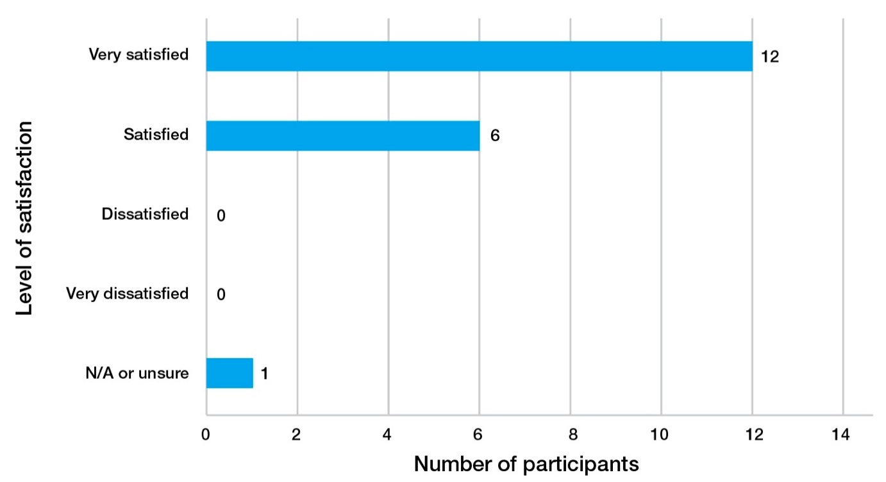
Source: Post-workshop survey.
In the post-workshop survey, participants were asked about their most important learning from the event. Responses were diverse, however some of the most commonly mentioned learnings included circular economy metrics (3 participants), best practice (3 participants), and methods of collaboration (2 participants). A snapshot of some of the participant responses is highlighted below in Figure 5:

Figure 5. Key learnings from workshop, as stated by the workshop participants
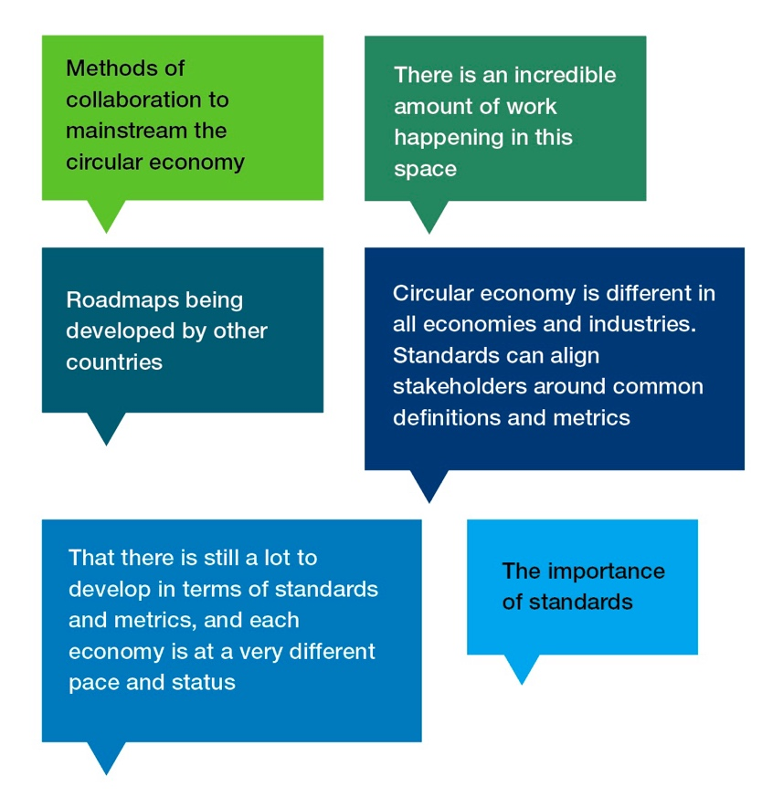
The favorable outcome of the workshop on participants’ awareness of circular economy standards builds on a baseline of positively self-assessed understanding of circular economy concepts. Three quarters of the 24 survey participants rated their understanding as “moderate” or “good” (Figure 6), while 12.5% of participants had no prior understanding of the concept and 12.5% already had a comprehensive understanding. The strong baseline self-assessment could be attributed to the pre-workshop survey participants being predominantly professionals working in the field of circular economy and/or circular economy standards.
Figure 6. Participants’ self-assessment of their understanding of circular economy concepts
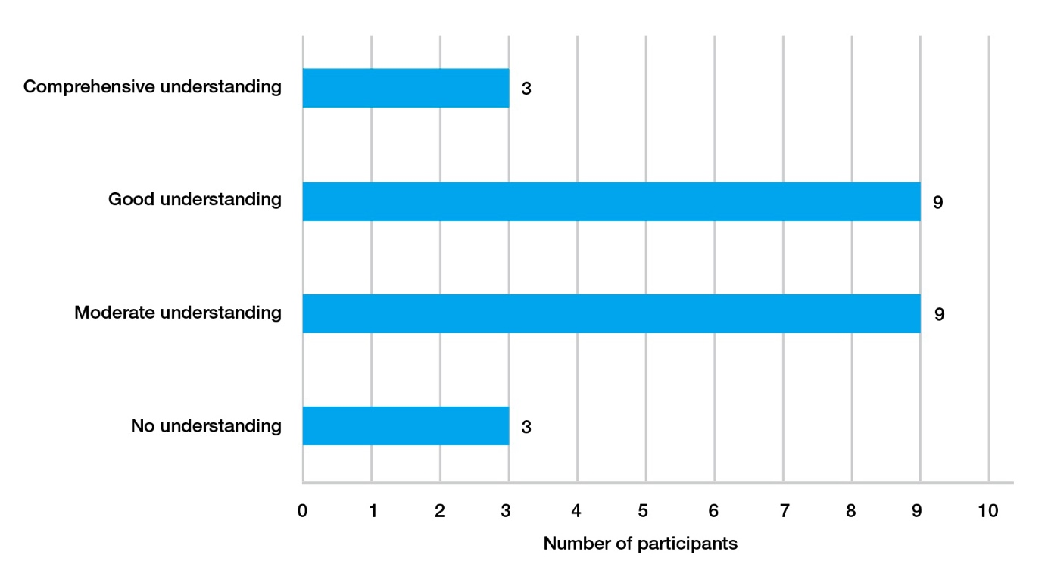
Source: Pre-workshop survey.
Outcome 2: Participants more aware of how to incorporate circular practices into their economies
Raising awareness about the incorporation of circular economic practices in APEC economies was one of the key project outcomes. In the post-workshop survey, 19 participants listed changes or actions they will seek to make in their economy following the workshop sessions. Responses generally fit under five broad categories, as listed in Table 3. Taking steps to increase awareness about the circular economy and relevant standards was the most commonly mentioned action (6 participants). Participants described wanting to increase awareness among regulators, colleagues and the community. In addition, four participants highlighted their desire to develop guidelines and goals to enhance the implementation of circular economic practices. A small selection of participant responses is shown in Figure 7.
Table 3. Actions to incorporate circular practices in their economies, as reported by the workshop participants
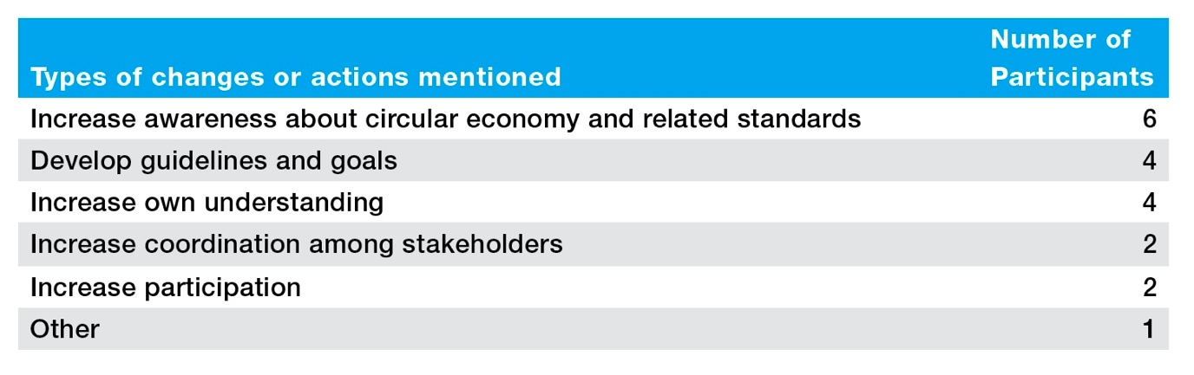
Source: Post-workshop survey.
Figure 7. Some actions to incorporate circular practices in their economies, as reported by the workshop participants
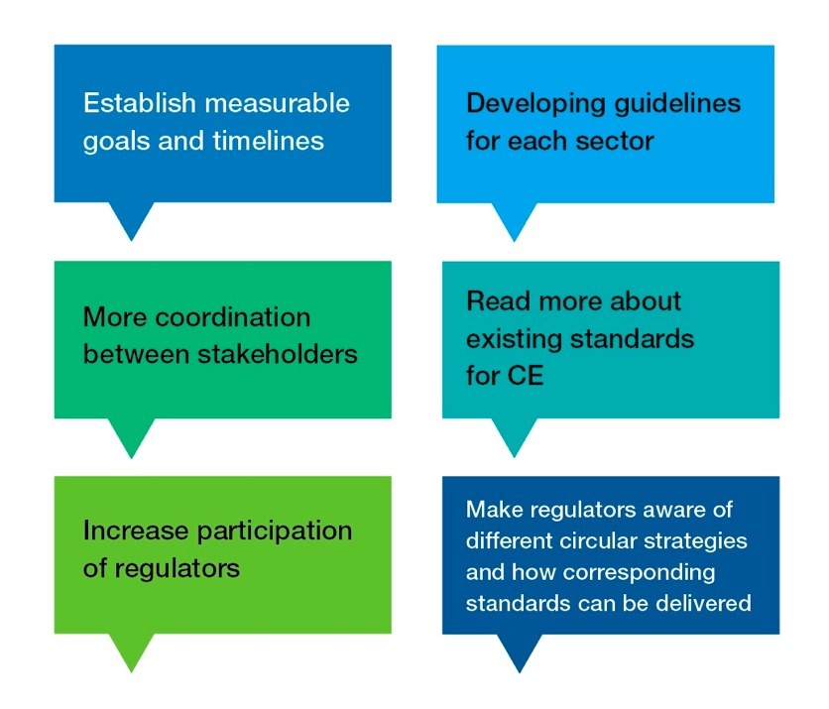
Source: Post-workshop survey.
Outcome 3: Satisfaction with Workshop and Project
Participants reported a very high level of overall satisfaction with the workshop. On a scale of 1 to 5 with 5 being most favorable, the average satisfaction rating given by participants was 4.6. Participants were extremely satisfied with the quality of presenters, speakers, and facilitators at the workshop, scoring them 4.7 out of 5 on average.
Before attending the workshop, participants were asked to review the background paper titled Implementing Circular Economy Standards in the APEC Region. The paper explored circular economy principles, the role of standards, policy implementation across APEC economies, and the circular economy standards landscape. The topics covered in the background paper were of great value to participants, with 89% of the 19 participants surveyed stating that they were satisfied or very satisfied with the topics covered.
The two-day workshop covered a range of topics through various formats including panel discussions, interactive sessions, and case study presentations. Participants learned about circular economy metrics, policy perspectives, strategies from APEC economies, and actionable opportunities. Very high levels of satisfaction were expressed by participants regarding the topics addressed in the workshop. Ninety-seven percent of the 19 participants surveyed stated that they were satisfied or very satisfied with the topics covered over the two days.
Outcome 4: Gender Responsiveness and Diversity
Gender considerations were key in the design and delivery of the workshop. Over half of the speakers and panelists (53%) identified as female. Of the workshop participants, 45% identified as female.
Participants were overall highly satisfied with the extent to which the workshop was delivered in an inclusive and gender responsive manner. On a scale of 1 to 5, participants gave the workshop a mean score of 4.6 with regards to gender responsiveness.
Appendix B: Methods
The intended outcomes of this project were twofold. Firstly, to increase the uptake of circular economy standards in APEC economies. Secondly, to increase participation in the circular economy by enhancing knowledge of good practice among standards bodies, governments, businesses and research organisations. The methodology used to achieve these project outcomes included a background paper, a workshop, surveys, semi-structured interviews, and case study videos.
Background paper
The background paper was reviewed by participants prior to the workshop in order to stimulate ideas and generate discussion during the sessions. The paper was prepared based on a desktop review on standards’ roles in the transition to a circular economy, analysis of a dataset of circular economy related standards, and a review of data on circulareconomy.earth to identify circular economy related legislative instruments in the APEC region. These reviews also yielded examples from the APEC region on how circular economy related standards were implemented, and two of these examples were included in the paper.
The dataset of circular economy related standards was sourced from an extensive review undertaken by the German Institute for Standardization (DIN), the DKE German Commission for Electrical, Electronic & Information Technologies (DKE), and Association of German Engineers (VDI) in 2022. The team filtered the dataset for international standards as the dataset contains German and international standards. Each standard in the dataset was already classified to relevant R-strategies under the 9R framework of the United Nations Environment Programme (based on Potting et al. 2017), and relevant products or sectors – i.e., batteries, electrotechnology and ICT, packaging, plastics, textiles, and construction and infrastructure. The project team used a pivot table in Microsoft Excel to add up and calculate the percentage of standards in each category relative to the total.
Workshop
A two-day hybrid workshop was held in Seattle, USA. Participants from 15 APEC member economies came together to co-produce knowledge in order to build collective capacity around circular economy related international standards, and ways to increase the uptake of circular economy standards and practices in the APEC region. The participants were standards experts, policymakers, and circular economy experts from member economies and delegates attending the third APEC Senior Officials’ and Ministerial Meetings (APEC SOM Meetings), within which the workshop is a meeting activity. The workshop was attended by 48 participants both in-person and online.
Over the two days, participants heard from leading experts in circular economy and standards through case study presentations and panel discussions. Case studies highlighted circular economy best practices from the APEC region, and included speakers from the American Chemical Association, the China National Institute of Standardization, and the Ministry of Environment in Chile.
Panel discussions were held on both days to provide new perspectives on the matter. On Day 1, a panel of experts explored the crucial role of standards in guiding industries towards circular business practices. On Day 2, government and industry leaders discussed how policymaking can shape and drive the pivotal shift towards sustainable growth and environmental stewardship.
Interactive sessions were an important feature of the workshop to co-produce knowledge and enhance collective learning and innovation. These sessions gave participants the opportunity to discuss perspectives and brainstorm ideas relating to the circular economy. For the first session, participants were divided into small groups and tasked with identifying barriers and opportunities in implementing standards. For the second session, the primary focus was on creating actionable strategies within the context of circular economy. At the end of the session, all participants voted on the strategies to prioritise key actions and ideas. The actions and strategies identified formed the basis of the recommendations in this report.
Discussions from the expert panels and interactive sessions were recorded in workshop minutes, and the project team qualitatively analysed the workshop minutes to identify themes on ways that standards support, barriers and recommendations to increase the uptake of circular economy standards and practices.
Surveys
Pre- and post-workshop surveys were administered for monitoring and evaluation of project outcomes (see Appendix A for analysis results). The pre-workshop survey was also used to identify use cases, specific issues, and areas of interest that participants wanted to address in the workshop. Standards Australia sent the pre-workshop survey to its counterparts in each economy who distributed the survey as they saw fit. The post-workshop survey was administered at the end of the workshop. A total of 46 and 24 participants completed the pre- and post-workshop surveys, respectively.
The pre-workshop survey was distributed as a Microsoft Word document to participants from 10 APEC member economies. The post-workshop survey was disseminated to participants at the conclusion of the workshop and conducted using Mentimeter, an online survey platform. Standards Australia used a pivot table in Microsoft Excel to analyse the data and calculate the arithmetic mean for each data series. For qualitative data, participant responses were coded thematically to identify insights and trends.
Interviews
The CSIRO researchers conducted 20 semi-structured interviews with experts in the fields of standard implementation and circular economy standards to gain rich firsthand data to complement the information gathered in the workshop. Participants were identified through a snowball referral method, where the initial referrals were based on the research team’s network. Standards Australia also referred 10 participants from the workshop to be invited for interview. Participants consisted of representatives from government, industry, research organisations, the sustainability advisory industry, and civic society organisations.
These interviews were conducted remotely via Microsoft Teams and lasted on average 45 minutes. The interview questions were adapted to each participant in line with the semi-structured format and centered around topics discussed in the workshop and the background paper, e.g., circular economy standards, implementation challenges, standard gaps, use case and best practice examples, and recommendations to increase the uptake of circular economy standards and practices.
Interview notes were prepared with the use of Teams’ automated transcription function, and analysed qualitatively into themes around ways that standards support, barriers and recommendations to increase the uptake of circular economy standards and practices, using Dedoose (https://www.dedoose.com/). Participant identity was anonymised in transcripts and data analysis. The analysis results were integrated with those from the workshop.
The team obtained approval from the CSIRO human research ethics and privacy review processes to conduct these interviews.
Case study videos
A series of short videos was produced by Standards Australia to highlight case studies of standards being used to help drive circularity in the APEC region. Selected participants from the workshop were contacted via email and invited to participate. A privacy disclosure statement was shared with participants and written consent was obtained prior to filming. For the videos, the chosen individuals were asked to share a case study of a circular economy success story in the APEC region, and how standards played a role in achieving the desired outcomes. The videos were recorded using an online video recording platform.

